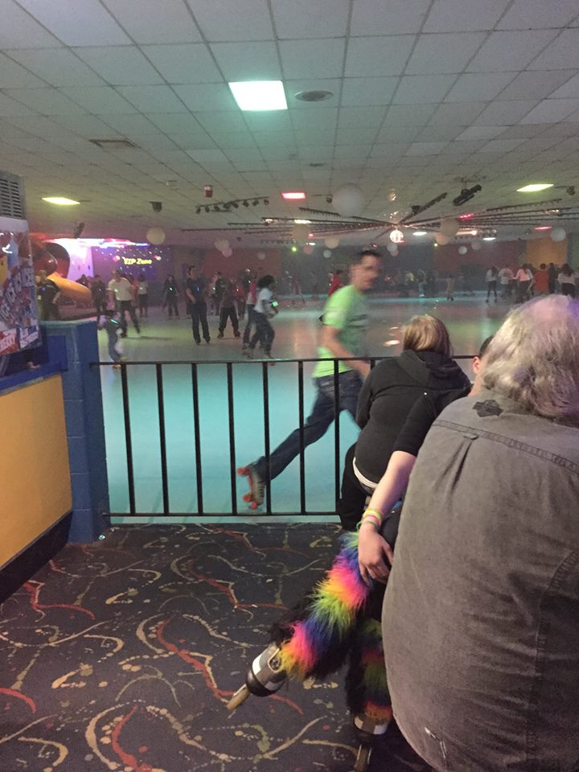  - mARCH 3RD, 2019  wee ARE HERE AREA ROLLER SKATING PARTY!  Come skate with us from 1-5pm  $4.99+tax per Skater  $2-Roller Skate rental $3-Rollerblade Rental  OR just come hang out for free!  (Tell them your with NA for the group rate)
  Come Skate with us!
  ____
  We will be giving away:
  ____
  1 FULL MNNAC REGISTRATION
  ____
  1 BASIC MNNAC REGISTRATION
  ____
  Prize for best costume!
  CheapSkate
  3075 Coon Rapids Blvd.
  Coon Rapids, MN 55433
  For more info call:
  Nate: 715-529-1224
  Kelly: 651-707-7202

