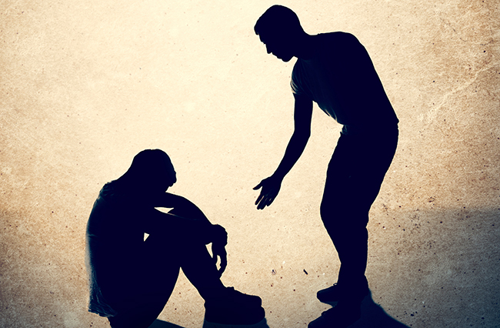

Find a Meeting
The miracle of recovery happens addict to addict at NA meetings. Please take one of our meeting lists with you.
You can always find the closest NA meeting on:
NAMINNESOTA.ORG

