Wee Are Here Area
Living Clean Campout Schedule

Friday – June 1

1 p.m. – Gates Open

8 p.m. – Speaker Meeting – Chrissy D.

Dark – Campfire Hug-up Meeting

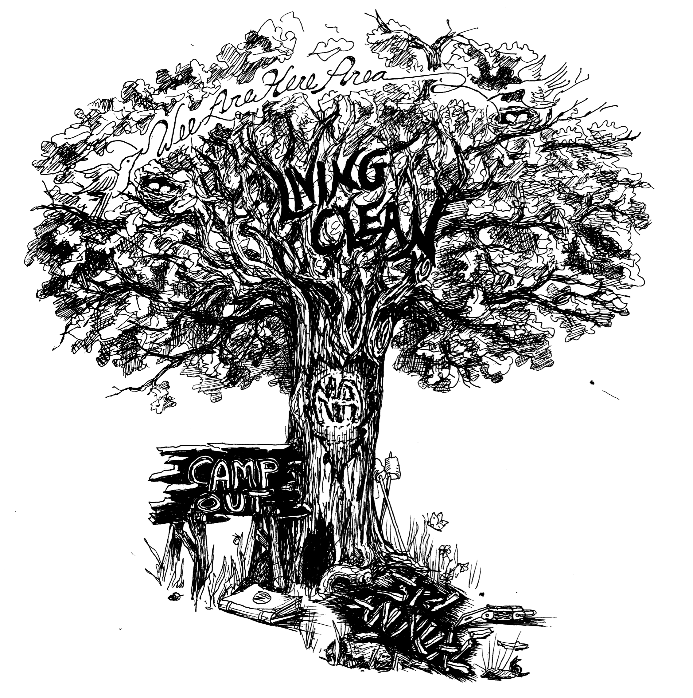

Saturday – June 2

Sunrise – Just For Today Meeting

10 a.m. – Workshop Joe & Sandy
Kids Activity

1 p.m. – Volleyball
Kids Activity

2 p.m. – Horseshoe Tournament

3 p.m. – Workshop JD & Greg
Kids Activity

5 p.m. – Dinner

6:30 p.m. – Cleantime Countdown

7 p.m. – Speaker Meeting John T.
(Raffle to follow speaker)

9 p.m. – Speaker Meeting Monte J.

Dark – Campfire Meeting

Sunday – June 3

Sunrise – Just For Today Meeting

8 a.m. – Breakfast

9 a.m. – Speaker – Natalie

10 a.m. – Clean-up (Help is appreciated)

Must be out by noon

Noon – Campout committee meeting

