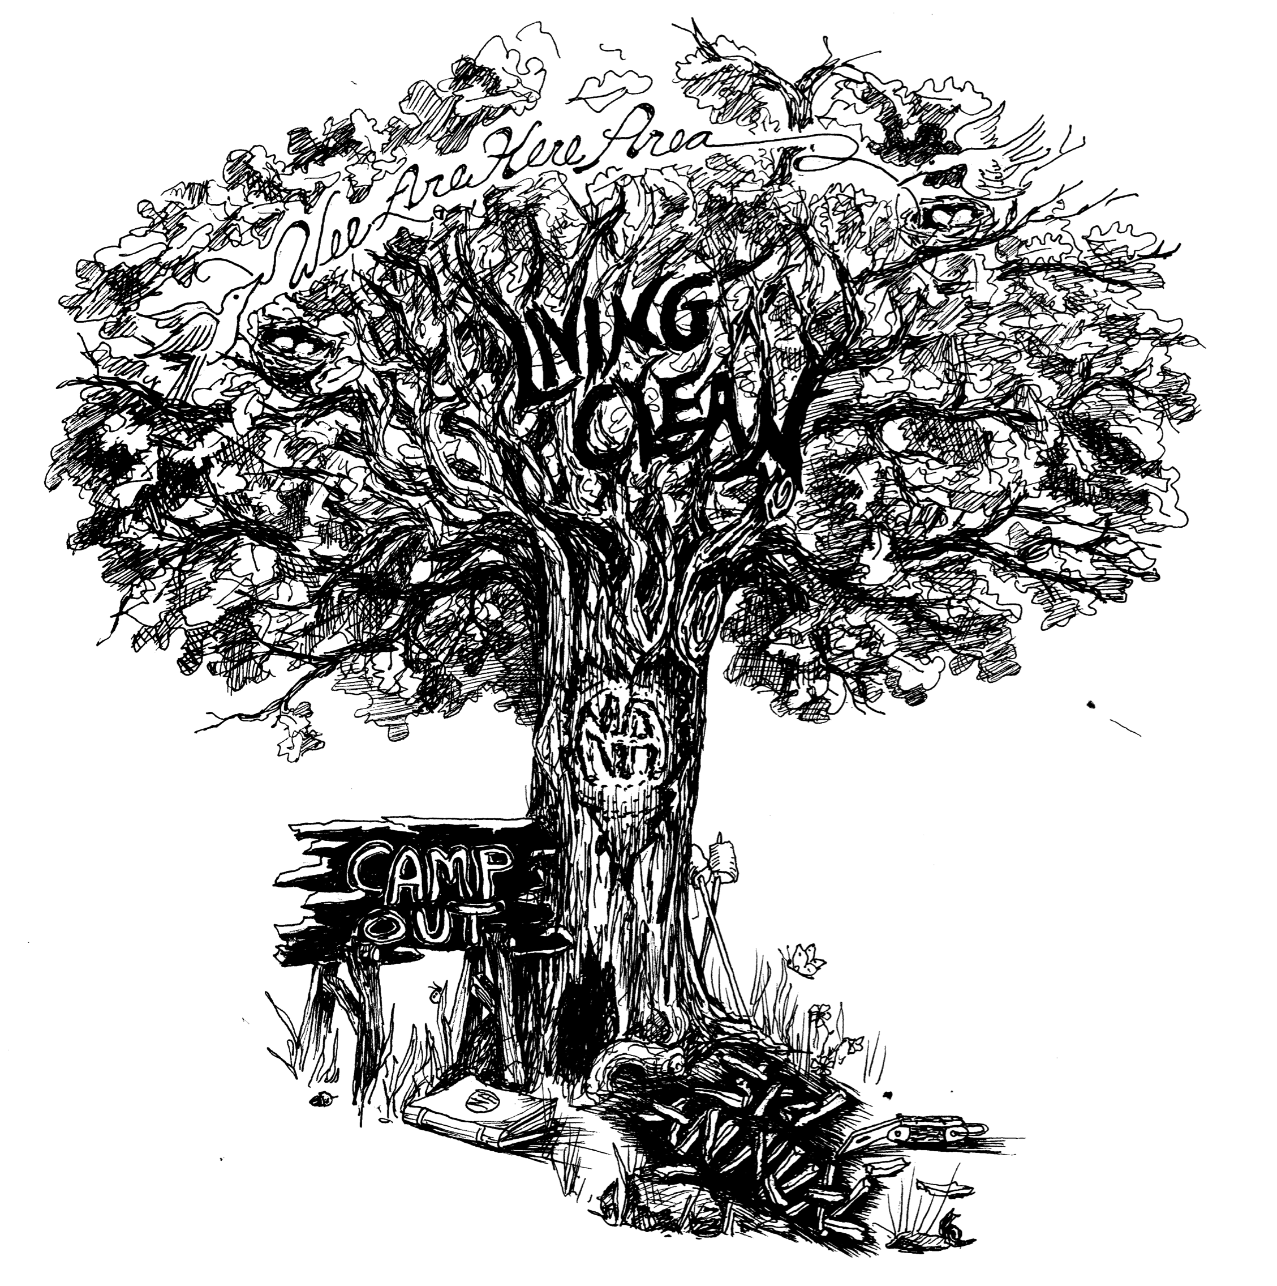
3rd Annual Wee Are Here Area of Narcotics Anonymous
Living Clean Campout June 1st, 2nd, and 3rd 2012
Serenity Shores Campground on Big Marine Lake
3rd Annual Wee Are Here Area of Narcotics Anonymous

Living Clean Campout

June 1st, 2nd, and 3rd 2012

Serenity Shores Campground on Big Marine Lake

Speakers, workshops, campfire meetings, clean-time countdown, kids activities, horseshoes, volleyball, raffle, concessions, fishing, boating, Saturday dinner, Sunday breakfast, bring an item to tie-dye and swimming (at your own risk there are no lifeguards so please watch your children).

Early bird registration must be received by May 15th
$25 per person -kids 15 & under are free
After May 15th the cost is $30 per person
Day pass $10
$5 discount if you donate an NA related item for the raffle
Registration includes all activities and 2 meals

CABINS ARE FULL!

No addict turned away.
Gates open at 1 p.m.

No pets allowed. Vehicles must be parked in the parking lot.
Campfires only allowed in the fire pit.

For more information contact :
Greg 651-925-6783 or Sandy 651-955-6717

Directions from 35:
Take exit 129 MN-97/ CR-23. Head east on MN-97 in Forest Lake – Follow to Lofton Ave. Take a right (Serenity Shores sign on south side of the road) Follow to Maxwill Ave. Take a right. Campground is down the road on the right (follow the signs) Address is 20060 Maxwill Ave. N. Marine on St. Croix, MN 55047

To pre-register mail this form with check or money order made payable to Wee Are Here Area to:
Wee Are Here Area P.O. Box 346 North Branch, MN 55056

Name__________________________ Phone ___________________________

# Of People over 15 __________ x price ___________ = $___________

# Of kids (under 15) ________ kids are free

