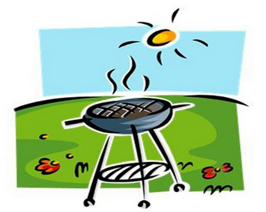


Park Grove NA is hosting an afternoon of food, fun, fellowship, and two speakers!

We will be serving burgers, hot dogs, chips, and potato salad – no admission cost, all are welcome!

Grilling begins at 1:00 p.m.
Games for all ages thru out the afternoon
Speaker meeting starts at 4:00 p.m.

