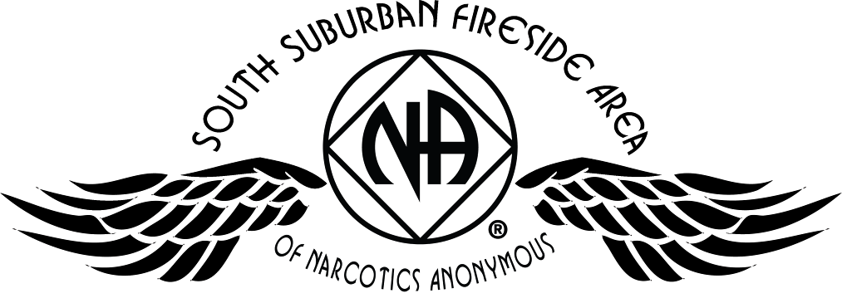
Area Service Committee Meeting Minutes
February 1, 2018

Meeting opened at 7:00 PM by Area Chair Brad S.

Introductions: 23 members in attendance, with 1 newcomer.

Readings: 12 Steps read by Eric B.; 12 Traditions read by John W.; 12 Concepts read by Lizze K.

Call for quorum: 14 voting members present (minimum for quorum is 7). With 14 voting members present, motions require 9 votes to pass (per bylaws “A motion or nomination requires support of two-thirds (66%) of the quorum in order to be accepted.”)

Approval of Minutes: Motion made by Tim N., seconded by John W. to approve the minutes of the January ASC meeting;
Vote: Support – 14, Opposed – 0, Abstentions – 0, passed.

7th Tradition: Collected (see Treasurer’s Report, p. 4)

Subcommittee Reports
Meetings for the Activities, Hospitals & Institutions, Outreach, and Public Relations Subcommittees are held at 7:00pm on the 2nd Thursday of each month at Faith Methodist Church, 1530 Oakdale Ave., West St. Paul, MN.

Vice-Chair:
(Chair: Lizze K. – no report)

Regional Committee Member (RCM):
(Chair: Anne R. – no report)
- Will attend next meeting in March

Activities:
(Chair: Dannielle – present)
- No report

Public Relations:
(Chair: Open)
- Please mention at meetings that this position is currently open.

Hospitals & Institutions:
(Chair: James M. reported)
- 4 Scheduled monthly commitments
- 4th Tuesday of each month Cochran recovery program @ 8pm – New panel leader – Lizze K.
- 4th Thursday of each month Dakota County Detox @ 7pm – New panel leader Steve P.
- Draft policy/guidelines created. Hoping to get area/group feedback for next month area
- Currently all scheduled commitments have panel leaders

Current H&I commitments:
Every Saturday: Dakota Co. Jail (Hastings) 1:00pm
(no more volunteers needed at this time due to background check)
Contact: Jason C. 612-353-7958
2nd Saturday of every month: Cochran Recovery Program (Hastings) 2:00pm
Contact: Kierstin K. 651-347-7032
4th Tuesday of every month: Cochran Recovery Program (Hastings) 8:00pm
Contact: Lizze K. 763-219-2871
4th Thursday of every month: Dakota County Detox. (Hastings) 7:00pm
Contact: Steve P. 612-499-7668

Webmaster:
(Chair Mellissa M. – reported)
- Submitted feedback to region from the groups and individuals from SSF Area. The Region will present the new website at our next ASC meeting with training to follow for area webmasters.

Treasurer:
(Chair: Erica D. reported) [See Treasurer report, p. 5 ]
- Opening balance is $1,899.43

Outreach:
(Chair: Open)
- Please mention at meetings that this position is currently open

PIG:
(Chair: Amber M-D reported) [See Financial report, p. 9 ]
- Financially Stable – balance of $4,178.40
- PIG will be July 20th – 22nd 2018
- In need of positions being filled
- Pig fundraiser Chili Feed March 17th, 2018 – T-shirts and registrations will be for sale.

Literature:
(Chair – Gina C. reported). [See Literature Order report, pp. 10-11]
- Gina C. is may need to step down
- Please e-mail orders ahead of time if possible, address is ssfalit@gmail.com
- Out of some items. Will be heading to service center next month

Group Concerns & Announcements

[Note: written GSR reports are now at the end of the ASC minutes.]

- No Name NA
  - Needs attendance
- Peace of Mind
  - Male and Female sponsors needed
- From Darkness Into Light
  - Need more attendance
- Peace of Mind NA
  - Needs male and female sponsor
- TNT
  - Concern that they do not sponsor any activities
- Addicts in Recovery
  - Need more female sponsors

Open Forum
- Region visited to discuss the current state of Region and what things are currently happening.
  - New website is nearing release. Training for area webmasters will be coming up. Each area will be able to have control over the content available on the website.
  - Region is looking for more attendance at region meetings.
  - Insurance for NA will no longer be carried by UMSO. The Region is currently researching and working on getting insurance coverage for the meetings and events.
  - There has been an increase in cost for literature through UMSO which is 10%.
- Mike S. is making a motion to send the draft of the H&I policy to the groups and hold discussion on the draft until March area meeting.

Elections
- Ad-Hoc chair – Mike S.
  - Vote: Support – 11, Opposed – 0, Abstentions – 0, election passed.

Current Positions - GSRs, please announce open positions at your meetings.
Officers/Committees | Chair | Elected | Co-Chair | Elected
Area Chair (2 Yrs, 1 Yr) | Brad S.(2) | 10/2017 | Rachel M. | 4/2017
Secretary (2 Yrs, 1 Yr) | Eric B. | 8/2017 | --open--
Treasurer (3 Yrs, 2 Yrs) | Erica D. | 2/2017 | --open--
RCM (2 Yrs, 1 Yr) | Anne R. | 10/2017 | Andrew S | 10/2017
Literature (3 Yrs, 2 Yrs) | Gina C. | 4/2017 | Kiersten K. | 9/2016
Activities (2 Yrs, 1 Yr) | Dannielle W. | 11/2017 | --open--
Hospitals & Institutions (2 Yrs, 1 Yr) | James M. | 3/2017 | Mike S. | 4/2017
Outreach (1 Yr, 6 Mo) | --open-- |  | --open--
Public Relations (2 Yrs, 1 Yr) | --open-- |  | --open--
Webmaster (1 Yr) | Melissa M. | 11/2017 | NA
PIG (2 Yrs, 1 Yr) | Amber M-D | 10/2017 | Brad S. | 12/2017
PIG Treasurer (3 Yrs, 2 Yrs) | Tim N. | 10/2017 | --open--
PIG Merchandise Chair (2 Yrs, 1 Yr) | --open-- |  | --open--
PIG Gate Chair (2 Yrs, 1 Yr) | Steely W. | 10/2017 | --open--
PIG Secretary (6 Mo) | Melissa M. | 1/2018 | NA
PIG Food Chair (1 Yr) | --open-- |  | NA
PIG Dinner Coordinator (6 Mo) | Dan K. | 1/2018 | NA
PIG Adult Activities (6 Mo) | --open-- |  | NA
PIG Children Activities (6 Mo) | --open-- |  | NA
PIG Volunteer Coordinator (6 Mo) | --open-- |  | NA
(2) Denotes election is to a second consecutive term in the same position.

Old Business
- None

New Business
- Melissa – Filled in for treasurer. The treasurer log is not here. The log book and receipt book should be left here. Brad will discuss with Erica.

Motions
- Motion Title: H&I Policy/Guidelines
Author: was Mike S., seconded by Eric B.
Motion to: Hold discussion for feedback on draft of policy at the March area meeting
Intent: To get input from all area members

Discussion: To take place at March area meeting
Financial impact: $0.00
Vote: Support – 0, Opposed – 0, Abstentions – 0, motion tabled until March area meeting

Motion to close made by Tim N., seconded by the group.; meeting closed with the Gratitude Statement at 8:30 pm.

Treasurer’s Report

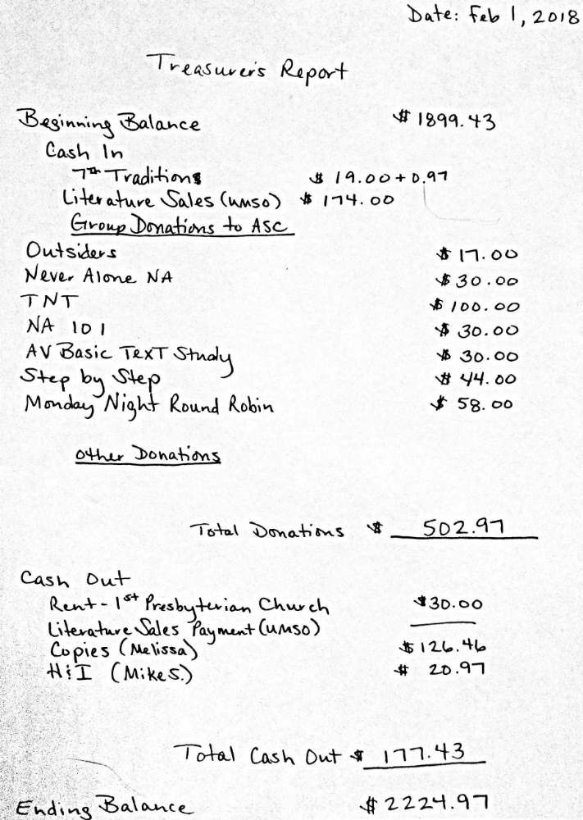

GSR Reports

Woodbury Freebirds |  | 6:00pm Sunday
GSR(A): not present |  | Status:
Avg. Attendance |  |  | Avg. Newcomers
ASC Donation
H&I Activities
Scheduled Activities
Other

Step by Step |  | 7:00pm Sunday
GSR: Jake N |  | Status:Stable
Avg. Attendance | 20 |  | Avg. Newcomers | 2
ASC Donation |  | $44
H&I Activities
Scheduled Activities |  | NA Snow Tubing 2/17/18
Other

Never Alone |  | 7:00pm Sunday
GSR: Amber M-D |  | Status: Stable
Avg. Attendance | 15-25 |  | Avg. Newcomers | 5-10
ASC Donation |  | ASC $30 - PIG $30
H&I Activities |  | Announced
Scheduled Activities
Other

Ties That Bind Us |  | 7:00pm Monday
GSR: Eric B. |  | Status: Stable
Avg. Attendance | 14 |  | Avg. Newcomers | 1
ASC Donation
H&I Activities |  | Announced
Scheduled Activities |  | Dakota Cty Detox 1st Wed. of the month
Other

Seeking Solutions |  | 7:00pm Monday
GSR: Not Present |  | Status:
Avg. Attendance |  |  | Avg. Newcomers
ASC Donation
H&I Activities
Scheduled Activities
Other

Monday Night Round Robin |  | 7:00pm Monday
GSR: Jason & Justin |  | Status: Stable
Avg. Attendance | 10 |  | Avg. Newcomers | 2
ASC Donation |  | $58.00
H&I Activities
Scheduled Activities
Other

Addicts in Recovery |  | 7:00pm Tuesday
GSR: Liz C. |  | Status: Stable
Avg. Attendance | 25-30 |  | Avg. Newcomers | 3-5
ASC Donation |  | Pig $42
H&I Activities |  | Announced
Scheduled Activities |  | Potluck/Speaker mtg 5th Tues.
Other

TNT: Tues. Nights Together |  | 7:00pm Tuesday
GSR: Jay |  | Status: Stable
Avg. Attendance | 15 |  | Avg. Newcomers | 1
ASC Donation |  | $100
H&I Activities |  | Announced
Scheduled Activities
Other

Midweek NA |  | 7:00pm Wednesday
GSR: Chris W. |  | Status: Stable
Avg. Attendance | 10 |  | Avg. Newcomers | 2
ASC Donation
H&I Activities |  | Announced
Scheduled Activities
Other

Stillwater NA |  | 7:30pm Wednesday
GSR: Not Present |  | Status:
Avg. Attendance |  |  | Avg. Newcomers
ASC Donation
H&I Activities
Scheduled Activities
Other

Serenity Sisters |  | 7:00pm Thursday
GSR: Anne R : |  | Status: Stable
Avg. Attendance | 14 |  | Avg. Newcomers | 2
ASC Donation
H&I Activities |  | Announced
Scheduled Activities
Other

No Name NA |  | 7:00pm Thursday
GSR: Andrew S |  | Status: Stable
Avg. Attendance | 10 |  | Avg. Newcomers | 1
ASC Donation
H&I Activities |  | Announced
Scheduled Activities
Other

GSR Reports (continued)

Peace of Mind |  | 7:30pm Friday
GSR: Tim N. |  | Status: Stable
Avg. Attendance | 15 |  | Avg. Newcomers | 3.7
ASC Donation
H&I Activities |  | Announced
Scheduled Activities
Other

NA Day |  | 7:30pm Friday
GSR: Danielle W. |  | Status: Stable
Avg. Attendance | 25-30 |  | Avg. Newcomers | 2-3
ASC Donation
H&I Activities
Scheduled Activities |  | Chili Feed March 17th
Other

Friday Night Outsiders NA |  | 8:00pm Friday
GSR: Tom J |  | Status: Stable
Avg. Attendance | 6-12 |  | Avg. Newcomers | 1-2
ASC Donation |  | $17
H&I Activities |  | Announced
Scheduled Activities
Other

From Darkness Into Light NA |  | 6:30pm Saturday
GSR: Marissa M. |  | Status: Stable
Avg. Attendance | 12 |  | Avg. Newcomers | 1
ASC Donation
H&I Activities
Scheduled Activities
Other

NA 101 |  | 7:00pm Saturday
GSR: John M |  | Status: Stable
Avg. Attendance | 10-12 |  | Avg. Newcomers | 1
ASC Donation |  | $30
H&I Activities
Scheduled Activities
Other

Apple Valley Basic Text Study |  | 9:00pm Saturday
GSR: Hope |  | Status: Stable
Avg. Attendance | 15 |  | Avg. Newcomers | 1-2
ASC Donation |  | $30
H&I Activities |  | Announced
Scheduled Activities
Other

Pig Monthly Treasury Report

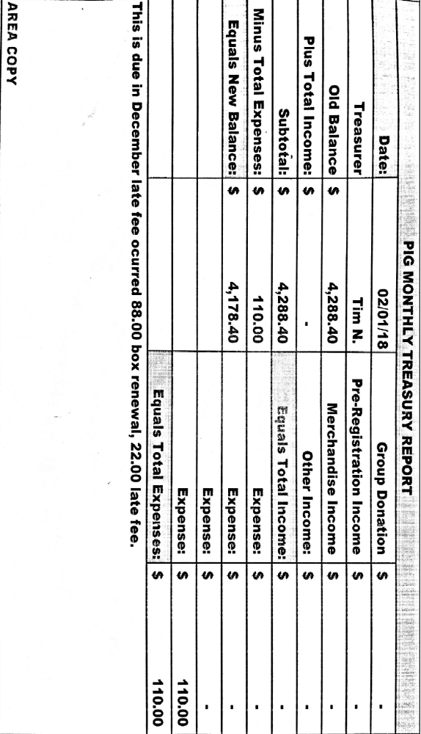

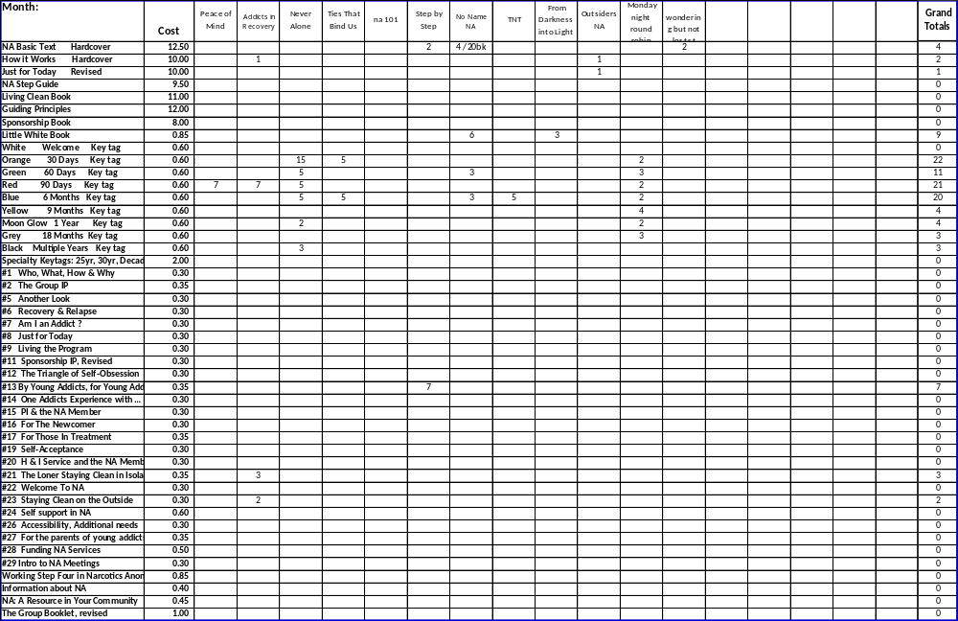
Literature Sales Report

Literature Sales Report (continued)

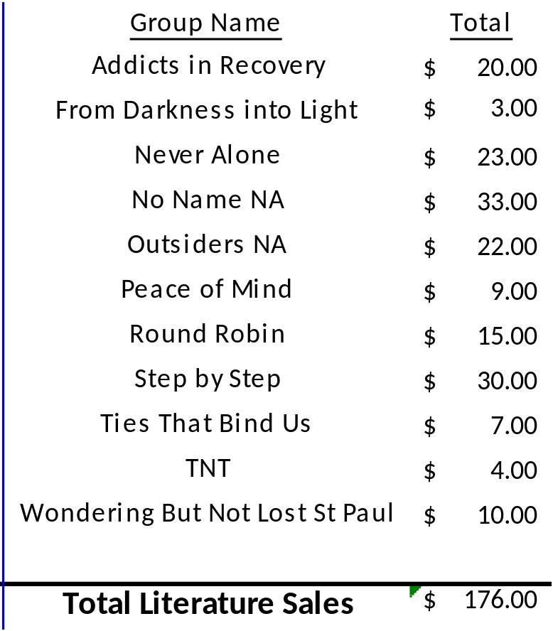

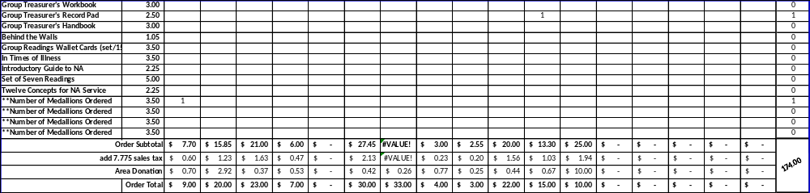

South Suburban Fireside Area Subcommittee Meeting Minutes
2/8/2018

Meeting opened at 7:00 pm with Serenity Prayer by Lizze K. with 5 addicts in attendance.

Mike S. made a motion to accept the minutes. Steve seconded
    - Vote: Support – 4, Opposed – 0, Abstentions – 0, Passed.

Mike S. read the 12 Concepts of NA service.
Collected 7th tradition of $4.97, which was given to the church as rent.

Hospitals and Institutions Subcommittee

H&I Dos and Don'ts read by: Mike S.

Literature Report:
Mike S. – Intro guides will be picked up at UMSO or next months meeting

Panel leader reports:
Dakota Co. Jail (Saturdays): Not Present
We’ve been making our commitment. In need of more JFT’s

Detox (4th Thursday): Steve Reported
Went well with 4 panel members and 5 or 6 clients. Talked with Adam about agreement sheet and updating contact info if needed

Cochran Recovery Center (2nd Saturday): Not Present
Mike – From James/Kiersten – Going well. In need of more intro guides

Cochran Recovery Center (4th Tuesday): Lizze K. reported
Went great. 3 panel members with 6 clients

Other H&I business:
Mike S. – Gave H&I draft to GSR’s at area meeting to get feedback from groups for next months area meeting.

Mike S. – Monday Ties That Bind Us are sponsoring a NA meeting at Dakota Cty. Detox the first Wednesday of the month. This is not an H&I commitment. Other groups bring in meetings to institutions without commitments. Subcommittee suggests attending area or subcommittee meeting in order to get help from the group.

Outreach Subcommittee (Open)
Meeting of the month:

Activities Subcommittee (Not Present)

Public Relations Subcommittee (Open)

Webmaster Subcommittee – Melissa M.
Region was at area and spoke about the new website. Once up and running our H&I commitments will be uploaded without contacts

Other Business
Mike S. – Jason C wrote: I am sad to report I cannot continue chairing the jail meeting. Still attending meetings though. We will need a panel leader for this commitment. Please announce at meetings.

Meeting closed at 7:45

South Suburban Fireside Area Subcommittee Meeting Agenda
Opening
Introductions
Approval of minutes
Reading of 12 Concepts of NA Service
7th Tradition
Hospitals and Institutions Subcommittee
H&I Introduction/Dos and Don’ts
Literature Report
Panel Leader Reports
Dakota Co. Jail
Dakota Co. Detox
Cochran Recovery Center (Saturday)
Cochran Recovery Center (Tuesday)
Other H&I items
Outreach Subcommittee
Activities Subcommittee
Public Relations Subcommittee
Webmaster Subcommittee
Other old/new business

Adjournment

