
Area Service Committee Meeting Minutes
January 4, 2017

Meeting opened at 7:00 PM by Area Chair Brad S.

Introductions: 20 members in attendance, with 2 newcomers.

Readings: 12 Steps read by John W.; 12 Traditions read by Tom.; 12 Concepts read by Nicole

Call for quorum: 10 voting members present (minimum for quorum is 7). With 10 voting members present, motions require 7 votes to pass (per bylaws “A motion or nomination requires support of two-thirds (66%) of the quorum in order to be accepted.”)

Approval of Minutes: Motion made by John W., seconded by Tom. to approve the minutes of the January ASC meeting;
Vote: Support – 10, Opposed – 0, Abstentions – 0, passed.

7th Tradition: Collected (see Treasurer’s Report, p. 4)

Subcommittee Reports
Meetings for the Activities, Hospitals & Institutions, Outreach, and Public Relations Subcommittees are held at 7:00pm on the 2nd Thursday of each month at Faith Methodist Church, 1530 Oakdale Ave., West St. Paul, MN.

Vice-Chair:
(Chair: Lizze K. – no report)

Regional Committee Member (RCM):
(Chair: Anne R. – no report)
- Will attend next meeting in March

Activities:
(Chair: Dannielle – not present)
- No report

Public Relations:
(Chair: Catie O. not present)
- No report

Hospitals & Institutions:
(Chair: James M. reported)
- 4 Scheduled monthly commitments
- 4th Tuesday of each month Cochran recovery program @ 8pm – New panel leader – Lizze K.
- 4th Thursday of each month Dakota County Detox @ 7pm – New panel leader Steve P.
- Developing H&I policy guidelines

Current H&I commitments:
Every Saturday: Dakota Co. Jail (Hastings) 1:00pm
(no more volunteers needed at this time due to background check)
Contact: Jason C. 612-353-7958
2nd Saturday of every month: Cochran Recovery Program (Hastings) 2:00pm
Contact: Kierstin K. 651-347-7032
4th Tuesday of every month: Cochran Recovery Program (Hastings) 8:00pm
Contact: Lizze K. 763-219-2871
4th Thursday of every month: Dakota County Detox. (Hastings) 7:00pm
Contact: Steve P. 612-499-7668

Webmaster:
(Chair Mellissa M. – reported)
- Waiting for feedback on the website.

Treasurer:
(Chair: Erica D. reported) [See Treasurer report, p. 4 ]
- Opening balance is $1,656.43

Outreach:
(Chair: Open)
- Please mention at meetings that this position is currently open
- Meeting of the month
  - February 19th at 7:00 – Seeking Solutions Prior Lake

PIG:
(Chair: Amber M-D reported) [See Financial report, p. 9 ]
- Financially Stable – balance of $4,288.40
- PIG will be July 20th – 22nd 2018
- In need of positions being filled
- Brad S. voted in as co-chair

Literature:
(Chair – Kiersten K. reported). [See Literature Order report, pp. 10-11]
- Gina C. is moving to literature chair and Kiersten K. is moving to co-chair
- Please e-mail orders ahead of time if possible, address is ssfalit@gmail.com
- Out of some items. Will be heading to service center next month

Group Concerns & Announcements

[Note: written GSR reports are now at the end of the ASC minutes.]

- No Name NA
  - Needs attendance
- Peace of Mind
  - Male and Female sponsors needed
- From Darkness Into Light
  - Need support
- Peace of Mind NA
  - Needs male and female sponsor
- NA 101
  - Needs more addicts and more sponsors
- TNT
  - That we don’t have any activities

Open Forum
- Note any updates to meetings so schedule can be updated

Elections
- None

Current Positions - GSRs, please announce open positions at your meetings.
Officers/Committees | Chair | Elected | Co-Chair | Elected
Area Chair (2 Yrs, 1 Yr) | Brad S.(2) | 10/2017 | Rachel M. | 4/2017
Secretary (2 Yrs, 1 Yr) | Eric B. | 8/2017 | --open--
Treasurer (3 Yrs, 2 Yrs) | Erica D. | 2/2017 | --open--
RCM (2 Yrs, 1 Yr) | Anne R. | 10/2017 | Andrew S | 10/2017
Literature (3 Yrs, 2 Yrs) | Gina C. | 4/2017 | Kiersten K. | 9/2016
Activities (2 Yrs, 1 Yr) | Dannielle W. | 11/2017 | --open--
Hospitals & Institutions (2 Yrs, 1 Yr) | James M. | 3/2017 | Mike S. | 4/2017
Outreach (1 Yr, 6 Mo) | --open-- |  | --open--
Public Relations (2 Yrs, 1 Yr) | --open-- |  | --open--
Webmaster (1 Yr) | Melissa M. | 11/2017 | NA
PIG (2 Yrs, 1 Yr) | Amber M-D | 10/2017 | Brad S. | 12/2017
PIG Treasurer (3 Yrs, 2 Yrs) | Tim N. | 10/2017 | --open--
PIG Merchandise Chair (2 Yrs, 1 Yr) | --open-- |  | --open--
PIG Gate Chair (2 Yrs, 1 Yr) | Steely W. | 10/2017 | --open--
PIG Secretary (6 Mo) | Melissa M. | 1/2018 | NA
PIG Food Chair (1 Yr) | --open-- |  | NA
PIG Dinner Coordinator (6 Mo) | Dan K. | 1/2018 | NA
PIG Adult Activities (6 Mo) | --open-- |  | NA
PIG Children Activities (6 Mo) | --open-- |  | NA
PIG Volunteer Coordinator (6 Mo) | --open-- |  | NA
(2) Denotes election is to a second consecutive term in the same position.

Old Business
- None

New Business
- None

Motions
- None

Motion to close made by Tim N., seconded by the group.; meeting closed with the Gratitude Statement at 8:00 pm.

Treasurer’s Report

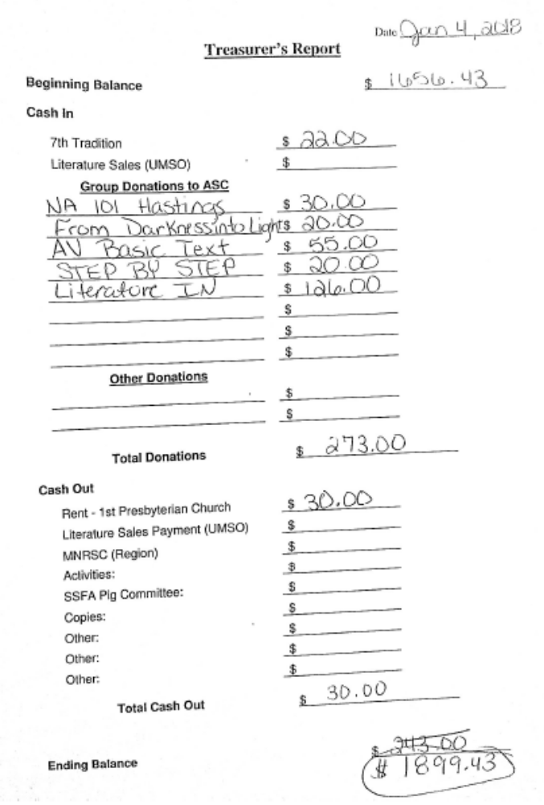

GSR Reports

Woodbury Freebirds |  | 6:00pm Sunday
GSR(A): not present |  | Status:
Avg. Attendance |  |  | Avg. Newcomers
ASC Donation
H&I Activities
Scheduled Activities
Other

Step by Step |  | 7:00pm Sunday
GSR: Anne |  | Status:
Avg. Attendance |  |  | Avg. Newcomers
ASC Donation
H&I Activities
Scheduled Activities
Other

Never Alone |  | 7:00pm Sunday
GSR: Nicole M. |  | Status: Stable
Avg. Attendance | 20 |  | Avg. Newcomers | 3-5
ASC Donation |  | $12
H&I Activities |  | Announced
Scheduled Activities
Other

Ties That Bind Us |  | 7:00pm Monday
GSR: Eric B. |  | Status: Stable
Avg. Attendance | 14 |  | Avg. Newcomers | 1.5
ASC Donation
H&I Activities |  | Announced
Scheduled Activities
Other

Seeking Solutions |  | 7:00pm Monday
GSR: Not Present |  | Status:
Avg. Attendance |  |  | Avg. Newcomers
ASC Donation
H&I Activities
Scheduled Activities
Other

Monday Night Round Robin |  | 7:00pm Monday
GSR: Not Present |  | Status:
Avg. Attendance |  |  | Avg. Newcomers
ASC Donation
H&I Activities
Scheduled Activities
Other

Addicts in Recovery |  | 7:00pm Tuesday
GSR: Amber M-D |  | Status: Stable
Avg. Attendance | 25 |  | Avg. Newcomers | 3
ASC Donation
H&I Activities |  | Announced
Scheduled Activities |  | Potluck/Speaker mtg 5th Tues.
Other

TNT: Tues. Nights Together |  | 7:00pm Tuesday
GSR: Jay |  | Status: Stable
Avg. Attendance | 12 |  | Avg. Newcomers | 1
ASC Donation
H&I Activities |  | Announced
Scheduled Activities
Other

Midweek NA |  | 7:00pm Wednesday
GSR: OPEN (Tim) |  | Status: Stable
Avg. Attendance | 15 |  | Avg. Newcomers | 2
ASC Donation
H&I Activities |  | Announced
Scheduled Activities
Other

Stillwater NA |  | 7:30pm Wednesday
GSR: Not Present |  | Status:
Avg. Attendance |  |  | Avg. Newcomers
ASC Donation
H&I Activities
Scheduled Activities
Other

Serenity Sisters |  | 7:00pm Thursday
GSR: Anne R : |  | Status: Stable
Avg. Attendance | 14 |  | Avg. Newcomers | 2
ASC Donation
H&I Activities |  | Announced
Scheduled Activities
Other

No Name NA |  | 7:00pm Thursday
GSR: Andrew S |  | Status: Stable
Avg. Attendance | 4 |  | Avg. Newcomers | 0
ASC Donation
H&I Activities |  | Announced
Scheduled Activities
Other

GSR Reports (continued)

Peace of Mind |  | 7:30pm Friday
GSR: Tim N. |  | Status: Stable
Avg. Attendance | 15-20 |  | Avg. Newcomers | 3
ASC Donation
H&I Activities |  | Announced
Scheduled Activities
Other

NA Day |  | 7:30pm Friday
GSR: Not Present |  | Status:
Avg. Attendance |  |  | Avg. Newcomers
ASC Donation
H&I Activities
Scheduled Activities
Other

Friday Night Outsiders NA |  | 8:00pm Friday
GSR: Tom J |  | Status: Stable
Avg. Attendance | 8-12 |  | Avg. Newcomers | 2
ASC Donation
H&I Activities |  | Announced
Scheduled Activities
Other

From Darkness Into Light NA |  | 6:30pm Saturday
GSR: Marissa M. |  | Status: Stable
Avg. Attendance | 10 |  | Avg. Newcomers | 0-1
ASC Donation |  | $20
H&I Activities
Scheduled Activities
Other

NA 101 |  | 7:00pm Saturday
GSR: John M |  | Status: Stable
Avg. Attendance | 10 |  | Avg. Newcomers | 1
ASC Donation |  | $30
H&I Activities
Scheduled Activities
Other

Apple Valley Basic Text Study |  | 9:00pm Saturday
GSR: Not present |  | Status:
Avg. Attendance |  |  | Avg. Newcomers
ASC Donation
H&I Activities
Scheduled Activities
Other

Pig Monthly Treasury Report

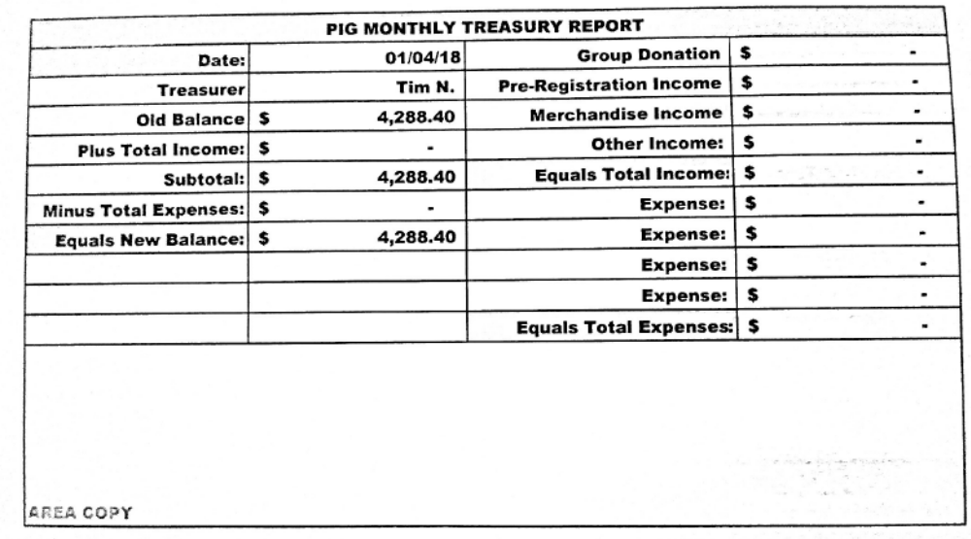

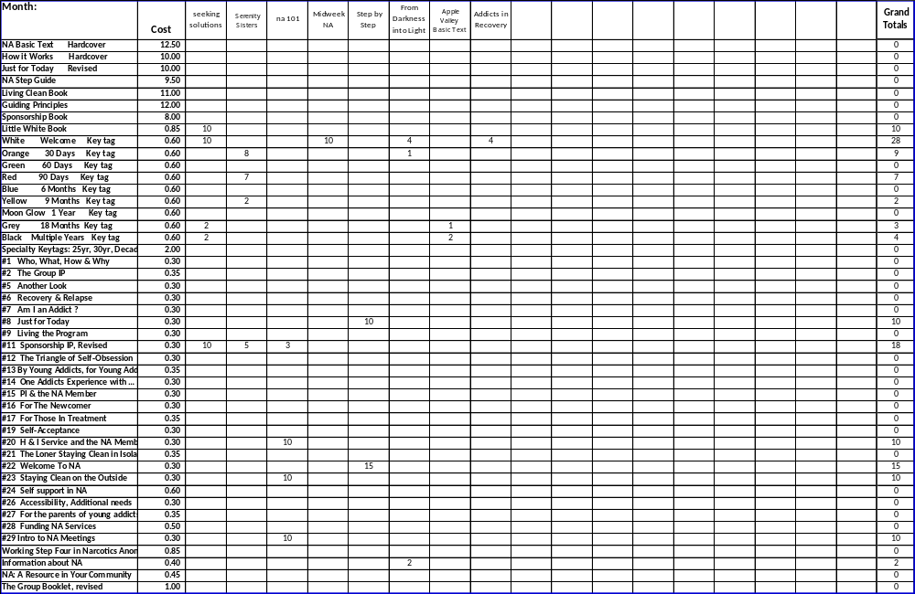
Literature Sales Report

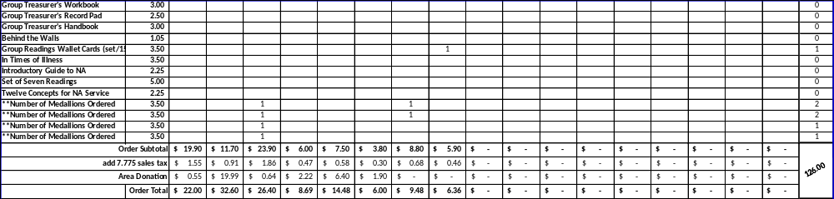
Literature Sales Report (continued)

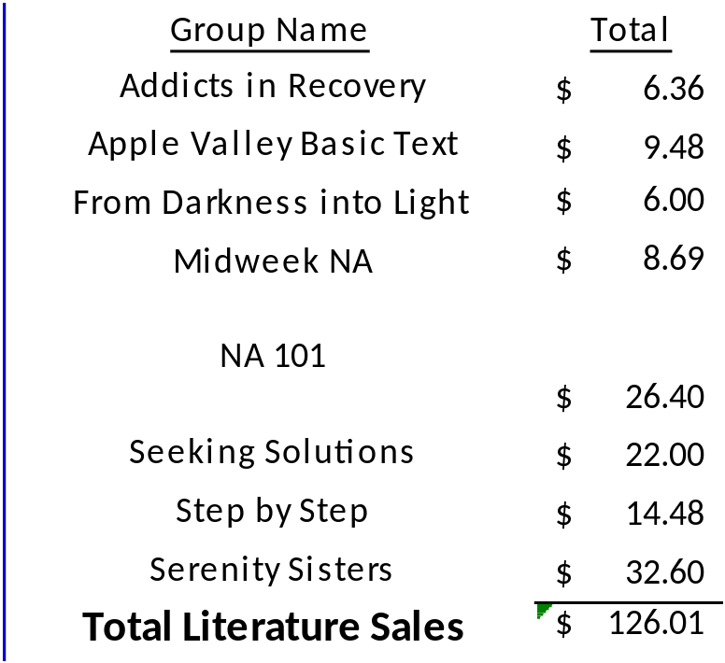

South Suburban Fireside Area Subcommittee Meeting Minutes
1/11/2018

Meeting opened at 7:00 pm with Serenity Prayer by Lizze K. with 7 addicts in attendance.

James M. made a motion to accept the minutes. Eric B seconded
    - Vote: Support – 5, Opposed – 0, Abstentions – 2, Passed.

Mike S. read the 12 Concepts of NA service.
Collected 7th tradition of $38, which was given to the church as rent.

Hospitals and Institutions Subcommittee

H&I Dos and Don'ts read by: James M.

Literature Report:
Mike S. – Will be unavailable for a couple weeks. Please contact James M. for any needs.

Panel leader reports:
Dakota Co. Jail (Saturdays): Not Present

Detox (4th Thursday): Steve Reported
Went well with 4 panel members and 5 or 6 clients.

Cochran Recovery Center (2nd Saturday): Not Present

Cochran Recovery Center (4th Tuesday): Lizze K. reported
Went great. 3 panel members with 6 to 7 clients

Other H&I business:
Mike S. – Review H&I Policy Guidelines. Once revised and reviewed, bring to ASC meeting. Policy to go out to the groups at next month’s ASC meeting. Groups to report back in March with any changes. If adjustments are needed, the vote will be delayed until April. If all items are acceptable the group will vote on the policy in March.

James – The 20 intro guides will be delivered to Dakota Co Drug Court within the week.

Jay – Will be contacting H&I panel leaders to get further involved in H&I commitments.

H&I commitments in need of additional meeting lists without contact info listed on them. Melissa M. to make adjustments to existing meeting list and have 50 printed for next month’s ASC meeting.

Outreach Subcommittee (Open)
Meeting of the month:
January 19th – NA Day
February 19th – Seeking Solutions

Activities Subcommittee (Not Present)

Public Relations Subcommittee (Open)

Webmaster Subcommittee – Melissa M.
New site to be launched in February with training in March for area webmasters. Contact Melissa M. with any specific changes in the meantime.

Other Business
Secretary to create a meeting agenda for running the subcommittee meeting. Eric B. to have complete for next month’s meeting where it can be reviewed and voted on.

Meeting closed at 7:50

South Suburban Fireside Area Subcommittee Meeting Agenda
Opening
Introductions
Approval of minutes
Reading of 12 Concepts of NA Service
7th Tradition
Hospitals and Institutions Subcommittee
H&I Introduction/Dos and Don’ts
Literature Report
Panel Leader Reports
Dakota Co. Jail
Dakota Co. Detox
Cochran Recovery Center (Saturday)
Cochran Recovery Center (Tuesday)
Other H&I items
Outreach Subcommittee
Activities Subcommittee
Public Relations Subcommittee
Other old/new business

Adjournment

