
Area Service Committee Meeting Minutes
September 7, 2017

Meeting opened at 7:00 PM by Area Chair Brad S.

Introductions: 24 members in attendance, with 1 newcomer.

Readings: 12 Steps read by Tim N.; 12 Traditions read by Tom; 12 Concepts read by Rachel.

Call for quorum: 13 voting members present (minimum for quorum is 7). With 13 voting members present, motions require 8 votes to pass (per bylaws “A motion or nomination requires support of two-thirds (66%) of the quorum in order to be accepted.”)

Approval of Minutes: Motion made by Tim, seconded by Rachel to approve the minutes of the August ASC meeting;
Vote: Support – 13, Opposed – 0, Abstentions – 0, passed.

7th Tradition: Collected (see Treasurer’s Report, p. 6)

Subcommittee Reports
Meetings for the Activities, Hospitals & Institutions, Outreach, and Public Relations Subcommittees are held at 7:00pm on the 2nd Thursday of each month at Faith Methodist Church, 1530 Oakdale Ave., West St. Paul, MN.

Vice-Chair:
(Rachel – reported)
- H&I Learning day coming up Oct. 21 – Flyers to follow
- Need more attendance

Regional Committee Member (RCM):
(open – no report)
- Please announce at your meetings this position is open and only needs meets four times a year.

Activities:
(open – no report)
- Please announce at your meetings this position is open and our area would really like to have some scheduled activities for addicts to enjoy and learn how to have fun in recovery.

Public Relations:
(Chair: Amber M-D. reported)
- Financially stable
- Balance $50.00
- Amber will be stepping down from Public Relations Chair.

Hospitals & Institutions:
(Chair: James M. reported)
- 4 Scheduled monthly commitments
- H&I Learning Day Oct 21st 2-5 PM – 3100 Park Ave Mpls, MN

Current H&I commitments:
Every Saturday: Dakota Co. Jail (Hastings) 1:00pm
(no more volunteers needed at this time due to background check)
Contact: Jason C. 612-353-7958
2nd Saturday of every month: Cochran Recovery Program (Hastings) 2:00pm
Contact: Kierstin K. 651-347-7032
4th Tuesday of every month: Cochran Recovery Program (Hastings) 8:00pm
Contact: Todd V. 651-285-1789
4th Thursday of every month: Dakota County Detox. (Hastings) 7:00pm
Contact: Rachel M. 612-384-4695

Webmaster:
(open – no report)
- Please announce at your meetings this position is open and only needs someone to update the website with our upcoming events, trusted servant position changes, and any other area news.

Treasurer:
(Chair: Erica D. reported) [See Treasurer report, p. 6 ]
- Opening balance is $2750.67

Outreach:
(Chair: Marissa reported)
- Northfield is switching areas and is in need of more attendance.

PIG:
(Chair: Amber M-D reported) [See Financial report, pp. 9 ]
- Financially Stable – balance of $4,188.40
- Positions are still available

Literature:
(Chair – Kiersten reported). [See Literature Order report, pp. 10-11]
- All items are stocked
- Please e-mail orders ahead of time if possible, address is ssfalit@gmail.com

Group Concerns & Announcements

[Note: written GSR reports are now at the end of the ASC minutes.]

- From Darkness Into Light new meeting contact – Marissa 612-239-0195
- NA Day has multiple positions open
- Step By Step needs co-positions filled
- Seeking Solutions needs attendance

Open Forum

- James M. made a motion to give 30 Basic Text & one set of group readings to H&I. 20 of these Basic Text (8 of them Spanish) to go to Dakota Co. Jail for H&I commitment along with 1 set of group readings. 5 basic text for Dakota Co. Detox for donation and 5 Basic Text to Cochran Recovery Center for donation. This is to provide NA literature to facilities where we hold H&I commitments. The total financial impact would be $393.24.
- Brad S.: SSFA is sitting on a lot of money. World lawyered up when requested to reveal their books. 48% of income at world goes to salaries. We should consider subsidizing books for meetings possibly. New comers need books. Vote in groups and revisit next month
- Jason is the new GSR for Round Robin
- Brad S.: $128.06 in printing this month.
  - New meeting lists (Qty. 600.00)
  - Email a PDF to southsuburbanfireside@gmail.com if printing is needed
- James M.: Info from Tonya at Dakota Co. drug court. (20) Intro to NA books were donated and all were handed out. Financially we are not able to donate books due to size and funding. Tonya was directed to the website for ordering which she stated that was not an option. It would be approximately $45.00 per month to donate (20) Intro to NA books monthly.

Elections
- None

Current Positions - GSRs, please announce open positions at your meetings.
Officers/Committees | Chair | Elected | Co-Chair | Elected
Area Chair (2 Yrs, 1 Yr) | Brad S. | 9/2016 | Rachel M. | 4/2017
Secretary (2 Yrs, 1 Yr) | Eric B. | 8/2017 | --open--
Treasurer (3 Yrs, 2 Yrs) | Erica D. | 2/2017 | --open--
RCM (2 Yrs, 1 Yr) | --open-- |  | --open--
Literature (3 Yrs, 2 Yrs) | Kierstin K. | 9/2016 | Gina C. | 4/2017
Activities (2 Yrs, 1 Yr) | --open-- |  | --open--
Hospitals & Institutions (2 Yrs, 1 Yr) | James M. | 3/2017 | Mike S. | 4/2017
Outreach (1 Yr, 6 Mo) | --open-- |  | --open--
Public Relations (2 Yrs, 1 Yr) | --open-- |  | --open--
Webmaster (1 Yr) | --open-- |  | NA
PIG (2 Yrs, 1 Yr) | Melissa C. | 9/2016 | Amber M-D. | 5/2017
PIG Treasurer (3 Yrs, 2 Yrs) | Todd V. | 9/2016 | Tim N. | 11/2016
PIG Merchandise Chair (2 Yrs, 1 Yr) | Steve H. (2) | 12/2016 | --open--
PIG Gate Chair (2 Yrs, 1 Yr) | Matt K. | 9/2016 | Steely W. | 4/2017
PIG Secretary (6 Mo) | Kris B. | 9/2016 | NA
PIG Food Chair (1 Yr) | Mary M. | 9/2016 | NA
PIG Dinner Coordinator (6 Mo) | Dina D. | 5/2017 | NA
PIG Adult Activities (6 Mo) | Leo J. | 7/2017 | NA
PIG Children Activities (6 Mo) | Rob R. | 2/2017 | NA
PIG Volunteer Coordinator (6 Mo) | --open-- |  | NA
(2) Denotes election is to a second consecutive term in the same position.

Old Business
- None

New Business
- None

Motions
- Motion Title: Basic Text for H&I
Author: was James M., seconded by Dan K.
Motion to: give 30 Basic Text & one set of group readings to H&I. 20 of these Basic Text (8 of them Spanish) to go to Dakota Co. Jail for H&I commitment along with 1 set of group readings. 5 basic text for Dakota Co. Detox for donation and 5 Basic Text to Cochran Recovery Center for donation. This is to provide NA literature to facilities where we hold H&I commitments. The total financial impact would be $393.24
Intent: To Provide NA Literature to Facilities where we hold H&I commitments

Discussion: Discussed during Open Forum (see above notes).
Financial impact: $393.24
Vote: Support – 13, Opposed – 0, Abstentions – 0, motion passed.

- Motion Title: Subsidize books
Author: was Brad S., seconded by Anne
Motion to: Subsidize Basic Text to the groups by the area purchasing $1,000.00 in books and selling to the groups at $5.00/book
Intent: Further our primary purpose

Discussion: Discussed during Open Forum (see above notes).
Financial impact: $1000.00
Vote: Support – 0, Opposed – 0, Abstentions – 0, motion was tabled until next month at which time it would be voted on after individual groups had a chance to vote.

Motion to close made by Tim N., seconded by Amber M-d.; meeting closed with the Gratitude Statement at 8:27 pm.

Treasurer’s Report


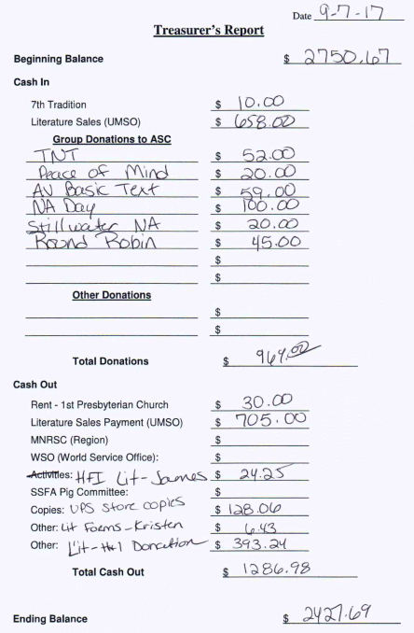

GSR Reports

Woodbury Freebirds |  | 6:00pm Sunday
GSR: NOT PRESENT |  | Status:
Avg. Attendance |  |  | Avg. Newcomers
ASC Donation
H&I Activities
Scheduled Activities
Other

Step by Step |  | 7:00pm Sunday
GSR: Steely W |  | Status:Stable
Avg. Attendance | 12 |  | Avg. Newcomers | 1
ASC Donation
H&I Activities |  | Announced
Scheduled Activities |  | Nothing Scheduled
Other

Never Alone |  | 7:00pm Sunday
GSR: Nicole M. |  | Status: Stable
Avg. Attendance | 15-25 |  | Avg. Newcomers | 2-5
ASC Donation
H&I Activities |  | Announced
Scheduled Activities
Other

Ties That Bind Us |  | 7:00pm Monday
GSR: Eric B. |  | Status: Stable
Avg. Attendance | 15 |  | Avg. Newcomers | 1-2
ASC Donation
H&I Activities |  | Announced
Scheduled Activities |  | 1st & 3rd mtg by the river
Other

Seeking Solutions |  | 7:00pm Monday
GSR: Rachel M. |  | Status: Stable
Avg. Attendance | 10-12 |  | Avg. Newcomers | 1 – 2
ASC Donation
H&I Activities |  | Announced
Scheduled Activities
Other

Monday Night Round Robin |  | 7:00pm Monday
GSR: Jason M |  | Status: Stable
Avg. Attendance | 14 |  | Avg. Newcomers | 2
ASC Donation |  | $45.00
H&I Activities |  | Announced
Scheduled Activities
Other

Addicts in Recovery |  | 7:00pm Tuesday
GSR: Amber M-D |  | Status: Stable
Avg. Attendance | 25-30 |  | Avg. Newcomers | 3 – 5
ASC Donation
H&I Activities |  | Announced
Scheduled Activities |  | Every 5th Tuesday Potluck
Other

TNT: Tues. Nights Together |  | 7:00pm Tuesday
GSR: Steve |  | Status: Stable
Avg. Attendance | 10-15 |  | Avg. Newcomers | 1-2
ASC Donation |  | $52.00
H&I Activities |  | Announced
Scheduled Activities
Other

Tuesday Night Serenity |  | 7:00pm Tuesday
GSR: NOT PRESENT : |  | Status:
Avg. Attendance |  |  | Avg. Newcomers
ASC Donation
H&I Activities
Scheduled Activities
Other

Midweek NA |  | 7:00pm Wednesday
GSR: OPEN |  | Status: Stable
Avg. Attendance | 15 |  | Avg. Newcomers | 2
ASC Donation
H&I Activities |  | Announced
Scheduled Activities |  | Announced
Other

Stillwater NA |  | 7:30pm Wednesday
GSR: Grant |  | Status: Stable
Avg. Attendance | 25-28 |  | Avg. Newcomers | 4 – 5
ASC Donation |  | $20.00
H&I Activities |  | Announced
Scheduled Activities |  | None
Other |  | None
Serenity Sisters |  | 7:00pm Thursday
GSR: Anne R. |  | Status: Stable
Avg. Attendance | 15 |  | Avg. Newcomers | 2 – 3
ASC Donation
H&I Activities |  | Announced
Scheduled Activities
Other

GSR Reports (continued)

No Name NA |  | 7:00pm Thursday
GSR: Andrew S |  | Status: Stable
Avg. Attendance | 19 – 20 |  | Avg. Newcomers | 1-3
ASC Donation
H&I Activities |  | Announced
Scheduled Activities |  | None
Other |  | New Location

Gaylord Serenity Seekers |  | 7:30pm Thursday
GSR: NOT PRESENT |  | Status:
Avg. Attendance |  |  | Avg. Newcomers
ASC Donation
H&I Activities
Scheduled Activities
Other

Peace of Mind |  | 7:30pm Friday
GSR: Tim N. |  | Status: Stable
Avg. Attendance | 20 |  | Avg. Newcomers | 2
ASC Donation |  | $20.00
H&I Activities |  | Announced
Scheduled Activities |  | Sat. Sept 9 road side cleanup
Other

NA Day |  | 7:30pm Friday
GSR: Open |  | Status: Stable
Avg. Attendance | 20-30 |  | Avg. Newcomers | 1-3
ASC Donation |  | $100.00
H&I Activities
Scheduled Activities
Other
Friday Night Outsiders NA |  | 8:00pm Friday
GSR: Tom J |  | Status: Stable
Avg. Attendance | 10 |  | Avg. Newcomers | 2
ASC Donation
H&I Activities
Scheduled Activities
Other

From Darkness Into Light NA |  | 6:30pm Saturday
GSR: Marissa M. |  | Status: Stable
Avg. Attendance | 15-20 |  | Avg. Newcomers | 1-2
ASC Donation
H&I Activities |  | None
Scheduled Activities |  | None
Other |  | Did not like the coin vote

NA 101 |  | 7:00pm Saturday
GSR: John M. |  | Status: Stable
Avg. Attendance | 8 |  | Avg. Newcomers | 1
ASC Donation
H&I Activities
Scheduled Activities
Other |  | New Location

Apple Valley Basic Text Study |  | 9:00pm Saturday
GSR: Dan K. |  | Status: Stable
Avg. Attendance | 17 |  | Avg. Newcomers | 3
ASC Donation |  | $59.00
H&I Activities |  | Announced
Scheduled Activities
Other

Pig Monthly Treasury Report

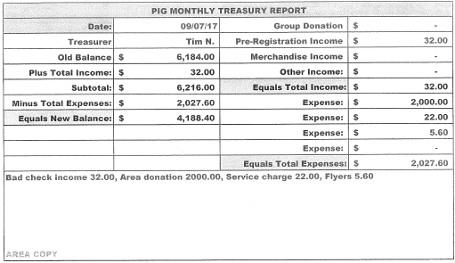

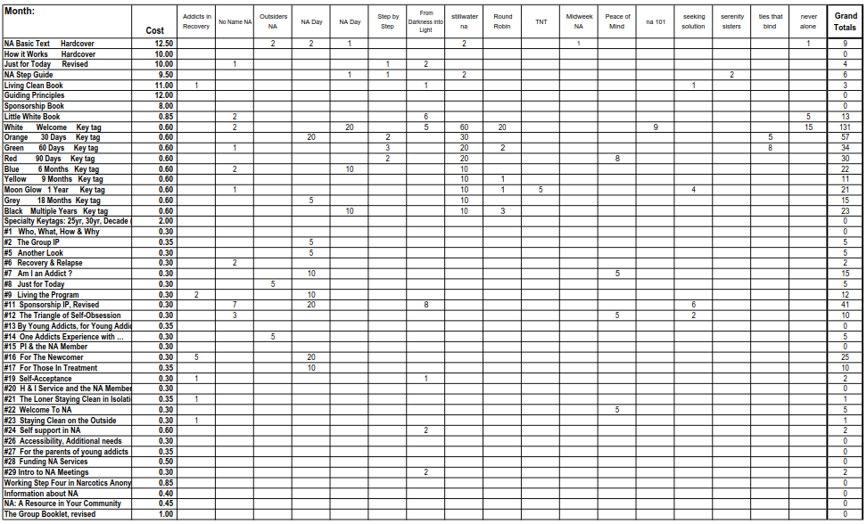
Literature Sales Report

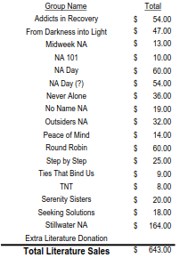
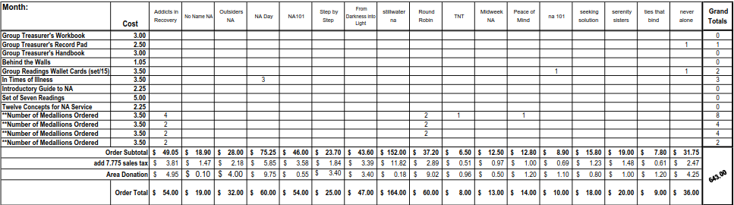
Literature Sales Report (continued)

