
Area Service Committee Meeting Minutes
October 5, 2017

Meeting opened at 7:00 PM by Area Chair Brad S.

Introductions: 19 members in attendance, with 1 newcomer.

Readings: 12 Steps read by John; 12 Traditions read by Rachel; 12 Concepts read by Katie.

Call for quorum: 9 voting members present (minimum for quorum is 7). With 9 voting members present, motions require 6 votes to pass (per bylaws “A motion or nomination requires support of two-thirds (66%) of the quorum in order to be accepted.”)

Approval of Minutes: Motion made by Tim, seconded by Rachel to approve the minutes of the September ASC meeting;
Vote: Support – 11, Opposed – 0, Abstentions – 1, passed.

7th Tradition: Collected (see Treasurer’s Report, p. 6)

Subcommittee Reports
Meetings for the Activities, Hospitals & Institutions, Outreach, and Public Relations Subcommittees are held at 7:00pm on the 2nd Thursday of each month at Faith Methodist Church, 1530 Oakdale Ave., West St. Paul, MN.

Vice-Chair:
(Rachel – reported)
- Meeting of the month
  - October 17th Northfield Tuesday Night Serenity
  - November 15th Cottage Grove Midweek NA
- H&I Learning day coming up Oct. 21 from 2-5 PM – 3100 Park Ave, Minneapolis, MN

Regional Committee Member (RCM):
(open – no report)
- Please announce at your meetings this position is open and only needs meets four times a year.

Activities:
(open – no report)
- Please announce at your meetings this position is open and our area would really like to have some scheduled activities for addicts to enjoy and learn how to have fun in recovery.

Public Relations:
(open – no report)
- Please announce at your meetings this position is open and only needs meets four times a year.

Hospitals & Institutions:
(Chair: James M. reported)
- 4 Scheduled monthly commitments
- H&I Learning Day Oct 21st 2-5 PM – 3100 Park Ave Mpls, MN
- Panel leader needed for the 4th Tuesday at 8 PM Cochran commitment

Current H&I commitments:
Every Saturday: Dakota Co. Jail (Hastings) 1:00pm
(no more volunteers needed at this time due to background check)
Contact: Jason C. 612-353-7958
2nd Saturday of every month: Cochran Recovery Program (Hastings) 2:00pm
Contact: Kierstin K. 651-347-7032
4th Tuesday of every month: Cochran Recovery Program (Hastings) 8:00pm
Contact: Todd V. 651-285-1789
4th Thursday of every month: Dakota County Detox. (Hastings) 7:00pm
Contact: Rachel M. 612-384-4695

Webmaster:
(open – no report)
- Please announce at your meetings this position is open and only needs someone to update the website with our upcoming events, trusted servant position changes, and any other area news.

Treasurer:
(Chair: Melissa reported) [See Treasurer report, p. 6 ]
- Opening balance is $2427.69

Outreach:
(Chair: Marissa reported)
- Meeting of the month
  - October 17th Northfield Tuesday Night Serenity
  - November 15th Cottage Grove Midweek NA

PIG:
(Chair: Rachel reported) [See Financial report, pp. 9 ]
- Financially Stable – balance of $4,188.40
- Reviewed bylaws
- Voted in Rachel M as Co chair
- Slogans and Logos for PIG 2018 due by Dec. 7th – Give to GSR
- In need of the following positions
  - Co Treasurer
  - Co Gate
  - Merchandise
  - Co Merchandise

Literature:
(Chair – Kiersten reported). [See Literature Order report, pp. 10-11]
- All items are stocked
- Please e-mail orders ahead of time if possible, address is ssfalit@gmail.com
- 1 year medallions are fully stocked

Group Concerns & Announcements

[Note: written GSR reports are now at the end of the ASC minutes.]

- NA Day –
  - needs co-secretary, co-chair, co-treasurer
- No Name NA –
  - Meeting lists still not updated online
- From Darkness Into Light –
  - Meeting lists still not updated online
  - Group contact needs to be updated
- Peace of Mind NA –
  - Needs male and female sponsor
- Seeking Solutions –
  - Attendance
  - Open GSR position
- Step by Step –
  - In need of Co-positions

Open Forum

- Brad S: 3-books per meeting for subsidized books. We can buy 87 books through World or 86 books through Service Office. Order all books at one time and store at church. Order all hard cover books
- James: Sub-committee decided as a whole to donate 20 Intro to NA guides on an ongoing basis at $2.25/guide. Clients unable to pay for books and Dakota Cty is not able to purchase them at this time. This will be a monthly cost of $48.60/month
- James: The 30 Basic Texts arrived. We will be donating 5 of them that were for Cochran to Washington Cty. The remaining 25 books will be dispersed as needed per the original motion
- Kiersten: Cochran looking for Just For Today books. $10.00/each
- Brad S: Term is up for the 1 year commitment as chair. Brad is willing to take on an additional year if nominated and voted in.

Elections
- Area Chair Brad S:
  - Rachel M. Nominated Brad S
  - John M. Seconded the nomination
    - Passsed 9 yes (unanimous)
- Regional Committee Member Anne R.:
  - Clean time needed to be waived
    - Rachel M. motioned to waive clean time
    - Tim N. seconded the motion
      - Passed 8 yes (unanimous)
  - Rachel M. Nominated Anne R
  - Tim N. Seconded the nomination
    - Passed 8 yes (unanimous)
- Regional Committee Member Alternate Andrew S.
  - James M. Nominated Andrew S
  - Rachel seconded the nomination
    - Passed 8 yes (unanimous)
- Public Relations Catie O.:
  - Rachel Nominated Catie O
  - Tim Seconded the nomination
    - Passed 8 yes (unanimous)

- Pig Elections
  - Chair – Amber M-D
    - Passed 9 yes (unanimous)
  - Gate Chair – Steely W.
    - Passed 9 yes (unanimous)
  - Treasurer – Tim N.
    - Passed 8 yes (unanimous)
  - Co-Chair – Rachel M.
    - Passed 8 yes (unanimous)

Current Positions - GSRs, please announce open positions at your meetings.
Officers/Committees | Chair | Elected | Co-Chair | Elected
Area Chair (2 Yrs, 1 Yr) | Brad S.(2) | 10/2017 | Rachel M. | 4/2017
Secretary (2 Yrs, 1 Yr) | Eric B. | 8/2017 | --open--
Treasurer (3 Yrs, 2 Yrs) | Erica D. | 2/2017 | --open--
RCM (2 Yrs, 1 Yr) | Anne R. | 10/2017 | Andrew S | 10/2017
Literature (3 Yrs, 2 Yrs) | Kierstin K. | 9/2016 | Gina C. | 4/2017
Activities (2 Yrs, 1 Yr) | --open-- |  | --open--
Hospitals & Institutions (2 Yrs, 1 Yr) | James M. | 3/2017 | Mike S. | 4/2017
Outreach (1 Yr, 6 Mo) | --open-- |  | --open--
Public Relations (2 Yrs, 1 Yr) | Catie O. | 10/2017 | --open--
Webmaster (1 Yr) | --open-- |  | NA
PIG (2 Yrs, 1 Yr) | Amber M-D | 10/2017 | Rachel M. | 10/2017
PIG Treasurer (3 Yrs, 2 Yrs) | Tim N. | 10/2017 | --open--
PIG Merchandise Chair (2 Yrs, 1 Yr) | --open-- |  | --open--
PIG Gate Chair (2 Yrs, 1 Yr) | Steely W. | 10/2017 | --open--
PIG Secretary (6 Mo) | Kris B. | 9/2016 | NA
PIG Food Chair (1 Yr) | Mary M. | 9/2016 | NA
PIG Dinner Coordinator (6 Mo) | Dina D. | 5/2017 | NA
PIG Adult Activities (6 Mo) | Leo J. | 7/2017 | NA
PIG Children Activities (6 Mo) | Rob R. | 2/2017 | NA
PIG Volunteer Coordinator (6 Mo) | --open-- |  | NA
(2) Denotes election is to a second consecutive term in the same position.

Old Business
- None

New Business
- None

Motions

- Motion Title: Subsidize books
Author: was Brad S., seconded by Anne
Motion to: Subsidize Basic Text to the groups by the area purchasing $1,000.00 in books and selling to the groups at $5.00/book – Amended to 80 books
Intent: Further our primary purpose

Discussion: Discussed during Open Forum (see above notes).
Financial impact: $1000.00
Vote: Support – 9, Opposed – 0, Abstentions – 0, motion was passed

- Motion Title: Donate 5 Just For Today books
Author: James M., seconded by Dan K
Motion to: Donate 5 Just For Today books to Cochran Recovery Center
Intent: To Provide Clients with the NA Daily Meditations

Discussion: Discussed during Open Forum (see above notes).
Financial impact: $54.00
Vote: Support – 9, Opposed – 0, Abstentions – 0, motion was passed

- Motion Title: Recurring Donation of 20 Introductory Guides
Author: James M., seconded by Rachel M.
Motion to: Donate 20 Intro Guides on a recurring monthly basis to Dakota Co. Drug Court.
Intent: To Provide NA Literature to those that request it

Discussion: There are some concerns on this occurring monthly James will follow up monthly to ensure that they are in need of a full 20 guides.
Financial impact: $48.60 each time we donate 20 booklets
Vote: Support – 7, Opposed – 0, Abstentions – 2, motion was passed

- Motion Title: Limit Subsidized Books
Author: Brad S., seconded by Eric B.
Motion to: Limit each group to 4 books
Intent: To make sure all meetings get a chance to buy the subsidized books.

Discussion: Motion was originally made to limit each group to 3 books. Motion amended to 4 books per group. Motion excludes the Northfield group.
Financial impact: -
Vote: Support – 9, Opposed – 0, Abstentions – 2, motion was passed

Motion to close made by Tim N., seconded by the group.; meeting closed with the Gratitude Statement at 8:20 pm.

Treasurer’s Report

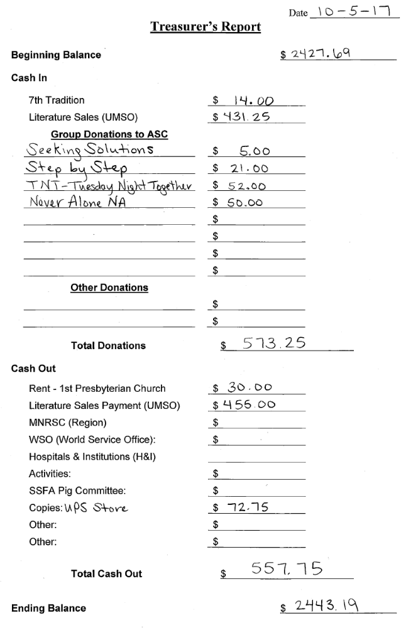

GSR Reports

Woodbury Freebirds |  | 6:00pm Sunday
GSR: NOT PRESENT |  | Status:
Avg. Attendance |  |  | Avg. Newcomers
ASC Donation
H&I Activities
Scheduled Activities
Other

Step by Step |  | 7:00pm Sunday
GSR: Steely W |  | Status:Stable
Avg. Attendance | 12 |  | Avg. Newcomers | 1
ASC Donation |  | $21
H&I Activities |  | Announced
Scheduled Activities |  | Nothing Scheduled
Other

Never Alone |  | 7:00pm Sunday
GSR: Nicole M. |  | Status: Stable
Avg. Attendance | 20-30 |  | Avg. Newcomers | 3-5
ASC Donation |  | $50
H&I Activities |  | Announced
Scheduled Activities
Other |  | $80 PIG donation

Ties That Bind Us |  | 7:00pm Monday
GSR: Eric B. |  | Status: Stable
Avg. Attendance | 15 |  | Avg. Newcomers | 1-2
ASC Donation
H&I Activities |  | Announced
Scheduled Activities
Other

Seeking Solutions |  | 7:00pm Monday
GSR: Open |  | Status: Stable
Avg. Attendance | 8-10 |  | Avg. Newcomers | 1
ASC Donation |  | $5
H&I Activities |  | Announced
Scheduled Activities
Other

Monday Night Round Robin |  | 7:00pm Monday
GSR: Not Present |  | Status:
Avg. Attendance |  |  | Avg. Newcomers
ASC Donation
H&I Activities
Scheduled Activities
Other

Addicts in Recovery |  | 7:00pm Tuesday
GSR: Amber M-D |  | Status: Stable
Avg. Attendance | 30-40 |  | Avg. Newcomers | 4
ASC Donation
H&I Activities |  | Announced
Scheduled Activities |  | Halloween Potluck Speaker
Other

TNT: Tues. Nights Together |  | 7:00pm Tuesday
GSR: Not Present |  | Status:
Avg. Attendance |  |  | Avg. Newcomers
ASC Donation
H&I Activities
Scheduled Activities
Other

Midweek NA |  | 7:00pm Wednesday
GSR: OPEN |  | Status: Stable
Avg. Attendance | 8-12 |  | Avg. Newcomers | 2
ASC Donation
H&I Activities |  | Announced
Scheduled Activities |  | Announced
Other

Stillwater NA |  | 7:30pm Wednesday
GSR: Not Present |  | Status:
Avg. Attendance |  |  | Avg. Newcomers
ASC Donation
H&I Activities
Scheduled Activities
Other

Serenity Sisters |  | 7:00pm Tuesday
GSR: Anne R : |  | Status: Stable
Avg. Attendance | 20 |  | Avg. Newcomers | 2
ASC Donation
H&I Activities |  | Announced
Scheduled Activities
Other

No Name NA |  | 7:00pm Thursday
GSR: Andrew S |  | Status: Stable
Avg. Attendance | 15 |  | Avg. Newcomers | 1
ASC Donation
H&I Activities |  | Announced
Scheduled Activities |  | None
Other

GSR Reports (continued)

Gaylord Serenity Seekers |  | 7:30pm Thursday
GSR: NOT PRESENT |  | Status:
Avg. Attendance |  |  | Avg. Newcomers
ASC Donation
H&I Activities
Scheduled Activities
Other
NA 101 |  | 7:00pm Saturday
GSR: John M. |  | Status: Stable
Avg. Attendance | 10 |  | Avg. Newcomers | 1
ASC Donation
H&I Activities
Scheduled Activities
Other |  | New Location

Peace of Mind |  | 7:30pm Friday
GSR: Tim N. |  | Status: Stable
Avg. Attendance | 15-18 |  | Avg. Newcomers | 2
ASC Donation
H&I Activities |  | Announced
Scheduled Activities
Other
Apple Valley Basic Text Study |  | 9:00pm Saturday
GSR: Dan K. |  | Status: Stable
Avg. Attendance | 15-20 |  | Avg. Newcomers | 2
ASC Donation
H&I Activities |  | Announced
Scheduled Activities
Other

NA Day |  | 7:30pm Friday
GSR: Open |  | Status: Stable
Avg. Attendance | 30-40 |  | Avg. Newcomers | 6
ASC Donation
H&I Activities |  | Announced
Scheduled Activities |  | Chili Feed
Other
Friday Night Outsiders NA |  | 8:00pm Friday
GSR: Tom J |  | Status: Stable
Avg. Attendance | 10-15 |  | Avg. Newcomers | 2
ASC Donation
H&I Activities |  | Announced
Scheduled Activities
Other

From Darkness Into Light NA |  | 6:30pm Saturday
GSR: Marissa M. |  | Status: Stable
Avg. Attendance | 20 |  | Avg. Newcomers | 2
ASC Donation
H&I Activities |  | None
Scheduled Activities |  | None
Other |  | Did not like the coin vote

Pig Monthly Treasury Report

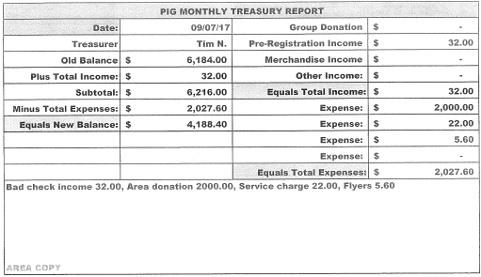

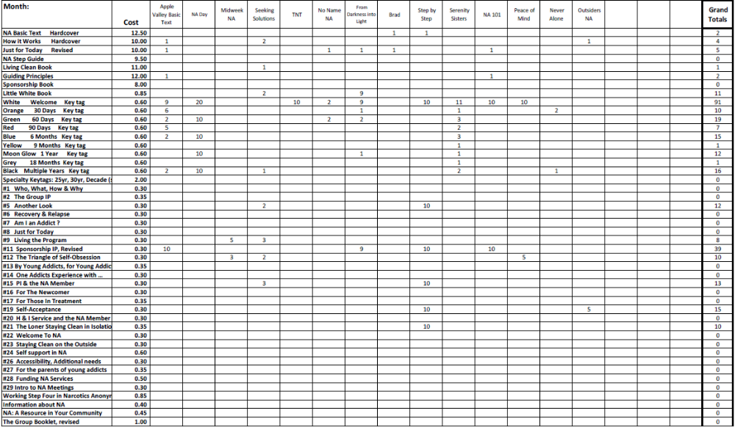
Literature Sales Report

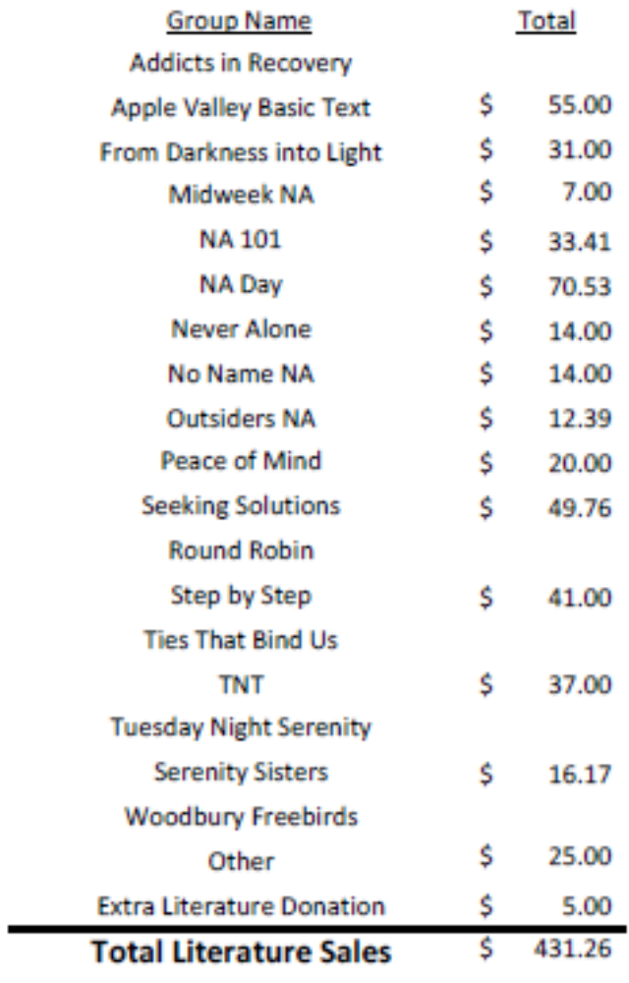
Literature Sales Report (continued)

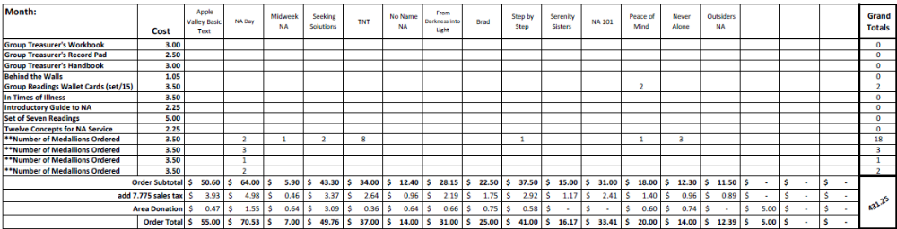

South Suburban Fireside Area Subcommittee Meeting Minutes
10/12/2017

Meeting opened at 7:00 pm with Serenity Prayer by Rachel M. with 10 addicts in attendance.
James read the 12 Concepts of NA service.
Collected 7th tradition of $6, which was given to the church as rent.

Hospitals and Institutions Subcommittee

H&I Dos and Don'ts read by: James

Literature Report:
Mike provided literature to the meetings that needed. Literature is purchased under the SSFA account. Let Mike know if anything is needed

Panel leader reports:
Dakota Co. Jail (Saturdays): Mike
Added 2 people to the list (Charles & Anthony). The first couple weeks had a few snags, but Jeff was able to get it fixed. Things went well. Meeting lists were handed out. Everyone on the current list goes at least once every 2 months.

Detox (4th Thursday): Rachel M.
Full panel was present. 8-9 eager clients were in attendance. The meeting went well. Contact Rachel if you would like to attend.

Cochran Recovery Center (2nd Saturday): Kiersten C.
It was voted and passed at area to provide the group with (5) Just For Today books.

Cochran Recovery Center (4th Tuesday): Open
Todd handed over the folder to James. James can fill in between panel leaders.

Other H&I business:
Approved for Basic Text and Readings being handed out for Dakota Cty Jail. James will be going back on Saturday to get Intro Guides. Cochran purchased used Basic Texts from used book store, so the 5extra books will be going to Washington County Jail.

In need of a panel leader for Cochran Recovery Center on 4th Tuesdays. Justin is interested in this position and will attend multiple H&I commitments this month to better understand the process.

Jason will separate books and bags. Mike brought up the question if we should be finding an additional contact at the jail just in case Jeff leaves. Jason will contact Jeff to see if there is a back up contact available.

Kiersten brought up interest in Washington County Jail women’s commitment. James had talked with the coordinator. In order to get information, you need to sit through a meeting and sign up or opt out once complete. Coordinator is interested in a commitment. You would need to show up at orientation. James also has info on Scott County Jail. Writh area looking for someone to take on commitment. James will contact Writh.

Outreach Subcommittee (Marrisa)
Meeting of the month:
October 17th – Northfield Tuesday Night Serenity
November 15th – Cottage Grove Midweek NA
December 20th – Stillwater NA

Activities Subcommittee (Open)

Public Relations Subcommittee (Catie)
Catie was voted in as new PR chair. Looking over duties and updating meeting lists. Learning day is on Oct. 21st. Bring a new comer and they are eligible for a door prize.

MARRCH 10/30/17 – 11/1/17 St Paul River Center– Chemical health services in MN Expo. Volunteers wanted for the booth. 4 hour blocks. 2+ years clean time. Sign up at naminnesota.org. Go to members and check help wanted.

Other Business

Meeting closed at 7:45

South Suburban Fireside Area Subcommittee Meeting Agenda
Opening
Introductions
Approval of minutes
Reading of 12 Concepts of NA Service
7th Tradition
Hospitals and Institutions Subcommittee
H&I Introduction/Dos and Don’ts
Literature Report
Panel Leader Reports
Dakota Co. Jail
Dakota Co. Detox
Cochran Recovery Center (Saturday)
Cochran Recovery Center (Tuesday)
Other H&I items
Outreach Subcommittee
Activities Subcommittee
Public Relations Subcommittee
Other old/new business

Adjournment

