
Area Service Committee Meeting Minutes
November 2, 2017

Meeting opened at 7:00 PM by Area Chair Brad S.

Introductions: 22 members in attendance, with 1 newcomer.

Readings: 12 Steps read by Melissa M.; 12 Traditions read by John W.; 12 Concepts read by Rachel

Call for quorum: 11 voting members present (minimum for quorum is 7). With 11 voting members present, motions require 8 votes to pass (per bylaws “A motion or nomination requires support of two-thirds (66%) of the quorum in order to be accepted.”)

Approval of Minutes: Motion made by Tim, seconded by John W. to approve the minutes of the September ASC meeting;
Vote: Support – 11, Opposed – 0, Abstentions – 0, passed.

7th Tradition: Collected (see Treasurer’s Report, p. 6)

Subcommittee Reports
Meetings for the Activities, Hospitals & Institutions, Outreach, and Public Relations Subcommittees are held at 7:00pm on the 2nd Thursday of each month at Faith Methodist Church, 1530 Oakdale Ave., West St. Paul, MN.

Vice-Chair:
(Chair: Rachel – Not Present)

Regional Committee Member (RCM):
(Chair: Anne R. – no report)
- Next meeting held 11/11/2017 and will report back next month

Activities:
(open – no report)
- Please announce at your meetings this position is open and our area would really like to have some scheduled activities for addicts to enjoy and learn how to have fun in recovery.

Public Relations:
(Chair: Catie O. reported)
- Huge success with H&I Learning Day in Minneapolis on Oct. 21st.
- MARRCH conference went well for Twin Cities Area
- Concern: Area inventory planning Ad Hoc Committee?
- Concern: Need a committee and ideas to further our primary purpose.

Hospitals & Institutions:
(Chair: James M. reported)
- 4 Scheduled monthly commitments
- Delivered:
  - 20 Basic Text and 1 set of group readings to Dakota Co. Jail
  - 5 Basic Text to Dakota Co. Detox
  - 5 JFT Books to Cochran Recovery Center
  - 5 Basic Text still to be delivered to Washington Co. Jail
- We were unable to get the 20 introductory guides for Dakota Co Drug Court (only had 5 at the service office)
- Panel leader needed for the 4th Tuesday at 8 PM Cochran commitment

Current H&I commitments:
Every Saturday: Dakota Co. Jail (Hastings) 1:00pm
(no more volunteers needed at this time due to background check)
Contact: Jason C. 612-353-7958
2nd Saturday of every month: Cochran Recovery Program (Hastings) 2:00pm
Contact: Kierstin K. 651-347-7032
4th Tuesday of every month: Cochran Recovery Program (Hastings) 8:00pm
Contact: Todd V. 651-285-1789
4th Thursday of every month: Dakota County Detox. (Hastings) 7:00pm
Contact: Rachel M. 612-384-4695

Webmaster:
(open – no report)
- Please announce at your meetings this position is open and only needs someone to update the website with our upcoming events, trusted servant position changes, and any other area news.

Treasurer:
(Chair: Erica D. reported) [See Treasurer report, p. 6 ]
- Opening balance is $2443.19

Outreach:
(Chair: Marissa reported)
- Meeting of the month
  - November 15th Cottage Grove – Midweek NA
  - December 20th Stillwater – Stillwater NA
- Seeking Solutions in Prior Lake on Mondays is in need of support

PIG:
(Chair: Amber M-D reported) [See Financial report, pp. 9 ]
- Financially Stable – balance of $4,288.40
- Bylaws approved at PIG meeting and distributed to groups to bring back to area next month and vote on
- PIG will be July 20th – 22nd 2018
- Slogans and Logos for PIG 2018 due by Dec. 7th – Give to GSR
- In need of positions being filled

Literature:
(Chair – Kiersten reported). [See Literature Order report, pp. 10-11]
- All items are stocked
- Please e-mail orders ahead of time if possible, address is ssfalit@gmail.com
- All but 8 of the subsidized books have been purchased

Group Concerns & Announcements

[Note: written GSR reports are now at the end of the ASC minutes.]

- Woodbury Freebirds
  - Need male sponsors
  - Could use more support
- Addicts In Recovery
  - If interested in being a speaker for the 5th Tuesday of the month meetings, please contact John S. (612) 201-1636
- No Name NA
  - Attendance has dwindled and would like support
  - Not all meeting lists have been updated yet. Specifically the Metro and SSFA lists in the SSFA website link
- Peace of Mind
  - Male and Female sponsors needed
- NA Day
  - Need more attendance – would like to be the meeting of the month in the near future. Currently have low attendance and need to start looking into service positions for the Chili Feed.
- From Darkness Into Light
  - Meeting lists still not updated online
  - Attendance has went down since move and could use more attendance.
- Peace of Mind NA –
  - Needs male and female sponsor

Open Forum

- James M.: 20 intro guides needed
- Erica D.: The mailbox in Apple Valley was almost closed due to a different name being on the account. Erica has been picking up the mail monthly. Erica has volunteered to continue to handle the mail box.
- Adam: Too Damn Early meeting will be held on Thanksgiving morning at 9:00 AM and will be chaired by Adam at the First Presbyterian Church
- Catie: Looking for ideas. Will continue to be in charge of the meeting lists. Request info from groups to bring back any questions or ideas. Possibly start sending more literature to treatments and halfway houses.

Elections
- Activities Chair:
  - Danielle W. is willing to take position and will require clean time to be waived.
    - Vote: Support – 10, Opposed – 0, Abstentions – 0, Passed.
  - Garrett L. nominated – Tim N. seconded
    - Vote: Support – 11, Opposed – 0, Abstentions – 0, Passed.
- Web Master:
  - Melissa is interested in the position.
  - Anne R. nominated – Garrett L. seconded
    - Vote: Support – 11, Opposed – 0, Abstentions – 0, Passed.

Current Positions - GSRs, please announce open positions at your meetings.
Officers/Committees | Chair | Elected | Co-Chair | Elected
Area Chair (2 Yrs, 1 Yr) | Brad S.(2) | 10/2017 | Rachel M. | 4/2017
Secretary (2 Yrs, 1 Yr) | Eric B. | 8/2017 | --open--
Treasurer (3 Yrs, 2 Yrs) | Erica D. | 2/2017 | --open--
RCM (2 Yrs, 1 Yr) | Anne R. | 10/2017 | Andrew S | 10/2017
Literature (3 Yrs, 2 Yrs) | Kierstin K. | 9/2016 | Gina C. | 4/2017
Activities (2 Yrs, 1 Yr) | Dannielle W. | 11/2017 | --open--
Hospitals & Institutions (2 Yrs, 1 Yr) | James M. | 3/2017 | Mike S. | 4/2017
Outreach (1 Yr, 6 Mo) | Marissa M. | 9/2017 | --open--
Public Relations (2 Yrs, 1 Yr) | Catie O. | 10/2017 | --open--
Webmaster (1 Yr) | Melissa M. | 11/2017 | NA
PIG (2 Yrs, 1 Yr) | Amber M-D | 10/2017 | Rachel M. | 10/2017
PIG Treasurer (3 Yrs, 2 Yrs) | Tim N. | 10/2017 | --open--
PIG Merchandise Chair (2 Yrs, 1 Yr) | --open-- |  | --open--
PIG Gate Chair (2 Yrs, 1 Yr) | Steely W. | 10/2017 | --open--
PIG Secretary (6 Mo) | --open-- |  | NA
PIG Food Chair (1 Yr) | --open-- |  | NA
PIG Dinner Coordinator (6 Mo) | --open-- |  | NA
PIG Adult Activities (6 Mo) | --open-- |  | NA
PIG Children Activities (6 Mo) | --open-- |  | NA
PIG Volunteer Coordinator (6 Mo) | --open-- |  | NA
(2) Denotes election is to a second consecutive term in the same position.

Old Business
- None

New Business
- None

Motions

No Motions

Motion to close made by Tim N., seconded by the group.; meeting closed with the Gratitude Statement at 8:20 pm.

Treasurer’s Report

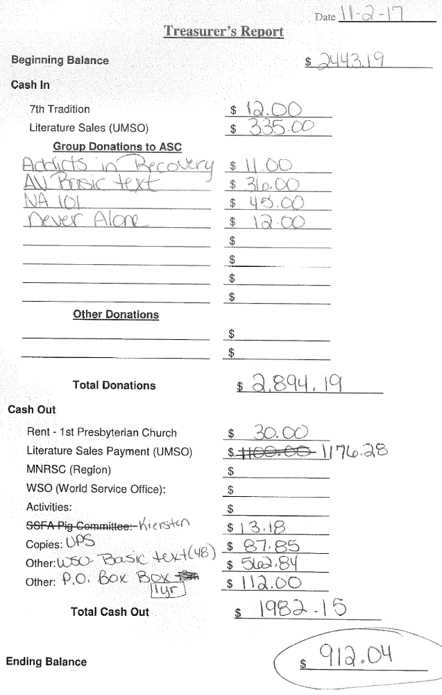

GSR Reports

Woodbury Freebirds |  | 6:00pm Sunday
GSR(A): Garrett L. |  | Status: Stable
Avg. Attendance | 8 |  | Avg. Newcomers | 2
ASC Donation
H&I Activities |  | Announced
Scheduled Activities
Other

Step by Step |  | 7:00pm Sunday
GSR: Not Present |  | Status:
Avg. Attendance |  |  | Avg. Newcomers
ASC Donation
H&I Activities
Scheduled Activities
Other

Never Alone |  | 7:00pm Sunday
GSR: Nicole M. |  | Status: Stable
Avg. Attendance | 20 |  | Avg. Newcomers | 3-5
ASC Donation |  | $12
H&I Activities |  | Announced
Scheduled Activities
Other

Ties That Bind Us |  | 7:00pm Monday
GSR: Eric B. |  | Status: Stable
Avg. Attendance | 14 |  | Avg. Newcomers | 1.5
ASC Donation
H&I Activities |  | Announced
Scheduled Activities
Other

Seeking Solutions |  | 7:00pm Monday
GSR: Not Present |  | Status:
Avg. Attendance |  |  | Avg. Newcomers
ASC Donation
H&I Activities
Scheduled Activities
Other

Monday Night Round Robin |  | 7:00pm Monday
GSR: Jason M |  | Status: Stable
Avg. Attendance | 12 |  | Avg. Newcomers | 2
ASC Donation
H&I Activities |  | Announced
Scheduled Activities
Other

Addicts in Recovery |  | 7:00pm Tuesday
GSR: Amber M-D |  | Status: Stable
Avg. Attendance | 25-35 |  | Avg. Newcomers | 2-5
ASC Donation |  | $11
H&I Activities |  | Announced
Scheduled Activities |  | Potluck/Speaker mtg 5th Tues.
Other

TNT: Tues. Nights Together |  | 7:00pm Tuesday
GSR: Not Present |  | Status:
Avg. Attendance |  |  | Avg. Newcomers
ASC Donation
H&I Activities
Scheduled Activities
Other

Midweek NA |  | 7:00pm Wednesday
GSR: OPEN |  | Status: Stable
Avg. Attendance | 12 |  | Avg. Newcomers | 2
ASC Donation
H&I Activities |  | Announced
Scheduled Activities
Other

Stillwater NA |  | 7:30pm Wednesday
GSR: Not Present |  | Status:
Avg. Attendance |  |  | Avg. Newcomers
ASC Donation
H&I Activities
Scheduled Activities
Other

Serenity Sisters |  | 7:00pm Tuesday
GSR: Anne R : |  | Status: Stable
Avg. Attendance | 15 |  | Avg. Newcomers | 2-3
ASC Donation
H&I Activities |  | Announced
Scheduled Activities
Other

No Name NA |  | 7:00pm Thursday
GSR: Andrew S |  | Status: Stable
Avg. Attendance | 11 |  | Avg. Newcomers | 0
ASC Donation
H&I Activities |  | Announced
Scheduled Activities
Other

GSR Reports (continued)

Gaylord Serenity Seekers |  | 7:30pm Thursday
GSR: NOT PRESENT |  | Status:
Avg. Attendance |  |  | Avg. Newcomers
ASC Donation
H&I Activities
Scheduled Activities
Other
NA 101 |  | 7:00pm Saturday
GSR: John M. |  | Status: Stable
Avg. Attendance | 12-15 |  | Avg. Newcomers | 1
ASC Donation |  | $45
H&I Activities
Scheduled Activities
Other

Peace of Mind |  | 7:30pm Friday
GSR: Tim N. |  | Status: Stable
Avg. Attendance | 22 |  | Avg. Newcomers | 3
ASC Donation
H&I Activities |  | Announced
Scheduled Activities
Other
Apple Valley Basic Text Study |  | 9:00pm Saturday
GSR: Not Present |  | Status:
Avg. Attendance |  |  | Avg. Newcomers
ASC Donation
H&I Activities
Scheduled Activities
Other

NA Day |  | 7:30pm Friday
GSR: Dannielle W. |  | Status: Stable
Avg. Attendance | 15-20 |  | Avg. Newcomers | 1-2
ASC Donation
H&I Activities |  | Announced
Scheduled Activities |  | Chili Feed
Other
Friday Night Outsiders NA |  | 8:00pm Friday
GSR: Open |  | Status: Stable
Avg. Attendance | 10-12 |  | Avg. Newcomers | 2
ASC Donation
H&I Activities |  | Announced
Scheduled Activities
Other

From Darkness Into Light NA |  | 6:30pm Saturday
GSR: Marissa M. |  | Status: Stable
Avg. Attendance | 15 |  | Avg. Newcomers | 1
ASC Donation
H&I Activities |  | None
Scheduled Activities |  | None
Other

Pig Monthly Treasury Report

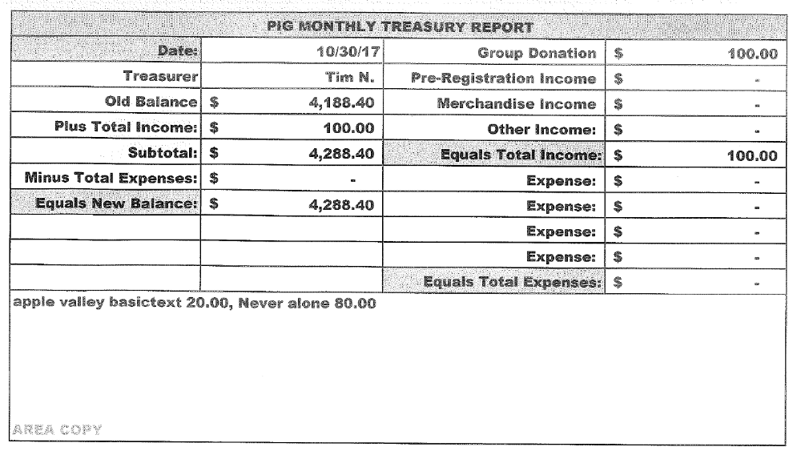

Literature Sales Report
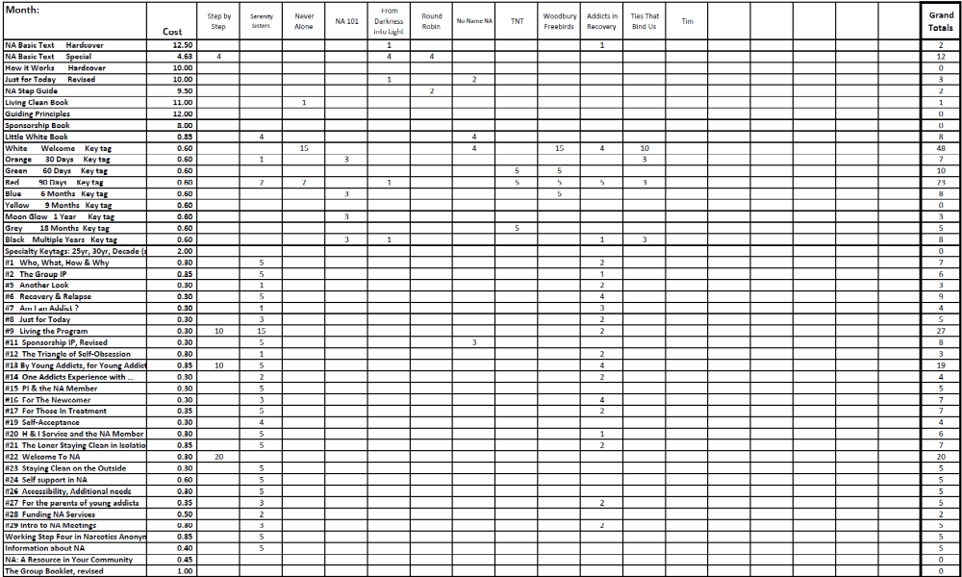

Literature Sales Report (continued)

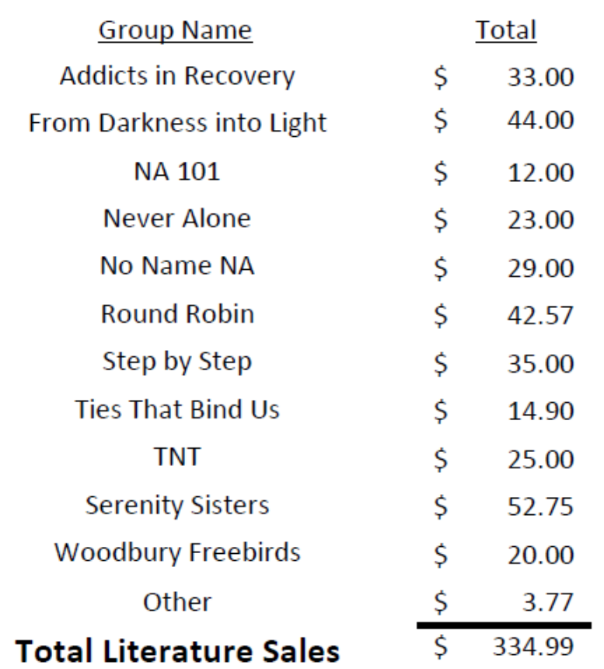

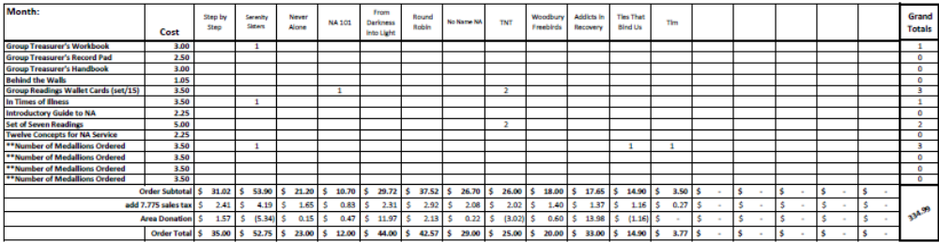

South Suburban Fireside Area Subcommittee Meeting Minutes
11/9/2017

Meeting opened at 7:00 pm with Serenity Prayer by Mike S. with 6 addicts in attendance.
James read the 12 Concepts of NA service.
Collected 7th tradition of $9, which was given to the church as rent.

Hospitals and Institutions Subcommittee

H&I Dos and Don'ts read by: Jason

Literature Report:
Mike provided literature to the meetings that needed. Literature is purchased under the SSFA account. Let Mike know if anything is needed

Panel leader reports:
Dakota Co. Jail (Saturdays): Jason
Jail is going good. New people have been going in. New books are being delivered. Meeting lists were handed out. Trying to rotate experienced people with new people.

Detox (4th Thursday): James.
Full panel was present. 12 clients were in attendance. The meeting went well. Rachel needs to step down. 5 books were dropped off.

Cochran Recovery Center (2nd Saturday): Not Present

Cochran Recovery Center (4th Tuesday): Open – James reported
5 panel members. 5 or 6 clients. 2 new H&I panel members. In need of panel leader

Other H&I business:
James – Next orientation at Washington County Jail is March 12th 2018. Showing up for orientation is for info only or if wanting to start a commitment. Have tried contacting RITH area about the Scott County Jail commitment that they want to step down from, but have not been able to connect.

Outreach Subcommittee (Marrisa)
Meeting of the month:
November 15th – Cottage Grove Midweek NA
December 20th – Stillwater NA
January 19th – NA Day

Activities Subcommittee (Not Present)

Public Relations Subcommittee (Not Present)

Other Business
Lizze K. is interested in the Cochran 4th Tuesday panel leader position. James is willing to lead again this month w/Lizze participating. Questions and ideas to be brought to subcommittee meeting.

Meeting closed at 7:45

South Suburban Fireside Area Subcommittee Meeting Agenda
Opening
Introductions
Approval of minutes
Reading of 12 Concepts of NA Service
7th Tradition
Hospitals and Institutions Subcommittee
H&I Introduction/Dos and Don’ts
Literature Report
Panel Leader Reports
Dakota Co. Jail
Dakota Co. Detox
Cochran Recovery Center (Saturday)
Cochran Recovery Center (Tuesday)
Other H&I items
Outreach Subcommittee
Activities Subcommittee
Public Relations Subcommittee
Other old/new business

Adjournment

