
Area Service Committee Meeting Minutes
May 4, 2017

Meeting opened at 6:02 PM by Area Chair Brad S.

Introductions: 27 members in attendance, with 1 newcomer.

Readings: 12 Steps read by Mary M.; 12 Traditions read by Rachel M.; 12 Concepts read by John M.

Call for quorum: 15 voting members present (minimum for quorum is 7). With 15 voting members present, motions require 10 votes to pass (per bylaws “A motion or nomination requires support of two-thirds (66%) of the quorum in order to be accepted.”)

Approval of Minutes: Motion to approve the minutes of the April ASC meeting;
Vote: Support – 13, Opposed – 0, Abstentions – 2, passed.

7th Tradition: Collected (see Treasurer’s Report, p. 5)

Subcommittee Reports
Meetings for the Activities, Hospitals & Institutions, Outreach, and Public Relations Subcommittees are held at 7:00pm on the 2nd Thursday of each month at Faith Methodist Church, 1530 Oakdale Ave., West St. Paul, MN.

Vice-Chair: (Rachel – reported)
- Ten people were in attendance at subcommittee meeting. All panel leaders were present. Kierstin was voted in as panel leader for the Saturday Cochran Recovery Program commitment, Rachel was voted in as panel leader for the Thursday Dakota County Detox commitment.
- Low attendance

Region: (RCM: open – no report)

Activities: (open – no report)

Public Relations: (Chair: Amber M-D. reported)
- NA Helpline Flyer Competition will be discussed during open forum (see pg. 3 for more details)
- In need of PR Co-Chair

Hospitals & Institutions: (Chair: James M. reported)
- The signup sheets generated 56 willing participants to go to commitments. The names will be combined into one spreadsheet and given to each panel leader to use when fulfilling our obligations.
- Meeting of the Month: May 15 Seeking Solutions & June 19 Monday Night Round Robin
- Have flyers to distribute with the current H&I commitments listed, currently have four commitments
Current H&I commitments:
Every Saturday: Dakota Co. Jail (Hastings) 1:00pm
(no more volunteers needed at this time due to background check)
Contact: Jason C. 612-353-7958
2nd Saturday of every month: Cochran Recovery Program (Hastings) 2:00pm
Contact: Kierstin K. 651-347-7032
4th Tuesday of every month: Cochran Recovery Program (Hastings) 8:00pm
Contact: Todd V. 651-285-1789
4th Thursday of every month: Dakota County Detox. (Hastings) 7:00pm
Contact: Rachel M. 612-384-4695

Webmaster: (open – no report)

Treasurer: (Chair: Erica D. reported) [See Treasurer report, p. 5]
- Opening balance is $1421.77
- Balanced the checkbook and the account was short by $0.25 due to the coin machine not taking the Canadian quarter.
- The check for the bus passes is still outstanding

Outreach: (open – no report)

PIG: (Chair: Melissa C. reported)
- Newcomer key tags continue to visit SSF Area meetings
- Speakers have been chosen for the Saturday evening, Men’s rap, and Woman’s rap
- DJ was voted upon by the committee and the price was negotiated down.
- Treasurer found more checks, so none will need to be ordered.
- Coffee chair is creating a volunteer form for shifts at PIG
- The PIG committee voted to donate a free registration to the Spring Thing on May 13 in the CMASC & a free registration to the Spiritual Refreshment on May 26 – 29 in the Upper Midwest Region
- The PIG committee voted in Amber M-D as PIG Co-Chair, and Dina D. as Dinner Coordinator.
- We are accepting recovery related raffle items – give them to anyone on the PIG committee
or bring them to the PIG meeting or Area.
- Open positions:

  - Merchandise Co-Chair
  - Adult Activities Chair
  - Volunteer Coordinator

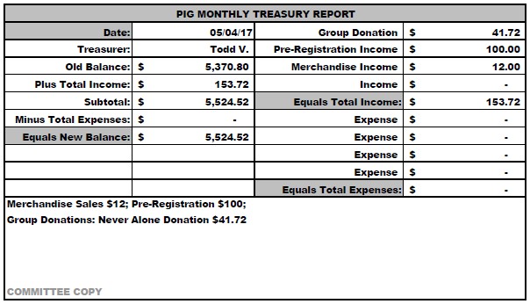

Literature: (Chair – Kierstin K. reported). [See Literature Order report, pp. 8-9.]
- Spent a small amount on supplies to replenish stock, gave invoice to treasurer.
- Currently out of Step Working Guides and unable to fill everyone’s order.
- Please e-mail orders ahead of time if possible, address is ssfalit@gmail.com

Ad Hoc: (Chair – Brad S. reported)
- Bylaw changes have been printed. Cover page is a summary of changes, other pages are changes that were made. Additions are in blue, deletions are in red. Please bring back to your groups to vote on the changes. The vote is to approve all of the changes or none of them.

Group Concerns & Announcements

[Note: written GSR reports are now at the end of the ASC minutes.]

- Woodbury Freebirds (Sunday) – Needs sponsors
- Ties That Bind Us (Monday) – Meet on Hastings River Walk area on 1st & 3rd Mondays during summer
- Seeking Solutions (Monday) – Low Attendance
- Addicts in Recovery (Tuesday) – Every 5th Tuesday they have a potluck
- Midweek NA (Wednesday) – Needs GSR
- Peace of Mind (Friday) – Changed meeting to Open Status
- NA Day (Friday) – Changed meeting to a Rotating Format
- NA 101 (Saturday) – Needs support

Open Forum

- Mike S. (H&I Co-Chair) – There was an opportunity to represent NA at the Dakota County Jail, the chair was given short notice about the event. Supplies were purchased directly from the UMSO on the SSFA Literature account, along with material being donated from the TCA H&I Chair (Buddy K.) All of the leftover materials were donated to the jail for the inmates since NA is not allowed to bring in literature during the weekly commitment.

- Amber M-D (PR Chair): More details were given about the friendly competition to see which group can post and/or distribute the most NA Helpline flyers between 5/4/17 – 8/3/17. Rules and FAQ’s were distributed to GSR’s, along with an explanation of the main objective of this competition (to carry the message to the still suffering addict). There was also a friendly warning to be safe when distributing the flyers, don’t go into dark alleys or unsafe situations. Flyers were printed for each group for distribution and handed out at Area. Ask the PR chair when your group needs more flyers. PR is also asking for prize ideas above and beyond the MNNAC registrations.

- Mike S. asked for clarification that GSR’s should bring the Bylaw revisions back to the groups and ask for a vote on all or individual changes to the Bylaws. Brad S. (Ad-hoc Chair) stated that the Bylaw revisions are to be voted on as all accepted or all rejected – not each individual update. There were minor changes to the Bylaws and the track change copies were distributed to the GSR’s at the ASC meeting.

Motions

- Motion Title: Fund Program Day at Dakota County Jail
Author was Mike S., seconded by Tim N.
Motion to: Reimburse the UMSO $72.21 for literature purchased and given to addict inmates at Dakota County Program Day
Intent: Carry the message

Discussion: Opportunity to represent NA at the Dakota County Jail; the chair was given short notice about the event. Supplies were purchased directly from the UMSO on the SSFA Literature account.
Financial impact: $72.21
Amendment: H&I will ask UMSO to create a separate H&I account for purchases
Vote: Support – 12, Opposed – 0, Abstentions – 3, passed.

- Motion Title: Coffee
Author was Rachel M., seconded by Matt
Motion to: keep and use old coffee
Intent: save money

Discussion: Does coffee go bad after three years even if it is vacuum sealed, mixed reviews
Financial impact: None
Vote: Support – 12, Opposed – 2, Abstentions – 1, passed.

Elections
- Melissa C. nominated Steely W. as Gate Co-Chair; nomination seconded by Rachel M.
Vote: Support - 13, Opposed - 0, Abstentions – 2; nomination accepted.
- Melissa C. nominated Amber M-D. as PIG Co-Chair; nomination seconded by Rachel M.
Vote: Support - 13, Opposed - 0, Abstentions – 1; nomination accepted.

Current Positions - GSRs, please announce open positions at your meetings.
Officers/Committees | Chair | Elected | Co-Chair | Elected
Area Chair (2 Yrs, 1 Yr) | Brad S. | 9/2016 | Rachel M. | 4/2017
Secretary (2 Yrs, 1 Yr) | --open-- |  | --open--
Treasurer (3 Yrs, 2 Yrs) | Erica D. | 2/2017 | --open--
RCM (2 Yrs, 1 Yr) | --open-- |  | --open--
Literature (3 Yrs, 2 Yrs) | Kierstin K. | 9/2016 | Gina C. | 4/2017
Activities (2 Yrs, 1 Yr) | --open-- |  | --open--
Hospitals & Institutions (2 Yrs, 1 Yr) | James M. | 3/2017 | Mike S. | 4/2017
Outreach (1 Yr, 6 Mo) | --open-- |  | --open--
Public Relations (2 Yrs, 1 Yr) | Amber M-D. | 3/2017 | --open--
Webmaster (1 Yr) | --open-- |  | NA
PIG (2 Yrs, 1 Yr) | Melissa C. | 9/2016 | Amber M-D. | 5/2017
PIG Treasurer (3 Yrs, 2 Yrs) | Todd V. | 9/2016 | Tim N. | 11/2016
PIG Merchandise Chair (2 Yrs, 1 Yr) | Steve H. (2) | 12/2016 | --open--
PIG Gate Chair (2 Yrs, 1 Yr) | Matt K. | 9/2016 | Steely W. | 4/2017
PIG Secretary (6 Mo) | Kris B. | 9/2016 | NA
PIG Food Chair (1 Yr) | Mary M. | 9/2016 | NA
PIG Dinner Coordinator (6 Mo) | Dina D. | 5/2017 | NA
PIG Adult Activities (6 Mo) | --open-- |  | NA
PIG Children Activities (6 Mo) | Rob R. | 2/2017 | NA
PIG Volunteer Coordinator (6 Mo) | --open-- |  | NA
(2) Denotes election is to a second consecutive term in the same position.

Old Business
- None.

New Business
- Mike S. (H&I Co-Chair) There was discussion about where H&I should purchase their materials from in the future, clarification on their monthly budget, and suggestion to update bylaws to reflect process for subcommittee budget. Erica D. (Treasurer) stated that each subcommittee is entitled to $50 per month for expenses. The suggestion to switch from monthly to an annual budget for subcommittees was brought up for people to think about for future discussion. Final decision that was made is that H&I will contact the UMSO to set up a separate charge account for their purchases, instead of depleting the Literature Chair supplies at ASC meeting. Mike S. (H&I Co-Chair) will purchase directly from the UMSO, since he works near the UMSO.

- James (H&I Chair) is going to contact Dakota County Jail to get more details about the event they were invited to. It would be nice to know if this is an annual event and if we could get more of a notice in the future.

Motion to close made by Garrett L., seconded by Tim N.; meeting closed with the Gratitude Statement at 8:23 pm.

Treasurer’s Report

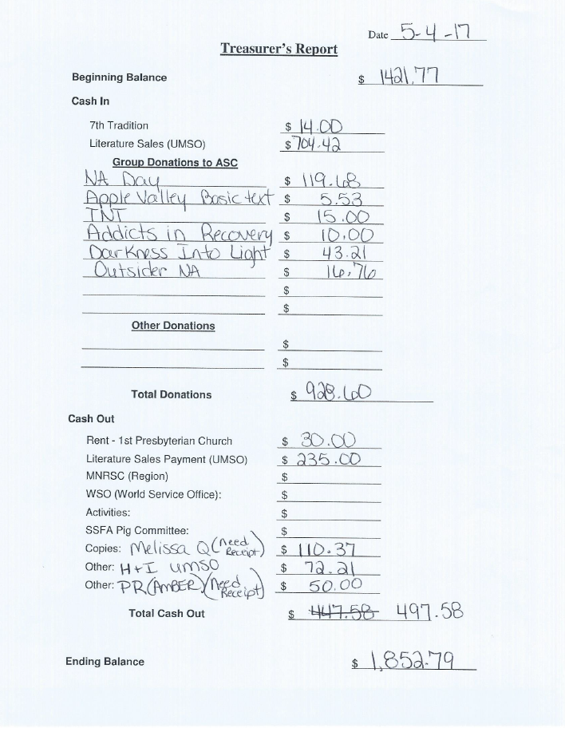

GSR Reports

Woodbury Freebirds |  | 6:00pm Sunday
GSR-A: Garrett L. |  | Status: Stable
Avg. Attendance | 10 |  | Avg. Newcomers | 1
ASC Donation
H&I Activities
Scheduled Activities
Other |  | Need sponsors

Step by Step |  | 7:00pm Sunday
GSR: NOT PRESENT |  | Status:
Avg. Attendance |  |  | Avg. Newcomers
ASC Donation
H&I Activities
Scheduled Activities
Other

Never Alone |  | 7:00pm Sunday
GSR: Nicole M. (not present) |  | Status: Stable
Avg. Attendance | 25 – 30 |  | Avg. Newcomers | 3 – 4
ASC Donation
H&I Activities |  | Announced
Scheduled Activities
Other

Ties That Bind Us |  | 7:00pm Monday
GSR: Matt K. |  | Status: Stable
Avg. Attendance | 15 |  | Avg. Newcomers | 3
ASC Donation
H&I Activities |  | Announced
Scheduled Activities |  | Meet on the river 1st & 3rd
Other |  | Monday’s

Seeking Solutions |  | 7:00pm Monday
GSR: Rachel M. |  | Status: Stable
Avg. Attendance | 10 |  | Avg. Newcomers | 1 – 2
ASC Donation
H&I Activities |  | Announced
Scheduled Activities |  | None
Other |  | Low attendance

Monday Night Round Robin |  | 7:00pm Monday
GSR: Matthew S. |  | Status: Stable
Avg. Attendance | 17 |  | Avg. Newcomers | 1
ASC Donation
H&I Activities
Scheduled Activities
Other

Addicts in Recovery |  | 7:00pm Tuesday
GSR: Amber M-D |  | Status: Stable
Avg. Attendance | 25 – 30 |  | Avg. Newcomers | 1 – 5
ASC Donation |  | $10
H&I Activities |  | Announced
Scheduled Activities |  | Every 5th Tuesday Potluck
Other

TNT: Tues. Nights Together |  | 7:00pm Tuesday
GSR: Jack |  | Status: Stable
Avg. Attendance |  |  | Avg. Newcomers | 1
ASC Donation |  | $15.00
H&I Activities
Scheduled Activities
Other

Tuesday Night Serenity |  | 7:00pm Tuesday
GSR: NOT PRESENT : |  | Status:
Avg. Attendance |  |  | Avg. Newcomers
ASC Donation
H&I Activities
Scheduled Activities
Other

Midweek NA |  | 7:00pm Wednesday
GSR: open |  | Status: Stable
Avg. Attendance | 15 |  | Avg. Newcomers | 2 – 4
ASC Donation
H&I Activities |  | Announced
Scheduled Activities |  | None
Other |  | PIG Donation $15.00

Rock Solid NA |  | 7:00pm Wednesday
GSR: NOT PRESENT : |  | Status:
Avg. Attendance |  |  | Avg. Newcomers
ASC Donation
H&I Activities
Scheduled Activities
Other

Stillwater NA |  | 7:00pm Wednesday
GSR: Grant |  | Status: Stable
Avg. Attendance | 22 – 26 |  | Avg. Newcomers | 5 – 7
ASC Donation
H&I Activities |  | Announced
Scheduled Activities
Other

GSR Reports (continued)

Serenity Sisters |  | 7:00pm Thursday
GSR: Anne R. |  | Status: Stable
Avg. Attendance | 15 |  | Avg. Newcomers | 2
ASC Donation
H&I Activities |  | Announced
Scheduled Activities
Other

No Name NA |  | 7:00pm Thursday
GSR: Gina C. |  | Status:
Avg. Attendance | 19 – 20 |  | Avg. Newcomers | 1 – 2
ASC Donation
H&I Activities |  | Announced at every meeting
Scheduled Activities |  | None
Other

Gaylord Serenity Seekers |  | 7:30pm Thursday
GSR: NOT PRESENT |  | Status:
Avg. Attendance |  |  | Avg. Newcomers
ASC Donation
H&I Activities
Scheduled Activities
Other

Peace of Mind |  | 7:30pm Friday
GSR: Tim N. |  | Status: Stable
Avg. Attendance | 18 |  | Avg. Newcomers | 2.137
ASC Donation
H&I Activities |  | Announced
Scheduled Activities |  | None
Other

NA Day |  | 7:30pm Friday
GSR: Phil C. |  | Status: Stable
Avg. Attendance | 20+ |  | Avg. Newcomers | 4 – 5
ASC Donation |  | $119.00
H&I Activities |  | None
Scheduled Activities |  | None
Other |  | Stay Clean
Friday Night Outsiders NA |  | 8:00pm Friday
GSR: Mary M. |  | Status: Stable
Avg. Attendance | 14 |  | Avg. Newcomers | 1
ASC Donation |  | $16.76
H&I Activities
Scheduled Activities
Other

From Darkness Into Light NA |  | 6:30pm Saturday
GSR: Marissa |  | Status: Stable
Avg. Attendance | 23 – 25 |  | Avg. Newcomers | 2 – 3
ASC Donation |  | $43.21
H&I Activities
Scheduled Activities |  | None
Other

NA 101 |  | 7:00pm Saturday
GSR: John M. |  | Status: Stable
Avg. Attendance | 8 |  | Avg. Newcomers | 1
ASC Donation
H&I Activities
Scheduled Activities
Other |  | Announce MoM and H&I

Apple Valley Basic Text Study |  | 9:00pm Saturday
GSR: Melissa C. |  | Status: Stable
Avg. Attendance | 21 |  | Avg. Newcomers | 2
ASC Donation |  | $21.00
H&I Activities |  | Announced
Scheduled Activities |  | Announced
Other

Literature Sales Report
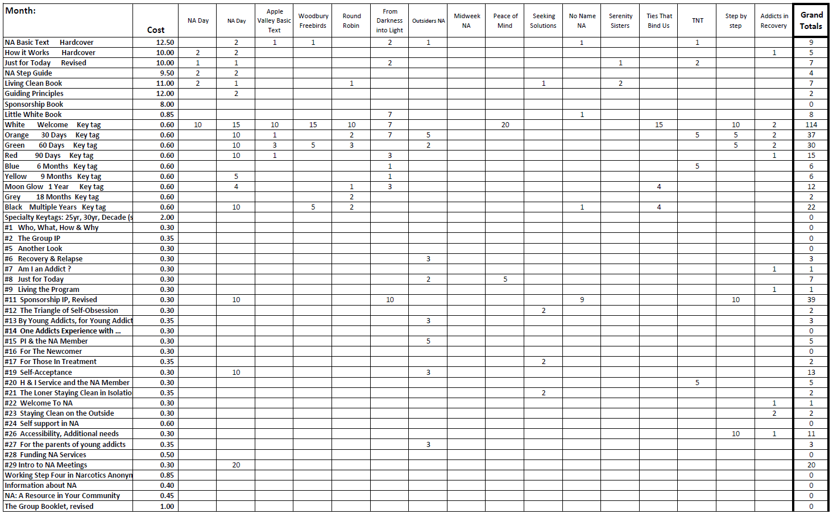

Literature Sales Report (continued)

