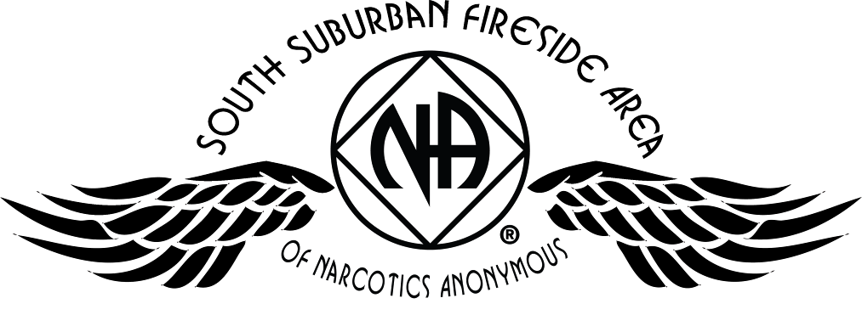
Area Service Committee Meeting Minutes
June 1, 2017

Meeting opened at 7:01 PM by Area Chair Brad S.

Introductions: 25 members in attendance, with 3 newcomers.

Readings: 12 Steps read by Rachel M.; 12 Traditions read by Tim N.; 12 Concepts read by Mary M.

Call for quorum: 14 voting members present (minimum for quorum is 7). With 14 voting members present, motions require 9 votes to pass (per bylaws “A motion or nomination requires support of two-thirds (66%) of the quorum in order to be accepted.”)

Approval of Minutes: Motion to approve the minutes of the May ASC meeting;
Vote: Support – 14, Opposed – 0, Abstentions – 0, passed.

7th Tradition: Collected (see Treasurer’s Report, p. 5)

Subcommittee Reports
Meetings for the Activities, Hospitals & Institutions, Outreach, and Public Relations Subcommittees are held at 7:00pm on the 2nd Thursday of each month at Faith Methodist Church, 1530 Oakdale Ave., West St. Paul, MN.

Vice-Chair:
(Rachel – reported)
- Not able to attend and meeting minutes were misplaced
- H&I commitments can be found in Area minutes

Region:
(RCM: open – no report)
- Please announce at your meetings this position is open and only needs meets four times a year.

Activities:
(open – no report)
- Please announce at your meetings this position is open and our area would really like to have some scheduled activities for addicts to enjoy and learn how to have fun in recovery.

Public Relations:
(Chair: Amber M-D. reported)
- NA Helpline Flyer Competition winner for the month of May was Never Alone NA. The group won a free PIG Registration.
- Push GSR’s to attract participants to put up NA flyers either as part of competition OR on their own.
- When taking the picture please have someone in the picture from the group.
- Contest goes until the end of August
- In need of PR Co-Chair

Hospitals & Institutions:
(Co-Chair: Mike S. reported)
- Possible learning day in August
- Looking into taking a meeting into women’s jails
- All current commitments filled and being met
- New flyers were created and distributed
- Meeting of the Month: June 19 Monday Night Round Robin & July 19 Stillwater NA

Current H&I commitments:
Every Saturday: Dakota Co. Jail (Hastings) 1:00pm
(no more volunteers needed at this time due to background check)
Contact: Jason C. 612-353-7958
2nd Saturday of every month: Cochran Recovery Program (Hastings) 2:00pm
Contact: Kierstin K. 651-347-7032
4th Tuesday of every month: Cochran Recovery Program (Hastings) 8:00pm
Contact: Todd V. 651-285-1789
4th Thursday of every month: Dakota County Detox. (Hastings) 7:00pm
Contact: Rachel M. 612-384-4695

Webmaster:
(open – no report)
- Please announce at your meetings this position is open and only needs someone to update the website with our upcoming events, trusted servant position changes, and any other area news.

Treasurer:
(Chair: Erica D. reported) [See Treasurer report, p. 5]
- Opening balance is $1852.89
- The check for the bus passes finally cleared.
- Literature spent approximately $700 on literature to replenish stock.
- Has an issue that will be brought up in open forum about changes at the bank.

Outreach:
(open – no report)
- Please announce at your meetings this position is open and needs someone to reach out to our local meetings to see if they need assistance from our Area.

PIG: (Chair: Melissa C. reported)
- Sunday morning speaker has been selected; Saralyn H from Twin Cities Area.
- Meat vendor was selected
- Storage locker will be inventoried on June 10th
- Committee voted to serve continental breakfast on Sunday, consisting of donuts, fruit, and juice
- Please announce in meetings we need recovery related raffle items
- Open positions:

Merchandise Co-Chair Adult Activities Chair Volunteer Coordinator
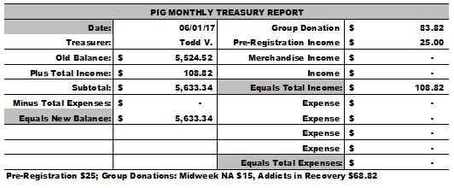
Literature:
(Chair – Kierstin K. reported). [See Literature Order report, pp. 8-9]
- Spent $700 to replenish out-of-stock Basic Texts, Living Clean books, and Step Working Guides.
- Kierstin will not be present in July or August, Co-Chair Gina C. will handle requests in her absence
- Please e-mail orders ahead of time if possible, address is ssfalit@gmail.com

Ad Hoc:
(Chair – Brad S. reported)
- Vote on bylaw changes will happen later during this meeting if GSRs have their votes.

Group Concerns & Announcements

[Note: written GSR reports are now at the end of the ASC minutes.]

- Woodbury Freebirds (Sunday) – Needs support, especially sponsors
- Step by Step (Sunday) – Secretary position and some co-chair positions available
- Ties That Bind Us (Monday) – Meet on Hastings River Walk area on 1st & 3rd Mondays during summer
- Seeking Solutions (Monday) – Needs some attendance support from more experienced members
- Addicts in Recovery (Tuesday) – Every 5th Tuesday they have a potluck
- Midweek NA (Wednesday) – Needs GSR
- Peace of Mind (Friday) – Needs sponsors
- From Darkness Into Light (Saturday) – Needs support
- NA 101 (Saturday) – Needs support

Open Forum

- Erica D. (Treasurer): Wells Fargo, the bank which the ASC uses, has removed the coin machines at all of their locations. This presents an issue for the Treasurer upon depositing any coins, as counting and wrapping the coins manually after each Area meeting would take a substantial amount of time and effort. Area members discussed pros and cons of switching to a different bank, as well as other potential solutions to this issue. Suggestion was made to submit a motion to no longer accept coins at the Area level.

- David M. (ICUCNA Activities & Fundraising Chair): Discussed the upcoming 1st Annual Tri-Area NA Birthday Games Competition. The Area of Hope, South Suburban Fireside, and Twin Cities Area will be competing for the “Birthday Games” trophy on Saturday, July 29th between 10:00am and 9:00pm at Lorraine Park in South St. Paul. You do not need to be from one of these 3 areas; everyone is welcome. The event itself is free to attend, but the games will be “pay-to-play” and food and beverages will be sold as well. There will also be kid-friendly activities, as well as a bonfire, speakers, and the Wheel of Recovery. We are looking for a speaker from SSFA to speak at the event, as well as additional volunteers for the event as a whole. Event info can be found on flyers which have been distributed to GSRs, on naminnesota.org, and will be posted on Facebook. For any questions or interest in volunteering, please call David M. at (612)730-3733.

Elections
- No willingness at this time.

Current Positions - GSRs, please announce open positions at your meetings.
Officers/Committees | Chair | Elected | Co-Chair | Elected
Area Chair (2 Yrs, 1 Yr) | Brad S. | 9/2016 | Rachel M. | 4/2017
Secretary (2 Yrs, 1 Yr) | --open-- |  | --open--
Treasurer (3 Yrs, 2 Yrs) | Erica D. | 2/2017 | --open--
RCM (2 Yrs, 1 Yr) | --open-- |  | --open--
Literature (3 Yrs, 2 Yrs) | Kierstin K. | 9/2016 | Gina C. | 4/2017
Activities (2 Yrs, 1 Yr) | --open-- |  | --open--
Hospitals & Institutions (2 Yrs, 1 Yr) | James M. | 3/2017 | Mike S. | 4/2017
Outreach (1 Yr, 6 Mo) | --open-- |  | --open--
Public Relations (2 Yrs, 1 Yr) | Amber M-D. | 3/2017 | --open--
Webmaster (1 Yr) | --open-- |  | NA
PIG (2 Yrs, 1 Yr) | Melissa C. | 9/2016 | Amber M-D. | 5/2017
PIG Treasurer (3 Yrs, 2 Yrs) | Todd V. | 9/2016 | Tim N. | 11/2016
PIG Merchandise Chair (2 Yrs, 1 Yr) | Steve H. (2) | 12/2016 | --open--
PIG Gate Chair (2 Yrs, 1 Yr) | Matt K. | 9/2016 | Steely W. | 4/2017
PIG Secretary (6 Mo) | Kris B. | 9/2016 | NA
PIG Food Chair (1 Yr) | Mary M. | 9/2016 | NA
PIG Dinner Coordinator (6 Mo) | Dina D. | 5/2017 | NA
PIG Adult Activities (6 Mo) | --open-- |  | NA
PIG Children Activities (6 Mo) | Rob R. | 2/2017 | NA
PIG Volunteer Coordinator (6 Mo) | --open-- |  | NA
(2) Denotes election is to a second consecutive term in the same position.

Old Business
- Final decision that was made is that H&I will contact the UMSO to set up a separate charge account for their purchases, instead of depleting the Literature Chair supplies at ASC meeting. Mike S. (H&I Co-Chair) will purchase directly from the UMSO, since he works near the UMSO.

New Business
- Bylaws were voted upon per the Ad-hoc changes that were presented to the groups last month.

Discussion: Question was made concerning “other service bodies” and Brad S. clarified that means the World Service Office (WSO) and the Upper Midwest Service Office (UMSO).
Vote: Support – 13, Opposed – 0, Abstentions – 0, passed.

Motions
- Motion Title: Coined Money
Author was Erica D., seconded by Mary M.
Motion to: Accept only paper money (cash & checks) for donations and literature orders at the Area.
Intent: Avoid the Treasurer needing to manually count and wrap coins due to Wells Fargo doing away with their coin machines at all branches. This will make it less time-consuming to manage money at Area.

Discussion: Discussed during Open Forum (see above notes). GSRs asked what to do if coins are received with donations at their meetings. It was suggested that GSRs can change out the coins at their own bank if they wish, or may instead write a check to Area.
Financial impact: None, however this will make the Literature and Treasurer processes easier to manage.
Amendment: Make checks payable to “SSFA” or “South Suburban Fireside Area”.
Vote: Support – 14, Opposed – 0, Abstentions – 0, passed.

Motion to close made by Garrett L., seconded by Kierstin K.; meeting closed with the Gratitude Statement at 8:17.

Treasurer’s Report


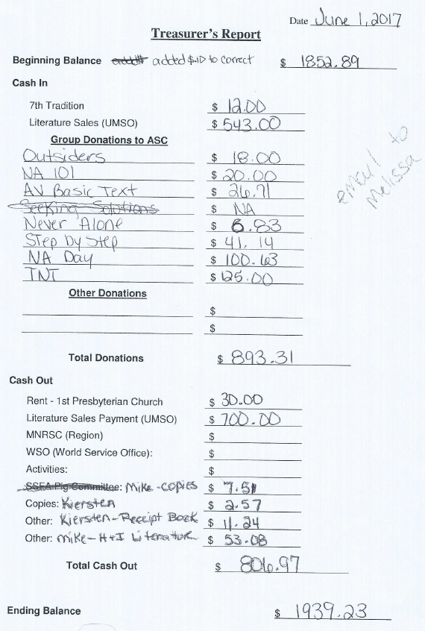

GSR Reports

Woodbury Freebirds |  | 6:00pm Sunday
GSR-A: Garrett L. |  | Status: Stable
Avg. Attendance | 10 |  | Avg. Newcomers | 3
ASC Donation
H&I Activities |  | Announced
Scheduled Activities
Other

Step by Step |  | 7:00pm Sunday
GSR: Steely W. |  | Status:
Avg. Attendance | 12 |  | Avg. Newcomers | 1
ASC Donation |  | $41.14
H&I Activities |  | None
Scheduled Activities |  | None
Other

Never Alone |  | 7:00pm Sunday
GSR: Nicole M. (Rachel reported) |  | Status: Stable
Avg. Attendance | 25 – 30 |  | Avg. Newcomers | 1 – 3
ASC Donation |  | $6.83
H&I Activities |  | Announced
Scheduled Activities
Other |  | Announced flyer competition

Ties That Bind Us |  | 7:00pm Monday
GSR: Matt K. (Eric B.) |  | Status: Stable
Avg. Attendance | 15 |  | Avg. Newcomers | 2 – 3
ASC Donation |  | $5.00
H&I Activities
Scheduled Activities |  | Meet on the river 1st & 3rd
Other |  | Monday’s of the month

Seeking Solutions |  | 7:00pm Monday
GSR: Rachel M. |  | Status: Stable
Avg. Attendance | 20 – 25 |  | Avg. Newcomers | 1 – 3
ASC Donation
H&I Activities |  | Announced
Scheduled Activities |  | Speaker/Potlucks on 5th Mon.
Other |  | Announced flyer competition

Monday Night Round Robin |  | 7:00pm Monday
GSR: Matthew S. (Kierstin reported) |  | Status: Stable
Avg. Attendance | 12 – 18 |  | Avg. Newcomers | 2
ASC Donation
H&I Activities
Scheduled Activities
Other

Addicts in Recovery |  | 7:00pm Tuesday
GSR: Amber M-D |  | Status: Stable
Avg. Attendance | 25 – 30 |  | Avg. Newcomers | 3 – 5
ASC Donation
H&I Activities |  | Announced
Scheduled Activities |  | Every 5th Tuesday Potluck
Other

TNT: Tues. Nights Together |  | 7:00pm Tuesday
GSR: Jessie O. |  | Status: Stable
Avg. Attendance | 15 |  | Avg. Newcomers | 1
ASC Donation |  | $125.00
H&I Activities |  | Announced
Scheduled Activities |  | None
Other

Tuesday Night Serenity |  | 7:00pm Tuesday
GSR: NOT PRESENT : |  | Status:
Avg. Attendance |  |  | Avg. Newcomers
ASC Donation
H&I Activities
Scheduled Activities
Other

Midweek NA |  | 7:00pm Wednesday
GSR: open |  | Status:
Avg. Attendance | 12 |  | Avg. Newcomers | 1
ASC Donation
H&I Activities |  | Announced
Scheduled Activities
Other

Rock Solid NA |  | 7:00pm Wednesday
GSR: NOT PRESENT : |  | Status:
Avg. Attendance |  |  | Avg. Newcomers
ASC Donation
H&I Activities
Scheduled Activities
Other

Stillwater NA |  | 7:00pm Wednesday
GSR: Grant |  | Status: Stable
Avg. Attendance | 20 – 25 |  | Avg. Newcomers | 5 – 8
ASC Donation
H&I Activities |  | Announced
Scheduled Activities |  | None
Other

GSR Reports (continued)

Serenity Sisters |  | 7:00pm Thursday
GSR: Anne R.  (Kierstin reported) |  | Status: Stable
Avg. Attendance | 16 – 20 |  | Avg. Newcomers | 3
ASC Donation
H&I Activities
Scheduled Activities
Other

No Name NA |  | 7:00pm Thursday
GSR: Mike M. |  | Status: Stable
Avg. Attendance | 20 |  | Avg. Newcomers | 1½–2
ASC Donation
H&I Activities |  | Announced at every meeting
Scheduled Activities |  | None
Other |  | Announced flyer competition

Gaylord Serenity Seekers |  | 7:30pm Thursday
GSR: NOT PRESENT |  | Status:
Avg. Attendance |  |  | Avg. Newcomers
ASC Donation
H&I Activities
Scheduled Activities
Other

Peace of Mind |  | 7:30pm Friday
GSR: Tim N. |  | Status: Stable
Avg. Attendance | 28 |  | Avg. Newcomers | 3
ASC Donation
H&I Activities |  | Announced
Scheduled Activities |  | None
Other |  | Helpline

NA Day |  | 7:30pm Friday
GSR: TBD |  | Status: Stable
Avg. Attendance | 20 – 25 |  | Avg. Newcomers | 0 – 5
ASC Donation |  | $100.63
H&I Activities |  | None
Scheduled Activities |  | None
Other |  | None
Friday Night Outsiders NA |  | 8:00pm Friday
GSR: Mary M. |  | Status: Stable
Avg. Attendance | 14 |  | Avg. Newcomers | 1
ASC Donation |  | $18.00
H&I Activities |  | Announced
Scheduled Activities
Other

From Darkness Into Light NA |  | 6:30pm Saturday
GSR: Marissa |  | Status: Stable
Avg. Attendance | 20 |  | Avg. Newcomers | 1 – 2
ASC Donation
H&I Activities
Scheduled Activities
Other

NA 101 |  | 7:00pm Saturday
GSR: John M. |  | Status: Stable
Avg. Attendance | 10 |  | Avg. Newcomers | 1
ASC Donation |  | $20.00
H&I Activities
Scheduled Activities
Other

Apple Valley Basic Text Study |  | 9:00pm Saturday
GSR: Dan K. |  | Status: Stable
Avg. Attendance | 17 |  | Avg. Newcomers | 1
ASC Donation |  | $26.71
H&I Activities
Scheduled Activities
Other

Literature Sales Report
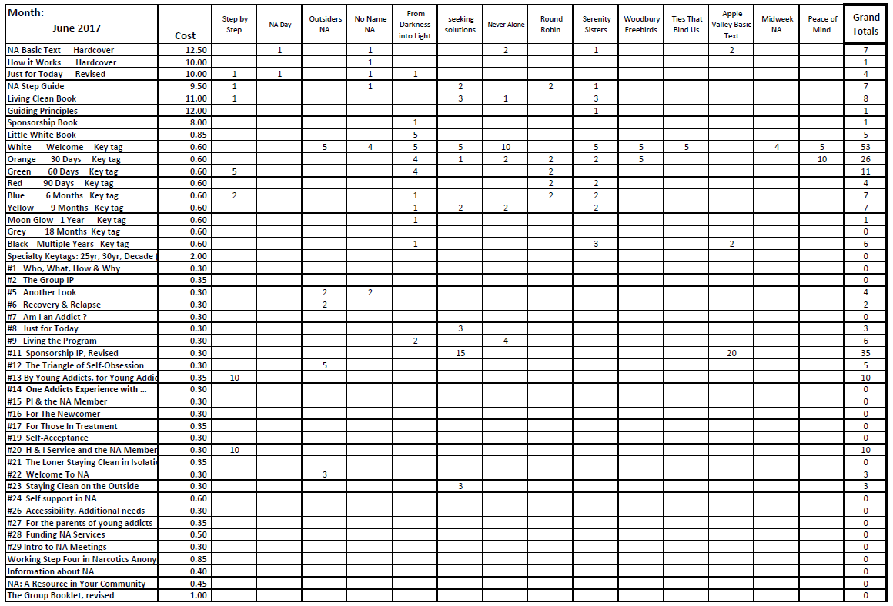

Literature Sales Report (continued)

