
Area Service Committee Meeting Minutes
July 6, 2017

Meeting opened at 7:00 PM by Area Chair Brad S.

Introductions: 19 members in attendance, with no newcomers.

Readings: 12 Steps read by Tim N.; 12 Traditions read by Rachel M.; 12 Concepts read by Marissa M.

Call for quorum: 12 voting members present (minimum for quorum is 7). With 12 voting members present, motions require 7 votes to pass (per bylaws “A motion or nomination requires support of two-thirds (66%) of the quorum in order to be accepted.”)

Approval of Minutes: Motion to approve the minutes of the June ASC meeting;
Vote: Support – 10, Opposed – 0, Abstentions – 2, passed.

7th Tradition: Collected (see Treasurer’s Report, p. 5)

Subcommittee Reports
Meetings for the Activities, Hospitals & Institutions, Outreach, and Public Relations Subcommittees are held at 7:00pm on the 2nd Thursday of each month at Faith Methodist Church, 1530 Oakdale Ave., West St. Paul, MN.

Vice-Chair:
(Rachel – reported)
- Talked about doing an H&I Learning Day
- Need more attendance

Regional Committee Member (RCM):
(open – no report)
- Please announce at your meetings this position is open and only needs meets four times a year.

Activities:
(open – no report)
- Please announce at your meetings this position is open and our area would really like to have some scheduled activities for addicts to enjoy and learn how to have fun in recovery.

Public Relations:
(Chair: Amber M-D. reported)
- NA Helpline Flyer Competition had no entries for the month of June so there were no winners.
- Push GSR’s to attract participants to put up NA flyers either as part of competition OR on their own.
- When taking the picture please have someone in the picture from the group.
- Contest goes until the end of August
- In need of PR Co-Chair

Hospitals & Institutions:
(Chair: James M. reported)
- No activity in August.
- Possibly in September a group of members will discuss options to have an H&I BBQ
- Mike will need reimbursement for purchased literature & flyers he printed
- Submitting a motion to move the subcommittee meeting in July to a later date due to PIG
- Looking into taking a meeting into women’s jails
- Meeting of the Month: July 19 Stillwater NA & August 15 Addicts in Recovery

Current H&I commitments:
Every Saturday: Dakota Co. Jail (Hastings) 1:00pm
(no more volunteers needed at this time due to background check)
Contact: Jason C. 612-353-7958
2nd Saturday of every month: Cochran Recovery Program (Hastings) 2:00pm
Contact: Kierstin K. 651-347-7032
4th Tuesday of every month: Cochran Recovery Program (Hastings) 8:00pm
Contact: Todd V. 651-285-1789
4th Thursday of every month: Dakota County Detox. (Hastings) 7:00pm
Contact: Rachel M. 612-384-4695

Webmaster:
(open – no report)
- Please announce at your meetings this position is open and only needs someone to update the website with our upcoming events, trusted servant position changes, and any other area news.

Treasurer:
(Chair: Erica D. reported) [See Treasurer report, p. 5]
- Opening balance is $1867.13 ($1939.23 – 74.76 = $1867.13)
- There was a discrepancy in the amount from the report due to not writing a check to Melissa for the printing cost of meeting lists and area minutes.
- There was a FedEx card for $0.22 that was donated to H&I.

Outreach:
(open – no report)
- Please announce at your meetings this position is open and needs someone to reach out to our local meetings to see if they need assistance from our Area.

PIG:
(Chair: Melissa C. reported)
- Schedule of Events were voted upon & Tie Dye T-Shirt Colors were selected
- Insurance Coverage was obtained by the UMSO
- Leo J. was voted in as the Adult Activities Chair
- Please announce in meetings we need recovery related raffle items
- Open positions: Merchandise Co-Chair Volunteer Coordinator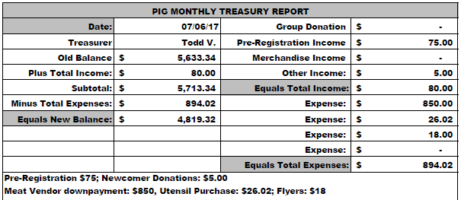

Literature:
(Chair – Gina C. reported). [See Literature Order report, pp. 8-9]
- The large wooden box is missing due to the homeless shelter being held downstairs
- No nine month keytags and limited supplies available.
- Cannot find UMSO receipt from prior month order.
- Kierstin will not be present in July or August, Co-Chair Gina C. will handle requests in her absence
- Please e-mail orders ahead of time if possible, address is ssfalit@gmail.com

Group Concerns & Announcements

[Note: written GSR reports are now at the end of the ASC minutes.]

- Seeking Solutions (Monday) – Needs sponsors & attendance support from more experienced members
- Peace of Mind (Friday) – Needs sponsors
- NA 101 (Saturday) – Needs more support

Open Forum

- James M.: Suggest moving the Subcommittee meeting to July 20th due to possible low attendance on the 13th. Brad will contact the church to see if it is available. Rachel will contact people to let them know of the change if it happens.

- Marissa M.: The group felt that the decision to not accept coins at area should have been brought down to the group level, rather than the area making the decision. It was reminded that the GSR’s voted on the motion at the Area meeting; it was not a mandate from the Area. As a GSR your position is to represent the group while attending the Area meeting and vote to the best of your ability in what you believe would be the group’s conscience.

- Rachel M.: Rock Solid NA in Northfield is believed to no longer be functioning. It was suggested that the Area find out what is going on. Brad stated that he will try to reach out to the group.

- James M.: H&I Panel Leaders are calling people that are on the H&I Sign Up lists, but unfortunately people are not familiar with what the commitment is that they signed up for.

- Melissa C.: Reminded the Area that we need someone to fulfill the Secretary duties.

Elections
- Rachel M. nominated Kaitee L. as SSFA Secretary; nomination seconded by Steely W. Kaitee has willingness and accepted the nomination.
Vote: Support - 12, Opposed - 0, Abstentions – 0; nomination accepted.

Current Positions - GSRs, please announce open positions at your meetings.
Officers/Committees | Chair | Elected | Co-Chair | Elected
Area Chair (2 Yrs, 1 Yr) | Brad S. | 9/2016 | Rachel M. | 4/2017
Secretary (2 Yrs, 1 Yr) | Kaitee L. | 7/2017 | --open--
Treasurer (3 Yrs, 2 Yrs) | Erica D. | 2/2017 | --open--
RCM (2 Yrs, 1 Yr) | --open-- |  | --open--
Literature (3 Yrs, 2 Yrs) | Kierstin K. | 9/2016 | Gina C. | 4/2017
Activities (2 Yrs, 1 Yr) | --open-- |  | --open--
Hospitals & Institutions (2 Yrs, 1 Yr) | James M. | 3/2017 | Mike S. | 4/2017
Outreach (1 Yr, 6 Mo) | --open-- |  | --open--
Public Relations (2 Yrs, 1 Yr) | Amber M-D. | 3/2017 | --open--
Webmaster (1 Yr) | --open-- |  | NA
PIG (2 Yrs, 1 Yr) | Melissa C. | 9/2016 | Amber M-D. | 5/2017
PIG Treasurer (3 Yrs, 2 Yrs) | Todd V. | 9/2016 | Tim N. | 11/2016
PIG Merchandise Chair (2 Yrs, 1 Yr) | Steve H. (2) | 12/2016 | --open--
PIG Gate Chair (2 Yrs, 1 Yr) | Matt K. | 9/2016 | Steely W. | 4/2017
PIG Secretary (6 Mo) | Kris B. | 9/2016 | NA
PIG Food Chair (1 Yr) | Mary M. | 9/2016 | NA
PIG Dinner Coordinator (6 Mo) | Dina D. | 5/2017 | NA
PIG Adult Activities (6 Mo) | Leo J. | 7/2017 | NA
PIG Children Activities (6 Mo) | Rob R. | 2/2017 | NA
PIG Volunteer Coordinator (6 Mo) | --open-- |  | NA
(2) Denotes election is to a second consecutive term in the same position.

Old Business
- Noted that Mike is still working on this. Final decision that was made is that H&I will contact the UMSO to set up a separate charge account for their purchases, instead of depleting the Literature Chair supplies at ASC meeting. Mike S. (H&I Co-Chair) will purchase directly from the UMSO, since he works near the UMSO.

New Business
- Brad suggested we should make a donation due to the large amount of prudent reserve we currently have. Erica will contact the UMSO to find out what our current bill is since we were not able to locate one with the literature that was delivered. It was decided to hold off on making a donation until the Area is current with our bill at the UMSO.

Motions
- Motion Title: Subcommittee Meeting
Author was James M., seconded by Tim N.
Motion to: Move the upcoming meeting on the 13th to the 20th of July
Intent: Low attendance on the 13th potentially, more participation on the 20th.

Discussion: Discussed during Open Forum (see above notes). This was thought to be a good idea with the exception that new members would not know it moved. It was suggested we post a sign stating the meeting was moved, either to a different location (if the church is not available) and date (on the 20th).
Financial impact: None
Vote: Support – 8, Opposed – 0, Abstentions – 4, motion passed.

Motion to close made by Todd V., seconded by Rachel M.; meeting closed with the Gratitude Statement at 8:20 pm.

Treasurer’s Report


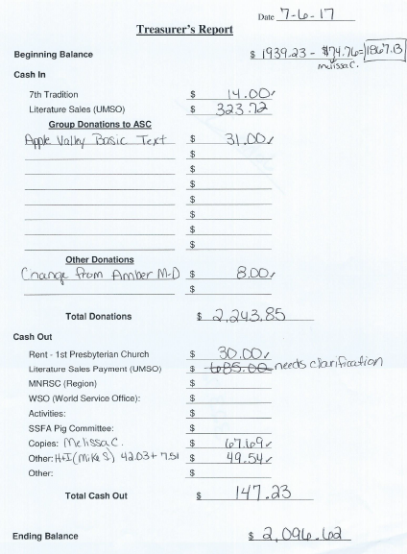

GSR Reports

Woodbury Freebirds |  | 6:00pm Sunday
GSR: NOT PRESENT |  | Status:
Avg. Attendance |  |  | Avg. Newcomers
ASC Donation
H&I Activities
Scheduled Activities
Other

Step by Step |  | 7:00pm Sunday
GSR: Steely W. |  | Status: Stable
Avg. Attendance | 11 |  | Avg. Newcomers | 1
ASC Donation
H&I Activities |  | Women’s jail mtg mentioned
Scheduled Activities |  | Mentioned flyer competition
Other

Never Alone |  | 7:00pm Sunday
GSR: Nicole M. |  | Status: Stable
Avg. Attendance | 15 – 30 |  | Avg. Newcomers | 1 – 5
ASC Donation
H&I Activities |  | Announced
Scheduled Activities |  | Announced
Other

Ties That Bind Us |  | 7:00pm Monday
GSR: NOT PRESENT |  | Status:
Avg. Attendance |  |  | Avg. Newcomers
ASC Donation
H&I Activities
Scheduled Activities
Other

Seeking Solutions |  | 7:00pm Monday
GSR: Rachel M. |  | Status: Stable
Avg. Attendance | 10 – 15 |  | Avg. Newcomers | 1 – 2
ASC Donation
H&I Activities |  | Announced
Scheduled Activities
Other |  | Announced flyer competition

Monday Night Round Robin |  | 7:00pm Monday
GSR: NOT PRESENT |  | Status:
Avg. Attendance |  |  | Avg. Newcomers
ASC Donation
H&I Activities
Scheduled Activities
Other

Addicts in Recovery |  | 7:00pm Tuesday
GSR: Amber M-D |  | Status: Stable
Avg. Attendance | 20 – 35 |  | Avg. Newcomers | 2 – 5
ASC Donation
H&I Activities |  | Announced
Scheduled Activities |  | Every 5th Tuesday Potluck
Other

TNT: Tues. Nights Together |  | 7:00pm Tuesday
GSR: OPEN |  | Status: Stable
Avg. Attendance | 15 |  | Avg. Newcomers | 1
ASC Donation
H&I Activities |  | Announced
Scheduled Activities
Other

Tuesday Night Serenity |  | 7:00pm Tuesday
GSR: NOT PRESENT : |  | Status:
Avg. Attendance |  |  | Avg. Newcomers
ASC Donation
H&I Activities
Scheduled Activities
Other

Midweek NA |  | 7:00pm Wednesday
GSR: OPEN |  | Status: Stable
Avg. Attendance | 21 |  | Avg. Newcomers | 2
ASC Donation
H&I Activities |  | Announced
Scheduled Activities |  | Announced
Other |  | PIG Donation $24.00

Rock Solid NA |  | 7:00pm Wednesday
GSR: NOT PRESENT : |  | Status:
Avg. Attendance |  |  | Avg. Newcomers
ASC Donation
H&I Activities
Scheduled Activities
Other

Stillwater NA |  | 7:30pm Wednesday
GSR: Grant |  | Status: Stable
Avg. Attendance | 24 – 27 |  | Avg. Newcomers | 4 – 5
ASC Donation
H&I Activities |  | Announced
Scheduled Activities |  | None
Other

GSR Reports (continued)

Serenity Sisters |  | 7:00pm Thursday
GSR: Anne R. |  | Status: Stable
Avg. Attendance | 15 |  | Avg. Newcomers | 2 – 3
ASC Donation
H&I Activities |  | Announced
Scheduled Activities
Other

No Name NA |  | 7:00pm Thursday
GSR: Mike M. |  | Status: Stable
Avg. Attendance | 19 – 20 |  | Avg. Newcomers | 2
ASC Donation
H&I Activities |  | Announced
Scheduled Activities |  | None
Other |  | None

Gaylord Serenity Seekers |  | 7:30pm Thursday
GSR: NOT PRESENT |  | Status:
Avg. Attendance |  |  | Avg. Newcomers
ASC Donation
H&I Activities
Scheduled Activities
Other

Peace of Mind |  | 7:30pm Friday
GSR: Tim N. |  | Status: Stable
Avg. Attendance | 30 |  | Avg. Newcomers | 3
ASC Donation
H&I Activities |  | Announced
Scheduled Activities |  | Announced
Other

NA Day |  | 7:30pm Friday
GSR: NOT PRESENT |  | Status:
Avg. Attendance |  |  | Avg. Newcomers
ASC Donation
H&I Activities
Scheduled Activities
Other
Friday Night Outsiders NA |  | 8:00pm Friday
GSR: NOT PRESENT |  | Status:
Avg. Attendance |  |  | Avg. Newcomers
ASC Donation
H&I Activities
Scheduled Activities
Other

From Darkness Into Light NA |  | 6:30pm Saturday
GSR: Marissa M. |  | Status: Stable
Avg. Attendance | 20 – 25 |  | Avg. Newcomers | 2
ASC Donation
H&I Activities |  | None
Scheduled Activities |  | None
Other |  | Did not like the coin vote

NA 101 |  | 7:00pm Saturday
GSR: John M. |  | Status: Stable
Avg. Attendance | 8 |  | Avg. Newcomers | 1
ASC Donation
H&I Activities
Scheduled Activities
Other

Apple Valley Basic Text Study |  | 9:00pm Saturday
GSR: Dan K. |  | Status: Stable
Avg. Attendance | 15 |  | Avg. Newcomers | 2
ASC Donation |  | $31.00
H&I Activities
Scheduled Activities
Other

Literature Sales Report
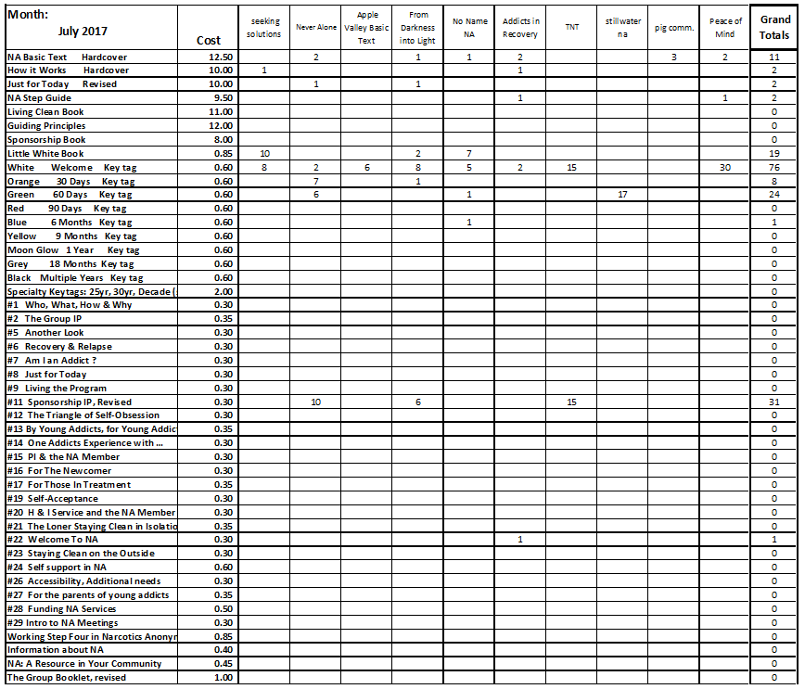

Literature Sales Report (continued)
