

Area Service Committee Meeting Minute

JANUARY 5, 2017

Meeting opened at 7:10 PM by Area Chair Brad S.

Introductions: 24 members in attendance, 17 GSRs Presents, 5 new comers

7th Tradition: Collected [see Treasurer’s Report on page 10]

Readings: 12 Steps read by not record; 12 Traditions read by not recorded ; 12 Concepts read by not recorded.

Call for Quorum: 17 voting members present (minimum for quorum is 7). motions require 7 votes to pass.

Approval of Minutes – Motion by Tim, 2nd by Amber - Minutes Approved.

Subcommittee Reports
Meetings for the Activities, Hospitals & Institutions, Outreach, and Public Relations Subcommittees are held at 7:00pm on the 2nd Thursday of each month at Faith Methodist Church, 1530 Oakdale Ave., West St. Paul, MN.

Vice-Chair: (open) Not Present.
Region: (RCM: not present)

Activities:
Rick H, No Report
Public Relations: (Open) No Report
Hospitals & Institutions: (Steve P. Chair- reports)
- Trying to get people to sign up if interested.

Current H&I commitments:

Every Saturday: Dakota Co. Jail 1:00pm
(Need pre-approval to participate, call contact for information) Contact: Jason C. 612-353-7985
4th Tuesday of every month: Cochran Recovery Program (Hastings) 7:30pm Contact: Todd V.
651-285-1789
4th Thursday of every month: Dakota County Detox. 7:00pm Contact: Steve P. 651-493-3537

Outreach: (open)
- Open report.

PIG: (Chair: Melissa C. Reported) Balance $3,729.53
- Flyers were distributed and are available on-line
- Voted on coffee chair
- T-shirts should be coming next month.
- Open positions
  - Co-chair, co- Merchandise chair, Co-Gate Chair, Adult & Children Activities Chair, Dinner Coordinator, Volunteer Coordinator.

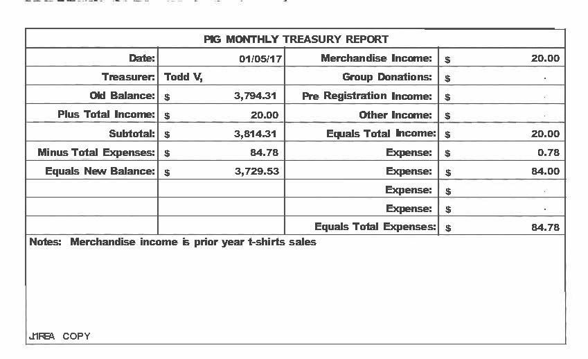

Literature: .(Chair - Kierstin K. present). [see report on page 11]
• literature email address ssfalit@gmail.com for orders and questions
- Service office not open too much over the holidays, she goes the last Saturday of the month.
Webmaster: (Char – Tom) Web information update, tried to put cookie exchange information on the website, having issues, will figure it out.

Group Concerns & Announcements
[Note: GSR reports are now at the end of the ASC minutes.]

Open Forum
• Brad S noted that we will be revising the by-laws, Meeting dates are the 3rd Thursday of the month.
• Ad Hoc will meet to revise by-laws as follows:
January 19, 2017, at the Robert Street Perkins in West St. Paul at ___
February 4, 2017 at the Cottage Grove (Pt. Douglas) Perkins 3pm.
February 18, 2017 at the Perkins in Apple Valley at 3pm.
• Subcommittee needs people, GSR’s need to bring those interested to the AREA meeting to get more involved. subcommittee held every 2nd Thursday of the month at 1530 Oakdale Avenue WSP at 7:00 p.m.

• Mark with Stillwater NA, located at the Joseph Roach Hall, in Stillwater Minnesota, with 30-35 attendees, with 5-6 newcomers wants to join SSFA
• Has many service area commitments, needs to be released from Area of Hope

Break 7:45 p.m.
back 8:00 p.m.
Elections and Motions
  - Motion to make coffee at Area motioned by Rachel and seconded by Gena..
    - Support - 16 ; Oppose - 0; Abstentions - 1 Motion PASSED

Open Positions — Announced with clean time requirements
Officers/Committes | Chair | Elected | Co-Chair Elected
Area Chair (2 Yrs,1 Yr) | Brad S. | 9/01 | open
Secretary (2 Yrs, 1 Yr) | Amber . | Temp – fill in | open
Treasurer (3 Yrs, 2 Yrs) | Tim. | ____ | Erica D. | 4/16
RCM (2 Yrs, 1 Yr) | Nick P. | 12/15 (2) | open
Literature (3 Yrs, 1 Yr) | Kierstin K. | 9/16
Activities (2 Yrs, 1 Yr) | Rick H. | 9/16
H&I (2 Yrs, 1 Yr) | Steve. P | 3/16 | James M. | 3/16
Outreach (1 Yr, 6 M) | open |  | open
Public Relations (2 Yr, 1Yr) | open |  | open
Webmaster (1 Yr) | Tom |  | N/A
PIG (2 Yrs, 1 Yr) | Melissa C. | 10/16 | open
PIG Treasurer (3 Yrs, 2 Yrs) | Todd V. | 10/16
PIG Merch. Chair (2 Yrs, 1 Yr) | Steve H. | 1/16 | open
PIG Gate Chair (2 Yrs, 1 Yr) | Matt. K. | 10/16 | open
(2) Denotes election is to a second consecutive term in the same position.

Old Business
- NONE

New Business
  - Motion to close made by Tim, seconded by Gina..

GSR Report

Woodbury Freebirds | 7:00pm Sunday Stable
GSR | Garrett L. NOT PRESENT
Avg. Attendance
Avg. Newcomers
H&I Activities
ASC Donation
Scheduled Activities
Other

Step by Step | 7:00pm Sunday
GSR | Rick H. NOT PRESENT
Avg. Attendance
Avg. Newcomers
H&I Activities
ASC Donation
Scheduled Activities
Other

Never Alone | 7:00pm Sunday Stable
GSR | Nicole PRESENT
Avg. Attendance | 15-25
Avg. Newcomers | 5
H&I Activities | announced
ASC Donation | $0.00
Scheduled Activities | announced
Other

Ties That Bind Us | 7:00pm Monday
GSR | Matt K. .
Avg. Attendance | 12
Avg. Newcomers | 1
H&I Activities | announced
ASC Donation | announced
Scheduled Activities
Other

Monday Night Round Robin | 7:00pm Monday Stable
GSR | Dan Z. PRESENT
Avg. Attendance | 15-20
Avg. Newcomers | 2
H&I Activities | Will handout sign up sheet
ASC Donation
Scheduled Activities
Other

Addicts in Recovery | 7:00pm Tuesday Stable
GSR | Angie F. PRESENT
Avg. Attendance | 20-30
Avg. Newcomers | 1-3
H&I Activities | announced
ASC Donation | $2.00
Scheduled Activities | 5th Tuesday is pot luck meeting
Other

TNT: Tues. Night Together | 7:00pm Tuesday Stable
GSR | Open (James as sub) Present
Avg. Attendance | 20
Avg. Newcomers | 2
H&I Activities
ASC Donation | $10.40
Scheduled Activities
Other

Tuesday Night Serenity | 7:00pm Tuesday
GSR | NOT PRESENT
Avg. Attendance
Avg. Newcomers
H&I Activities
ASC Donation
Scheduled Activities
Other

Rock Solid NA | 7:00pm Wednesday
GSR | NOT PRESENT
Avg. Attendance
Avg. Newcomers
H&I Activities
ASC Donation
Scheduled Activities
Other

Midweek NA | 7:00pm Wednesday Stable
GSR | Amber R. PRESENT
Avg. Attendance | 10-12
Avg. Newcomers | 2-3
H&I Activities
ASC Donation | $40.00 pig
Scheduled Activities
Other

No name NA | 7:00pm Thursday Stable
GSR | Gina PRESENT
Avg. Attendance | 20-25
Avg. Newcomers | 1-3
H&I Activities
ASC Donation | $0.00
Scheduled Activities
Other | Need more female sponors

Serenity Sisters | 7:00pm Thursday Stable
GSR | Anne R. PRESENT
Avg. Attendance | 10
Avg. Newcomers | 2
H&I Activities | announced
ASC Donation | 0.00
Scheduled Activities
Other

Serenity Seekers  GSR | 7:30pm Thursday Stable  Rachel PRESENT
Avg. Attendance | 10-15
Avg. Newcomers | 7
H&I Activities
ASC Donation
Scheduled Activities
Other | FEMALE SPONSORS NEEDED

Peace of Mind | 7:30pm Friday Stable
GSR | Tim N. PRESENT
Avg. Attendance | 10-3
Avg. Newcomers | 2
H&I Activities
ASC Donation
Scheduled Activities
Other

Na Day | 7:30pm Friday
GSR | Luke C PRESENT
Avg. Attendance | 25
Avg. Newcomers | 1-3
H&I Activities
ASC Donation
Scheduled Activities | 3/4/2017 – NA Day Chili Feed (11a – 4p)  Raffle item donation contact Rob 651-253-1292
Other | Items need for the raffle, need silent auction item.

Outsiders NA | 8:00pm Friday
GSR | Mary PRESENT
Avg. Attendance | 10
Avg. Newcomers | 1
H&I Activities | Announced and sign up encouraged
ASC Donation | $0.00
Scheduled Activities
Other

From Darkness into Light | 6:30pm Saturday Stable
GSR | Chris H.
Avg. Attendance | 15-20
Avg. Newcomers | 1-3
H&I Activities
ASC Donation | $57.75
Scheduled Activities
Other

NA 101 in Hastings | 7:00pm Saturday Stable
GSR | John M. PRESENT
Avg. Attendance | 5
Avg. Newcomers | 1
H&I Activities
ASC Donation
Scheduled Activities
Other | Need more members especially with substantial clean time.

Apple Valley Basic Text Study | 9:00pm Saturday Stable
GSR | Melissa C.
Avg. Attendance | 15-20
Avg. Newcomers | 2
H&I Activities | Announced
ASC Donation | $16.59
Scheduled Activities
Other

Stillwater NA | 7:30 pm Wednesday Stable
GSR | Grant
Avg. Attendance | 30-35
Avg. Newcomers | 5-6
H&I Activities | Announced
ASC Donation | $0.00
Scheduled Activities
Other

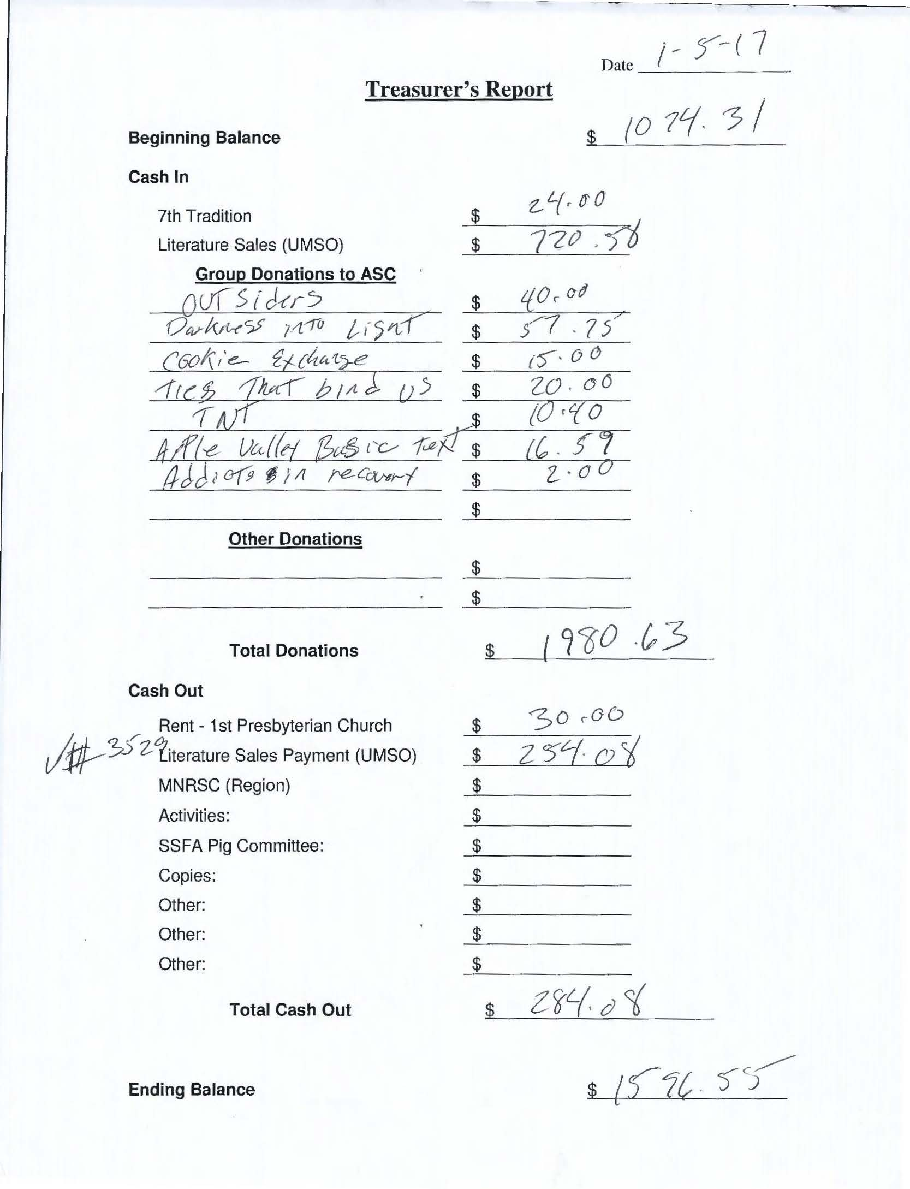

Literature Sales
