

Area Service Committee Meeting Minute

MARCH 2, 2017

Meeting opened at 7:10 PM by Area Chair Brad S.

Introductions: 24 members in attendance, 15 GSRs Presents, 1 new comer (GSR Adam for Midweek NA

7th Tradition: Collected [see Treasurer’s Report on page 10]

Readings: 12 Steps read by not record; 12 Traditions read by not recorded ; 12 Concepts read by not recorded.

Call for Quorum: 15 voting members present (minimum for quorum is 7). motions require 7 votes to pass.

Approval of Minutes –TABLED, COPIES NOT PROVIDED FOR JAN 2017 or FEBRUARY 2017.

Subcommittee Reports
Meetings for the Activities, Hospitals & Institutions, Outreach, and Public Relations Subcommittees are held at 7:00pm on the 2nd Thursday of each month at Faith Methodist Church, 1530 Oakdale Ave., West St. Paul, MN.

Vice-Chair: (open) Not Present.
Region: (RCM: not present)

Activities:
Rick H, Resigned - Open
Public Relations: Amber M-D nominated and voted in
Hospitals & Institutions: (Steve P. Chair- reports)
- Stepping down as chair, nominating new chair (see motions)
- James Nominated as new Chair, Steve will step into co-chair temp

Outreach: (open)
- Open report.

PIG: (Chair: Melissa C. Reported) Balance $2919.57
- T—shirt have arrived, they are $12.00 each.
- Chili feed on Sat 3/3/17
- Look for newcomer key tags at your meetings
- Agreed to allow ICUC host “wheel of fortune” at PIG more details to come;
- Agreed to hire same meat cooker from last year.
- Open positions
  - Co-chair
  - co- Merchandise chair
  - Co-Gate Chair
  - Adult Activities Chair
  - Dinner Coordinator,

Recovery related raffle items are welcome to any PIG committee member.

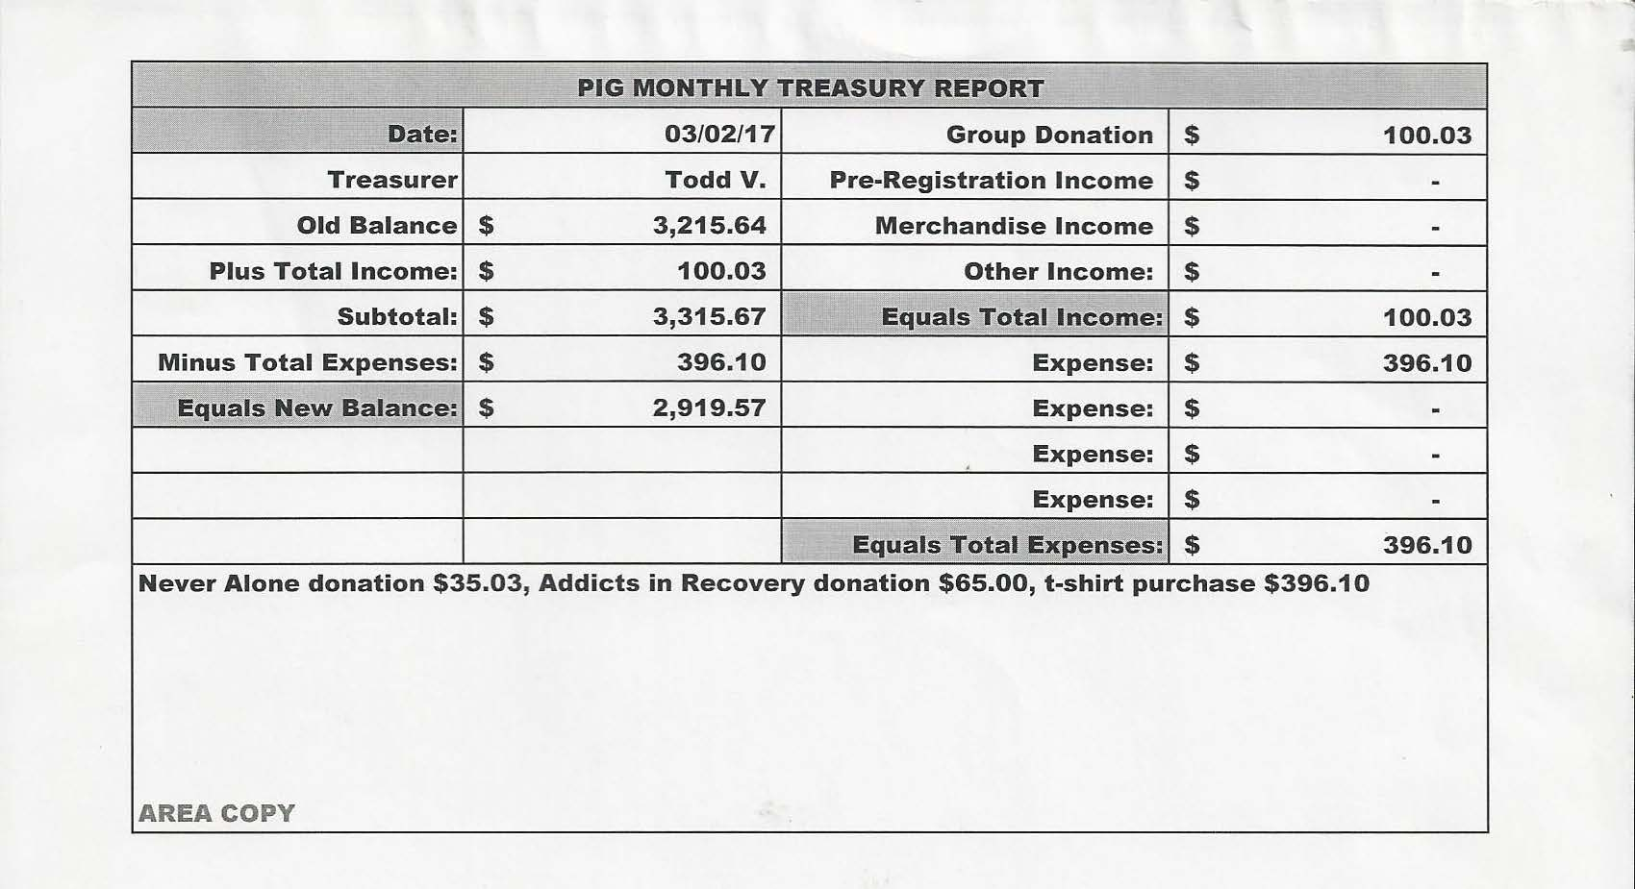

Literature: .(Chair - Kierstin K. present). [see report on page 11]
• literature email address ssfalit@gmail.com for orders and questions

Webmaster: (fill in is Tom) Web information update, tried to put cookie exchange information on the website, having issues, will figure it out.

Group Concerns & Announcements
[Note: GSR reports are now at the end of the ASC minutes.]

Open Forum
• Nothing

Break 7:45 p.m.
back 8:00 p.m.

Elections and Motions
  - Motion to approve January 2017 and February 2017 Minutes tabled due to acting secretary not bringing copy of minutes to meeting timely. Melissa will be sending minutes via e-mail once Amber notifies her of completed final.
  - Motion to Donate $500.00 to UMSO – Melissa lists a pro as when we buy from, helps service office
    - Made by Mary, Seconded by John, voted – 14 Pass, 0 Oppose, 0 Abstain MOTION PASSED
.
Open Positions — Announced with clean time requirements
Officers/Committes | Chair | Elected | Co-Chair Elected
Area Chair (2 Yrs,1 Yr) | Brad S. | 9/01 | open
Secretary (1 Yrs, 1 Yr) | Amber . | Temp – fill in | open
Treasurer (3 Yrs, 2 Yrs) | Erica D. | 2/17 | .
RCM (2 Yrs, 1 Yr) | open. |  | open
Literature (3 Yrs, 1 Yr) | Kiersten K. | 9/16
Activities (2 Yrs, 1 Yr) | OPEN
H&I (2 Yrs, 1 Yr) | James M | 3/17 |  | Steve (temp)
Outreach (1 Yr, 6 M) | OPEN |  | open
Public Relations (2 Yr, 1Yr) | Amber M-D 3/17 |  | open
Webmaster (1 Yr) | OPEN (tom resigned -filling in) |  | N/A
PIG (2 Yrs, 1 Yr) | Melissa C. | 9/16 | open
PIG Treasurer (3 Yrs, 2 Yrs) | Todd V. | 9/16 | Tim N 11/16
PIG Secretary | Kris B | 9/16
PIG Merch. Chair (2 Yrs, 1 Yr) | Steve H. | 12/16 | open
PIG Gate Chair (2 Yrs, 1 Yr) | Matt. K. | 8/16 | Open
PIG Children’s Activ (2yrs, 1Yr) | Rob R. | 2/17 | Open
PIG Food Chair (none) | Mary M. | 9/16
PIG Volunteer Coordinator | OPEN
PIG ADULT ACTIVITIES | OPEN
PIG Children Activities | OPEN
Coffee | Rachel M | 1/17
PIG Dinner Coordinator | OPEN
(2) Denotes election is to a second consecutive term in the same position.

Old Business
- January and February Minutes Tabled and need to be brought front and voted on.

New Business
- USMO DONATION MADE – SEE MOTIONS

GSR Report

Woodbury Freebirds | 7:00pm Sunday Stable
GSR | Garrett L. NOT PRESENT
Avg. Attendance
Avg. Newcomers
H&I Activities
ASC Donation
Scheduled Activities | None
Other

Step by Step | 7:00pm Sunday Stable
GSR | Rick H. PRESENT
Avg. Attendance | 15-20
Avg. Newcomers | 1-2
H&I Activities | Making weekly announcements
ASC Donation
Scheduled Activities
Other

Never Alone | 7:00pm Sunday Stable
GSR | Nicole PRESENT
Avg. Attendance | 20-30
Avg. Newcomers | 5
H&I Activities | announced
ASC Donation | $0.00
Scheduled Activities | Announced, none
Other

Ties That Bind Us | 7:00pm Monday Stable
GSR | Matt K. . PRESENT
Avg. Attendance | 15
Avg. Newcomers | 2
H&I Activities | Announced and signed up for
ASC Donation | 0
Scheduled Activities | 1st and 3rd Mondays – Meetings by River
Other

Monday Night Round Robin | 7:00pm Monday Stable
GSR | Dan Z. NOT PRESENT
Avg. Attendance
Avg. Newcomers
H&I Activities
ASC Donation
Scheduled Activities
Other

Seeking Solutions | 7:00pm Monday Stable
GSR | Rachel Morten PRESENT
Avg. Attendance | 20
Avg. Newcomers | 2
H&I Activities | Announced at each meeting
ASC Donation | $17.70
Scheduled Activities | Pot luck and speaker every 5th week
Other | Need females sponsors

Addicts in Recovery | 7:00pm Tuesday Stable
GSR | Angie F. PRESENT
Avg. Attendance | 25-30
Avg. Newcomers | 1-3
H&I Activities | announced
ASC Donation | $0
Scheduled Activities | 5th Tuesday is pot luck meeting
Other

TNT: Tues. Night Together | 7:00pm Tuesday Stable
GSR | Open (James as sub) Present
Avg. Attendance | 15
Avg. Newcomers | 1
H&I Activities | announced
ASC Donation | $20.00
Scheduled Activities
Other

Tuesday Night Serenity | 7:00pm Tuesday
GSR | NOT PRESENT
Avg. Attendance
Avg. Newcomers
H&I Activities
ASC Donation
Scheduled Activities
Other

Rock Solid NA | 7:00pm Wednesday
GSR | NOT PRESENT
Avg. Attendance
Avg. Newcomers
H&I Activities
ASC Donation
Scheduled Activities
Other

Midweek NA | 7:00pm Wednesday Stable
GSR | Adam R.. PRESENT
Avg. Attendance | 13
Avg. Newcomers | 2
H&I Activities | announced
ASC Donation | $25.00
Scheduled Activities
Other | Now an open group

No name NA | 7:00pm Thursday Stable
GSR | Gina PRESENT
Avg. Attendance | 20-25
Avg. Newcomers | 1-2
H&I Activities | announced
ASC Donation | $0.00
Scheduled Activities
Other

Na Day | 7:30pm Friday Stable
GSR | PHIL C PRESENT
Avg. Attendance | 25
Avg. Newcomers | 4
H&I Activities
ASC Donation
Scheduled Activities | 3/4/2017 – NA Day Chili Feed (11a – 4p)  Raffle item donation contact Rob 651-253-1292
Other
Serenity Sisters | 7:00pm Thursday
GSR | Anne R NOT PRESENT
Avg. Attendance | 12
Avg. Newcomers | 1
H&I Activities | Announced and sign up encouraged
ASC Donation | $0
Scheduled Activities
Other

Outsiders NA | 8:00pm Friday
GSR | Mary PRESENT
Avg. Attendance | 12
Avg. Newcomers | 1
H&I Activities | Announced and sign up encouraged
ASC Donation | $0
Scheduled Activities
Other

From Darkness into Light | 6:30pm Saturday Stable
GSR | Open (temp is Gina) PRESENT.
Avg. Attendance | 20-25
Avg. Newcomers | 1-2
H&I Activities | announced
ASC Donation | $0
Scheduled Activities
Other

NA 101 in Hastings | 7:00pm Saturday Stable
GSR | John M. PRESENT
Avg. Attendance | 8-10
Avg. Newcomers | 1
H&I Activities
ASC Donation
Scheduled Activities
Other

Apple Valley Basic Text Study | 9:00pm Saturday Stable
GSR | Melissa C. PRESENT
Avg. Attendance | 15-20
Avg. Newcomers | 1-2
H&I Activities | Announced
ASC Donation | $5.00
Scheduled Activities
Other

Stillwater NA | 7:30 pm Wednesday Stable
GSR | Grant PRESENT
Avg. Attendance | 28-35
Avg. Newcomers | 4-5
H&I Activities | Announced
ASC Donation | $25.00
Scheduled Activities | Tubing cancelled
Other

