

Area Service Committee Meeting Minute

FEBRUARY 2, 2017

Meeting opened at 7:10 PM by Area Chair Brad S.

Introductions: 24 members in attendance, 17 GSRs Presents, 5 new comers

7th Tradition: Collected [see Treasurer’s Report on page 10]

Readings: 12 Steps read by not record; 12 Traditions read by not recorded ; 12 Concepts read by not recorded.

Call for Quorum: 17 voting members present (minimum for quorum is 7). motions require 7 votes to pass.

Approval of Minutes –TABLED, COPIES NOT PROVIDED FOR JAN 2017 MTGH.

Subcommittee Reports
Meetings for the Activities, Hospitals & Institutions, Outreach, and Public Relations Subcommittees are held at 7:00pm on the 2nd Thursday of each month at Faith Methodist Church, 1530 Oakdale Ave., West St. Paul, MN.

Vice-Chair: (open) Not Present.
Region: (RCM: not present)

Activities:
Rick H, Nothing to Report
Public Relations: (Open) No Report
Hospitals & Institutions: (Steve P. Chair- reports)
- Panel leader for Cochran house 2nd Meeting, need new blood at our sub-committee meeting, ideas for more involvement.

Current H&I commitments:

None. 5
4th Tuesday of every month: Cochran Recovery Program (Hastings) 7:30pm Contact: Todd V.
651-285-1789
4th Thursday of every month: Dakota County Detox. 7:00pm Contact: Steve P. 651-493-3537

Outreach: (open)
- Open report.

WebMaster: (TomJay) reports:
- stable, will be giving up chair/be informally filling position needs and assisting with mailing list.

Ad-Hoc: Chair – Brad, Reports,
- financial status is 0. Meetings will be Feb 4 and Feb 18 both at 3p.m., Perkins, need participation.

PIG: (Chair: Melissa C. Reported) Balance $3215.64
- T—shirt vendor was selected, shirts will be ordered, newcomers key tags will be visiting local meetings to get NA love put on them for distribution at PIG.
- 2017 Event Contract was approved, deposit was made on the campground
- PIG donations will be made to NA day Chili Feed to help support their fundraising event
- Children’s activities position was filled by Rob R.
- Flyers distributed and are available on-line
- Open positions
  - Co-chair
  - co- Merchandise chair
  - Co-Gate Chair
  - Adult Activities Chair
  - Dinner Coordinator,

Literature: .(Chair - Kierstin K. present). [see report on page 11]
• literature email address ssfalit@gmail.com for orders and questions
Webmaster: (Char – Tom) Web information update, tried to put cookie exchange information on the website, having issues, will figure it out.

Group Concerns & Announcements
[Note: GSR reports are now at the end of the ASC minutes.]

Open Forum
• Brad S noted that we will be revising the by-laws, Meeting dates are the 3rd Thursday of the month.
• Ad Hoc will meet to revise by-laws as follows:
February 4, 2017 at the Cottage Grove (Pt. Douglas) Perkins 3pm.
February 18, 2017 at the Perkins in Apple Valley at 3pm.
• Subcommittee needs people, GSR’s need to bring those interested to the AREA meeting to get more involved. subcommittee held every 2nd Thursday of the month at 1530 Oakdale Avenue WSP at 7:00 p.m.

• Nothing more

Break 7:45 p.m.
back 8:00 p.m.
Elections and Motions
  - Motion to approve minutes tabled due to secretary not bringing copy of minutes to meeting.

Open Positions — Announced with clean time requirements
Officers/Committes | Chair | Elected | Co-Chair Elected
Area Chair (2 Yrs,1 Yr) | Brad S. | 9/01 | open
Secretary (1 Yrs, 1 Yr) | Amber . | Temp – fill in | open
Treasurer (3 Yrs, 2 Yrs) | Tim N. | ____ | Erica D. | 4/16
RCM (2 Yrs, 1 Yr) | open. |  | open
Literature (3 Yrs, 1 Yr) | Kierstin K. | 9/16
Activities (2 Yrs, 1 Yr) | Rick H. | 9/16
H&I (2 Yrs, 1 Yr) | Steve. P | 3/16 | James M. | 3/16
Outreach (1 Yr, 6 M) | open |  | open
Public Relations (2 Yr, 1Yr) | open |  | open
Webmaster (1 Yr) | Open (tom resigned) |  | N/A
PIG (2 Yrs, 1 Yr) | Melissa C. | 10/16 | open
PIG Treasurer (3 Yrs, 2 Yrs) | Todd V. | 10/16
PIG Merch. Chair (2 Yrs, 1 Yr) | Steve H. | 1/16 | open
PIG Gate Chair (2 Yrs, 1 Yr) | Matt. K. | 10/16 | Open
PIG Children’s Activ (2yrs, 1Yr | Rob R.
(2) Denotes election is to a second consecutive term in the same position.

Old Business
- NONE

New Business
- Motion to close made by Tim, seconded by not recorded.

GSR Report

Woodbury Freebirds | 7:00pm Sunday Stable
GSR | Garrett L. PRESENT
Avg. Attendance | 12
Avg. Newcomers | 1-2
H&I Activities
ASC Donation | $35
Scheduled Activities | None
Other | Needs Sponsors

Step by Step | 7:00pm Sunday Stable
GSR | Rick H. PRESENT
Avg. Attendance | 15-20
Avg. Newcomers | 2-3
H&I Activities | Making weekly announcements
ASC Donation
Scheduled Activities
Other

Never Alone | 7:00pm Sunday Stable
GSR | Nicole PRESENT
Avg. Attendance | 20-30
Avg. Newcomers | 5
H&I Activities | announced
ASC Donation | $0.00
Scheduled Activities | Announced, none
Other

Ties That Bind Us | 7:00pm Monday Stable
GSR | Matt K. .
Avg. Attendance | 10
Avg. Newcomers | 1-2
H&I Activities | announced
ASC Donation | 0
Scheduled Activities | 1st and 3rd Mondays – Meetings by River
Other

Monday Night Round Robin | 7:00pm Monday Stable
GSR | Dan Z. PRESENT
Avg. Attendance | 15-25
Avg. Newcomers | 3-5
H&I Activities | Announced at each meeting
ASC Donation
Scheduled Activities
Other

Seeking Solutions | 7:00pm Monday Stable
GSR | Rachel Morten PRESENT
Avg. Attendance | 20-25
Avg. Newcomers | 2
H&I Activities | Announced at each meeting
ASC Donation | $16.71
Scheduled Activities | Pot luck and speaker every 5th week
Other | Need females sponsors

Addicts in Recovery | 7:00pm Tuesday Stable
GSR | Angie F. PRESENT
Avg. Attendance | 20-30
Avg. Newcomers | 1-3
H&I Activities | announced
ASC Donation | $43.49 PIG DONATION: $65.00
Scheduled Activities | 5th Tuesday is pot luck meeting
Other

TNT: Tues. Night Together | 7:00pm Tuesday Stable
GSR | Open (James as sub) Present
Avg. Attendance | 15
Avg. Newcomers | 1
H&I Activities | announced
ASC Donation | $50.50
Scheduled Activities
Other

Tuesday Night Serenity | 7:00pm Tuesday
GSR | NOT PRESENT
Avg. Attendance
Avg. Newcomers
H&I Activities
ASC Donation
Scheduled Activities
Other

Rock Solid NA | 7:00pm Wednesday
GSR | NOT PRESENT
Avg. Attendance
Avg. Newcomers
H&I Activities
ASC Donation
Scheduled Activities
Other

Midweek NA | 7:00pm Wednesday Stable
GSR | Amber R. PRESENT
Avg. Attendance | 10
Avg. Newcomers | 2
H&I Activities | announced
ASC Donation | $____
Scheduled Activities
Other

No name NA | 7:00pm Thursday Stable
GSR | Gina PRESENT
Avg. Attendance | 20
Avg. Newcomers | 2-3
H&I Activities | announced
ASC Donation | $0.00
Scheduled Activities
Other

Serenity Sisters | 7:00pm Thursday Stable
GSR | Anne R. PRESENT
Avg. Attendance | 10
Avg. Newcomers | 2
H&I Activities | announced
ASC Donation | 0.00
Scheduled Activities
Other
Peace of Mind | 7:30pm Friday Stable
GSR | Tim N. PRESENT
Avg. Attendance | 11
Avg. Newcomers | 1
H&I Activities
ASC Donation
Scheduled Activities
Other
Na Day | 7:30pm Friday Stable
GSR | Luke C PRESENT
Avg. Attendance | 20-25
Avg. Newcomers | 2-3
H&I Activities
ASC Donation
Scheduled Activities | 3/4/2017 – NA Day Chili Feed (11a – 4p)  Raffle item donation contact Rob 651-253-1292
Other
Outsiders NA | 8:00pm Friday
GSR | Mary PRESENT
Avg. Attendance | 14
Avg. Newcomers | 1-2
H&I Activities | Announced and sign up encouraged
ASC Donation | $16.00
Scheduled Activities
Other

From Darkness into Light | 6:30pm Saturday Stable
GSR | Open (temp is Gina) PRESENT.
Avg. Attendance | 15-20
Avg. Newcomers | 1-2
H&I Activities | announced
ASC Donation | $11.64
Scheduled Activities
Other

NA 101 in Hastings | 7:00pm Saturday Stable
GSR | John M. PRESENT
Avg. Attendance | 8
Avg. Newcomers | 1
H&I Activities
ASC Donation
Scheduled Activities
Other

Apple Valley Basic Text Study | 9:00pm Saturday Stable
GSR | Melissa C. PRESENT
Avg. Attendance | 11
Avg. Newcomers | 1
H&I Activities | Announced
ASC Donation | $6.05
Scheduled Activities
Other

Stillwater NA | 7:30 pm Wednesday Stable
GSR | Grant
Avg. Attendance | 25-28
Avg. Newcomers | 5-6
H&I Activities | Announced
ASC Donation | $28.00
Scheduled Activities | TUBING AT GREENACRES 3/3/17 6 -9 PM 12.00 PER PERSON
Other

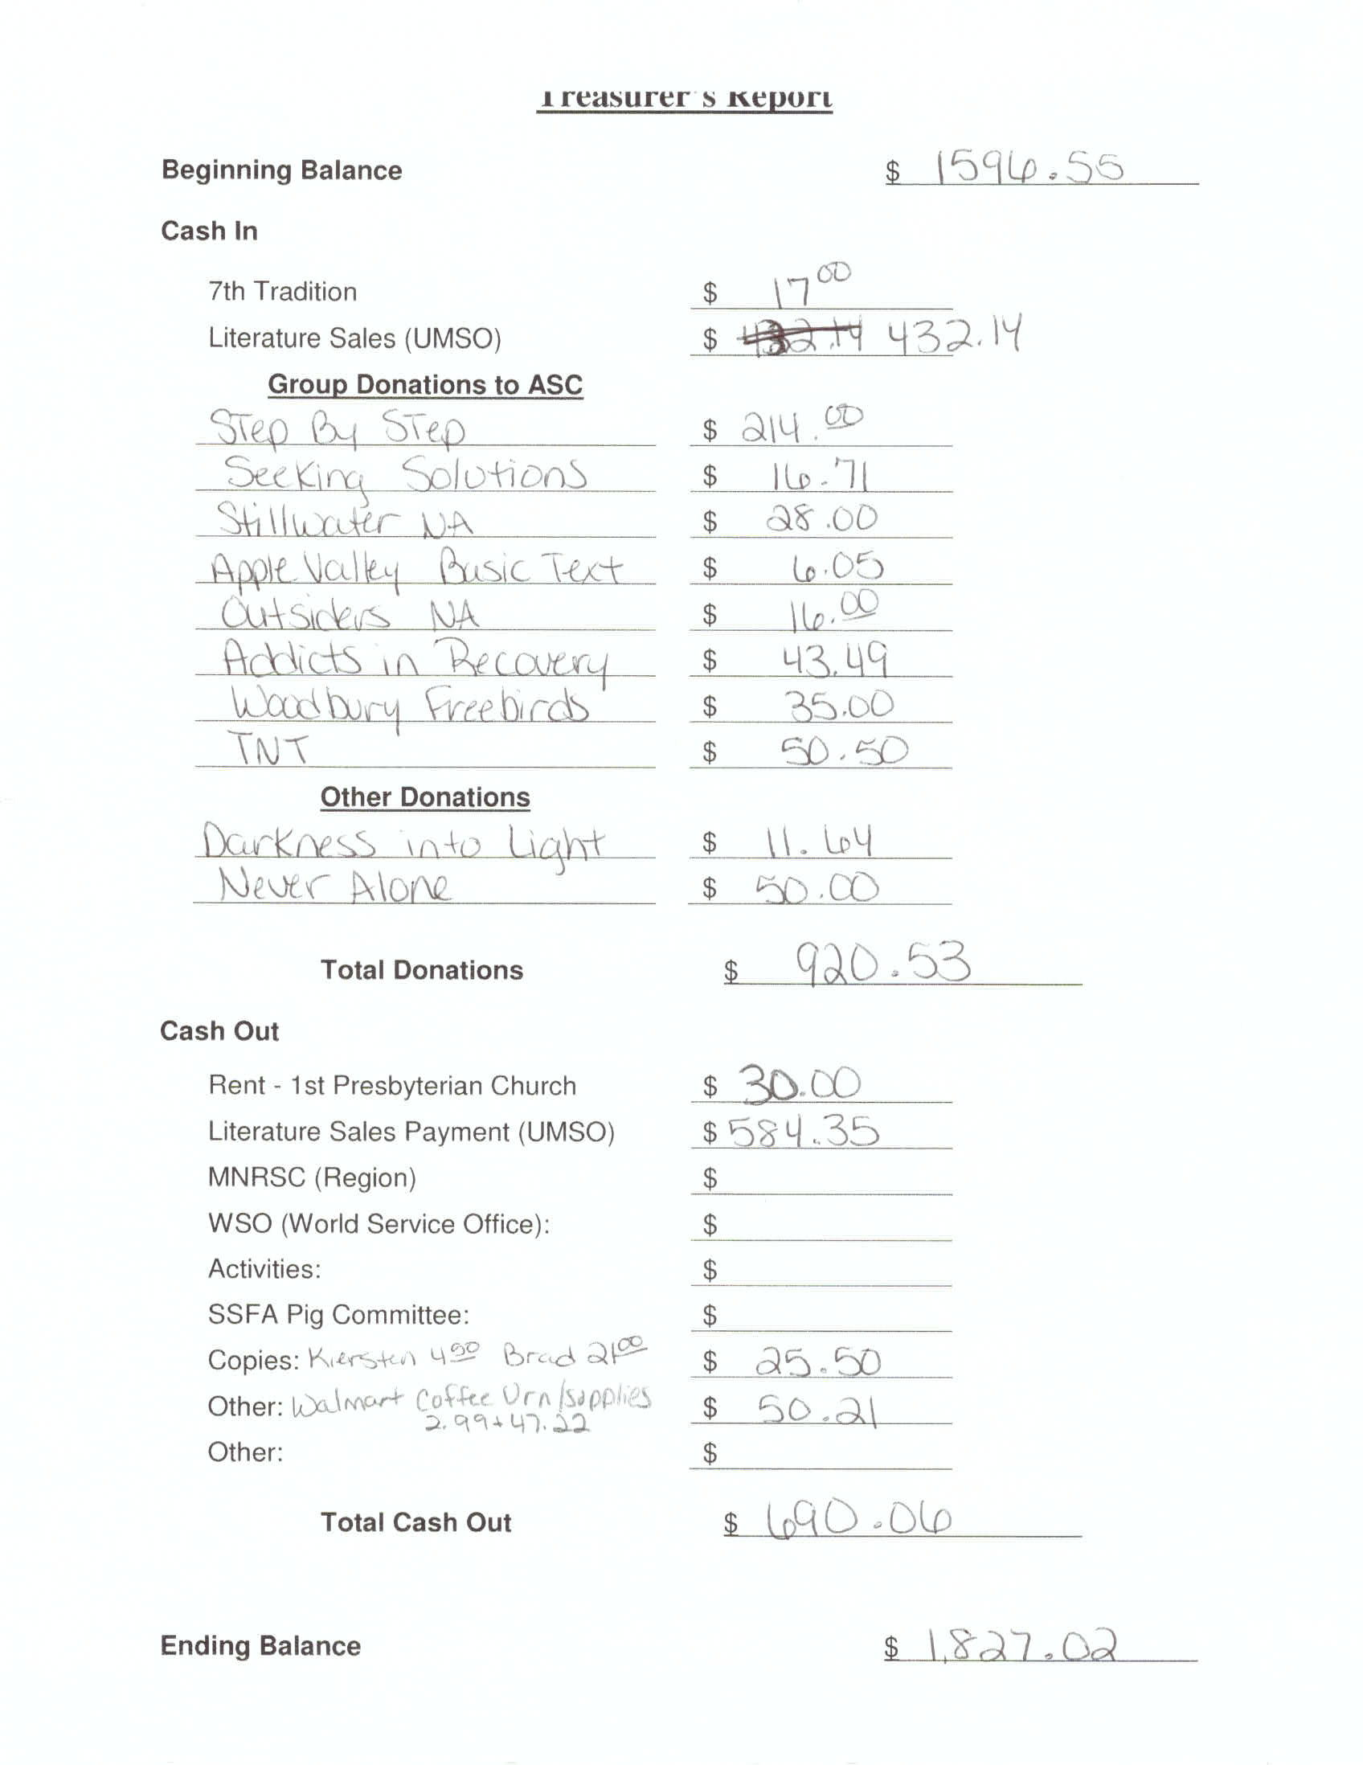
Literature Sales
