
Area Service Committee Meeting Minutes
December 7, 2017

Meeting opened at 7:00 PM by Area Chair Brad S.

Introductions: 23 members in attendance, with 1 newcomer.

Readings: 12 Steps read by Tom; 12 Traditions read by John W.; 12 Concepts read by Garrett

Call for quorum: 13 voting members present (minimum for quorum is 7). With 13 voting members present, motions require 8 votes to pass (per bylaws “A motion or nomination requires support of two-thirds (66%) of the quorum in order to be accepted.”)

Approval of Minutes: Motion made by Tim, seconded by John W. to approve the minutes of the September ASC meeting;
Vote: Support – 11, Opposed – 0, Abstentions – 2, passed.

7th Tradition: Collected (see Treasurer’s Report, p. 6)

Subcommittee Reports
Meetings for the Activities, Hospitals & Institutions, Outreach, and Public Relations Subcommittees are held at 7:00pm on the 2nd Thursday of each month at Faith Methodist Church, 1530 Oakdale Ave., West St. Paul, MN.

Vice-Chair:
(Chair: Open)

Regional Committee Member (RCM):
(Chair: Anne R. – no report)
- Was unable to make it to the meeting on 11/11/2017.

Activities:
(Chair: Dannielle W. – reported)
- Upcoming Winter Wonderland
- Looking for activity ideas

Public Relations:
(Chair: Catie O. – No Report)

Hospitals & Institutions:
(Chair: James M. reported)
- 4 Scheduled monthly commitments
- Received 20 intro guides to donate to Dakota County Drug Court
- In need of (2) panel leaders
  - 4th Tuesday of each month – 8pm at Cochran Recovery Center
  - 4th Thursday of each month – 7pm at Dakota County Detox

Current H&I commitments:
Every Saturday: Dakota Co. Jail (Hastings) 1:00pm
(no more volunteers needed at this time due to background check)
Contact: Jason C. 612-353-7958
2nd Saturday of every month: Cochran Recovery Program (Hastings) 2:00pm
Contact: Kierstin K. 651-347-7032
4th Tuesday of every month: Cochran Recovery Program (Hastings) 8:00pm
Contact: Todd V. 651-285-1789
4th Thursday of every month: Dakota County Detox. (Hastings) 7:00pm
Contact: Rachel M. 612-384-4695

Webmaster:
(Melissa M – Reported)
- Working with Jeff S. through the region to identify goals and objectives as the SSFASC Webmaster. Also discussed what parts of the website have been used in the past and what might need to be updated.
- Region has requested feedback from our area concerning what changes, if any, we would like to see on the website. A hand out was provided with a list of questions for each GSR to bring to each meeting for their opinions

Treasurer:
(Chair: Erica D. reported) [See Treasurer report, p. 6 ]
- Opening balance is $822.43

Outreach:
(Chair: Marissa reported)
- Meeting of the month
  - December 20th Stillwater – Stillwater NA
- January 19th NA Day – S. St. Paul

PIG:
(Chair: Amber M-D reported) [See Financial report, pp. 9 ]
- Financially Stable – balance of $4,288.40
- New Co-Chair: Brad S
- New Dinner Coordinator: Dan K
- Danielle W won both the PIG slogan and logo thus 2 free PIG registrations

Literature:
(Chair – Kiersten Not Present). [Literature Order report not available this month]
- Please e-mail orders ahead of time if possible, address is ssfalit@gmail.com

Group Concerns & Announcements

[Note: written GSR reports are now at the end of the ASC minutes.]

- Woodbury Freebirds
  - Need male sponsors
- No Name NA
  - Need insurance for group
  - Struggling. Need attendance
  - Not all meeting lists have been updated yet. Specifically the Metro and SSFA lists in the SSFA website link
- From Darkness Into Light
  - Meeting lists still not updated online
  - Need proof of liability insurance
- Peace of Mind NA –
  - Needs male and female sponsor

Open Forum

- Adam: Thanksgiving meeting went well! Thanks! 7th tradition was donated to the church.

Elections
- Co Chair:
  - Lizze K. is interested in the position
  - Danielle W. nominated – Tom. seconded
    - Vote: Support – 11, Opposed – 0, Abstentions – 0, Passed.
- Co Pig Chair:
  - Brad S is interested in the position.
    - Vote: Support – 14, Opposed – 0, Abstentions – 0, Passed.

Current Positions - GSRs, please announce open positions at your meetings.
Officers/Committees | Chair | Elected | Co-Chair | Elected
Area Chair (2 Yrs, 1 Yr) | Brad S.(2) | 10/2017 | Lizze K. | 12/2017
Secretary (2 Yrs, 1 Yr) | Eric B. | 8/2017 | --open--
Treasurer (3 Yrs, 2 Yrs) | Erica D. | 2/2017 | --open--
RCM (2 Yrs, 1 Yr) | Anne R. | 10/2017 | Andrew S | 10/2017
Literature (3 Yrs, 2 Yrs) | Kierstin K. | 9/2016 | Gina C. | 4/2017
Activities (2 Yrs, 1 Yr) | Dannielle W. | 11/2017 | --open--
Hospitals & Institutions (2 Yrs, 1 Yr) | James M. | 3/2017 | Mike S. | 4/2017
Outreach (1 Yr, 6 Mo) | Marissa M. | 9/2017 | --open--
Public Relations (2 Yrs, 1 Yr) | Catie O. | 10/2017 | --open--
Webmaster (1 Yr) | Melissa M. | 11/2017 | NA
PIG (2 Yrs, 1 Yr) | Amber M-D | 10/2017 | Brad S. | 12/2017
PIG Treasurer (3 Yrs, 2 Yrs) | Tim N. | 10/2017 | --open--
PIG Merchandise Chair (2 Yrs, 1 Yr) | --open-- |  | --open--
PIG Gate Chair (2 Yrs, 1 Yr) | Steely W. | 10/2017 | --open--
PIG Secretary (6 Mo) | --open-- |  | NA
PIG Food Chair (1 Yr) | --open-- |  | NA
PIG Dinner Coordinator (6 Mo) | --open-- |  | NA
PIG Adult Activities (6 Mo) | --open-- |  | NA
PIG Children Activities (6 Mo) | --open-- |  | NA
PIG Volunteer Coordinator (6 Mo) | --open-- |  | NA
(2) Denotes election is to a second consecutive term in the same position.

Old Business
- Pig bylaw voting
  - Vote: Support – 10, Opposed – 2, Abstentions – 1, Passed.

New Business
- None

Motions
- No Motions
Motion to close made by Tim N., seconded by the group.; meeting closed with the Gratitude Statement at 8:20 pm.

Treasurer’s Report

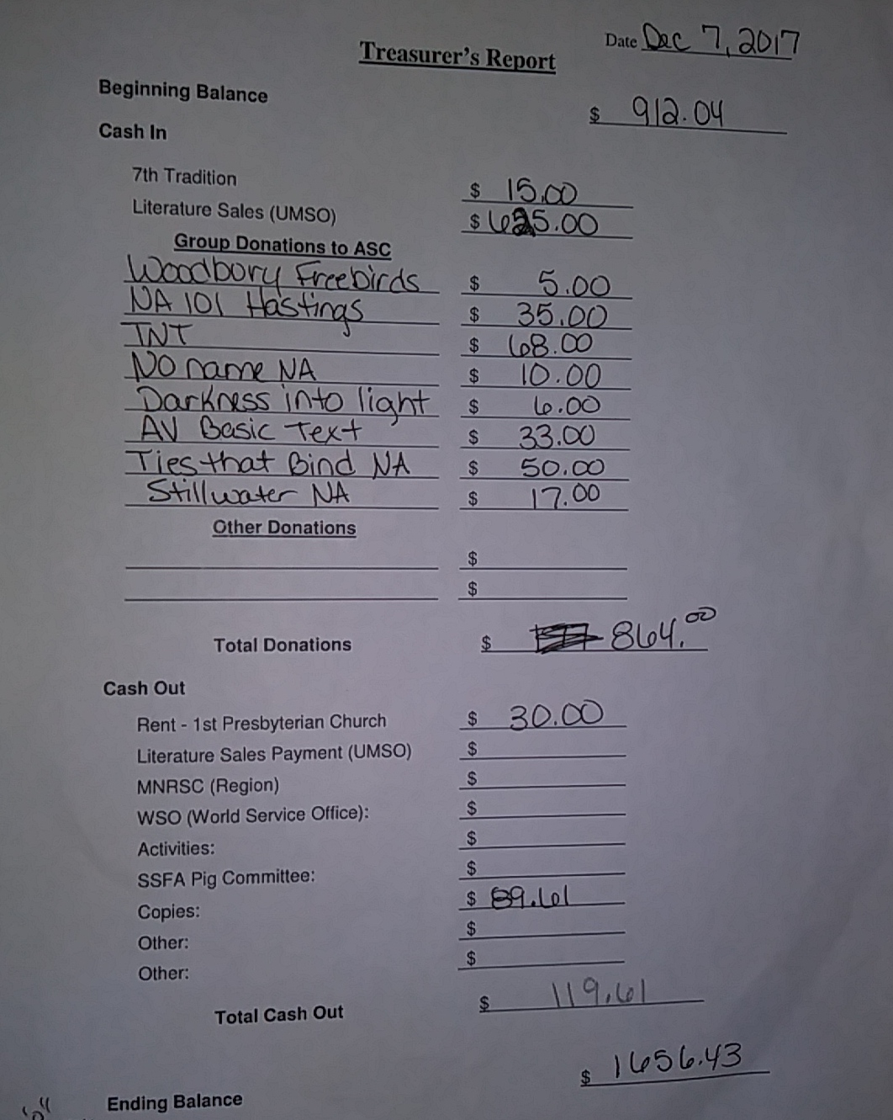

GSR Reports

Woodbury Freebirds |  | 6:00pm Sunday
GSR(A): Garrett L. |  | Status: Stable
Avg. Attendance | 12 |  | Avg. Newcomers | 3
ASC Donation |  | $5
H&I Activities |  | Announced
Scheduled Activities
Other

Step by Step |  | 7:00pm Sunday
GSR: Rob R |  | Status:Stable
Avg. Attendance | 12 |  | Avg. Newcomers | 1
ASC Donation
H&I Activities |  | Announced
Scheduled Activities
Other

Never Alone |  | 7:00pm Sunday
GSR: Nicole M. |  | Status: Stable
Avg. Attendance | 20-30 |  | Avg. Newcomers | 3-5
ASC Donation
H&I Activities |  | Announced
Scheduled Activities
Other

Ties That Bind Us |  | 7:00pm Monday
GSR: Eric B. |  | Status: Stable
Avg. Attendance | 14 |  | Avg. Newcomers | 1
ASC Donation
H&I Activities |  | Announced
Scheduled Activities
Other

Seeking Solutions |  | 7:00pm Monday
GSR: Not Present |  | Status:
Avg. Attendance |  |  | Avg. Newcomers
ASC Donation
H&I Activities
Scheduled Activities
Other

Monday Night Round Robin |  | 7:00pm Monday
GSR: Jason M |  | Status: Stable
Avg. Attendance | 12 |  | Avg. Newcomers | 1
ASC Donation
H&I Activities |  | Announced
Scheduled Activities
Other

Addicts in Recovery |  | 7:00pm Tuesday
GSR: Amber M-D |  | Status: Stable
Avg. Attendance | 25-30 |  | Avg. Newcomers | 3-5
ASC Donation
H&I Activities |  | Announced
Scheduled Activities |  | Potluck/Speaker mtg 5th Tues.
Other

TNT: Tues. Nights Together |  | 7:00pm Tuesday
GSR: Not Present |  | Status:
Avg. Attendance |  |  | Avg. Newcomers
ASC Donation
H&I Activities
Scheduled Activities
Other

Midweek NA |  | 7:00pm Wednesday
GSR: OPEN |  | Status: Stable
Avg. Attendance | 10 |  | Avg. Newcomers | 2
ASC Donation
H&I Activities |  | Announced
Scheduled Activities
Other

Stillwater NA |  | 7:30pm Wednesday
GSR: Grant S. |  | Status: Stable
Avg. Attendance | 22-25 |  | Avg. Newcomers | 4-5
ASC Donation |  | $17
H&I Activities |  | Announced
Scheduled Activities
Other

Serenity Sisters |  | 7:00pm Tuesday
GSR: Anne R : |  | Status: Stable
Avg. Attendance | 15 |  | Avg. Newcomers | 2
ASC Donation
H&I Activities |  | Announced
Scheduled Activities
Other

No Name NA |  | 7:00pm Thursday
GSR: Andrew S |  | Status: Stable
Avg. Attendance | 11 |  | Avg. Newcomers | 0
ASC Donation |  | $10
H&I Activities |  | Announced
Scheduled Activities
Other

GSR Reports (continued)

Gaylord Serenity Seekers |  | 7:30pm Thursday
GSR: NOT PRESENT |  | Status:
Avg. Attendance |  |  | Avg. Newcomers
ASC Donation
H&I Activities
Scheduled Activities
Other
NA 101 |  | 7:00pm Saturday
GSR: John M. |  | Status: Stable
Avg. Attendance | 12 |  | Avg. Newcomers | 1
ASC Donation |  | $35
H&I Activities
Scheduled Activities
Other

Peace of Mind |  | 7:30pm Friday
GSR: Tim N. |  | Status: Stable
Avg. Attendance | 20 |  | Avg. Newcomers | 5
ASC Donation
H&I Activities |  | Announced
Scheduled Activities
Other
Apple Valley Basic Text Study |  | 9:00pm Saturday
GSR: Hope |  | Status: Stable
Avg. Attendance | 12-15 |  | Avg. Newcomers | 1
ASC Donation |  | $33
H&I Activities |  | Announced
Scheduled Activities
Other

NA Day |  | 7:30pm Friday
GSR: Dannielle W. |  | Status: Stable
Avg. Attendance | 20-25 |  | Avg. Newcomers | 0-3
ASC Donation
H&I Activities |  | Announced
Scheduled Activities |  | Chili Feed March 17th
Other
Friday Night Outsiders NA |  | 8:00pm Friday
GSR: Tom J |  | Status: Stable
Avg. Attendance | 10-14 |  | Avg. Newcomers | 2
ASC Donation
H&I Activities |  | Announced
Scheduled Activities
Other

From Darkness Into Light NA |  | 6:30pm Saturday
GSR: Marissa M. |  | Status: Stable
Avg. Attendance | 11 |  | Avg. Newcomers | 1
ASC Donation |  | $6
H&I Activities
Scheduled Activities
Other

Pig Monthly Treasury Report

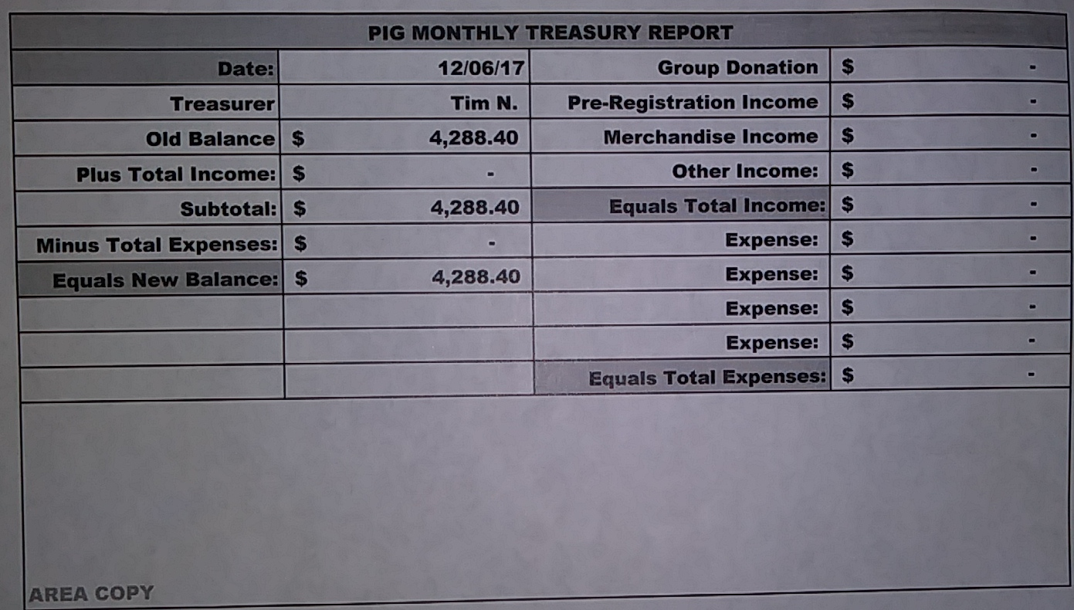

South Suburban Fireside Area Subcommittee Meeting Minutes
11/9/2017

Meeting opened at 7:00 pm with Serenity Prayer by Lizze K. with 6 addicts in attendance.
Steve read the 12 Concepts of NA service.
Collected 7th tradition of $12, which was given to the church as rent.

Hospitals and Institutions Subcommittee

H&I Dos and Don'ts read by: James

Literature Report:

Panel leader reports:
Dakota Co. Jail (Saturdays): James
Looking for 2 J.F.T. books

Detox (4th Thursday): James.
Looking for panel leader. Went Thanksgiving day. 4 panel members and lots of clients

Cochran Recovery Center (2nd Saturday): Not Present

Cochran Recovery Center (4th Tuesday): Open – James reported
Looking for panel leader. Last month went well. 5 panel members. Client participation was 5 or 6

Other H&I business:
James – In need of panel leaders. Adam is interested in a commitment. Dakota county Jail is looking for (2) JFT books. The 20 Intro guides for drug court were delivered. H&I Policy Guidelines draft has been put together and handed out for review.

James nominated Steve for Detox – 4th Tuesday – Lizze K seconded
  - Vote: Support – 5, Opposed – 0, Abstentions – 1, Passed.

James nominated Lizze K. for 4th Tuesday Cochran – Eric B seconded
  - Vote: Support – 6, Opposed – 0, Abstentions – 0, Passed.

Steve made a motion to approve JFT books to come from $50 budget – Melissa M seconded
  - Vote: Support – 6, Opposed – 0, Abstentions – 0, Passed.

Outreach Subcommittee (James)
Meeting of the month:
December 20th – Stillwater NA
January 19th – NA Day
February 19th – Seeking Solutions

Activities Subcommittee (Not Present)

Public Relations Subcommittee (Not Present)

Webmaster (Melissa M.)
Nothing to report

Other Business

Meeting closed at 7:28

South Suburban Fireside Area Subcommittee Meeting Agenda
Opening
Introductions
Approval of minutes
Reading of 12 Concepts of NA Service
7th Tradition
Hospitals and Institutions Subcommittee
H&I Introduction/Dos and Don’ts
Literature Report
Panel Leader Reports
Dakota Co. Jail
Dakota Co. Detox
Cochran Recovery Center (Saturday)
Cochran Recovery Center (Tuesday)
Other H&I items
Outreach Subcommittee
Activities Subcommittee
Public Relations Subcommittee
Other old/new business

Adjournment

