
Area Service Committee Meeting Minutes
July 6, 2017

Meeting opened at 7:00 PM by Area Chair Brad S.

Introductions: 22 members in attendance, with 1 newcomer.

Readings: 12 Steps read by Tim N.; 12 Traditions read by John M.; 12 Concepts read by Amber M-D.

Call for quorum: 13 voting members present (minimum for quorum is 7). With 13 voting members present, motions require 8 votes to pass (per bylaws “A motion or nomination requires support of two-thirds (66%) of the quorum in order to be accepted.”)

Approval of Minutes: Motion made by Rachel M., seconded by John M. to approve the minutes of the July ASC meeting;
Vote: Support – 11, Opposed – 0, Abstentions – 1, passed.

7th Tradition: Collected (see Treasurer’s Report, p. 5)

Subcommittee Reports
Meetings for the Activities, Hospitals & Institutions, Outreach, and Public Relations Subcommittees are held at 7:00pm on the 2nd Thursday of each month at Faith Methodist Church, 1530 Oakdale Ave., West St. Paul, MN.

Vice-Chair:
(Rachel – reported)
- Potential BBQ with speakers soon
- Need more attendance

Regional Committee Member (RCM):
(open – no report)
- Please announce at your meetings this position is open and only needs meets four times a year.

Activities:
(open – no report)
- Please announce at your meetings this position is open and our area would really like to have some scheduled activities for addicts to enjoy and learn how to have fun in recovery.

Public Relations:
(Chair: Amber M-D. reported)
- NA Helpline Flyer Competition is over and the winner for the month of July is No Name NA.
- The meeting that won the competition by submitting the most flyers is Never Alone NA.
- Please continue to post the flyers instead of just tossing them or recycling them.
- In need of PR Co-Chair

Hospitals & Institutions:
(Chair: James M. reported)
- Currently have flyers to distribute, will the area need more flyers?
- Meeting of the Month: August 15 Addicts in Recovery in Apple Valley & September 19 TNT in Farmington

Current H&I commitments:
Every Saturday: Dakota Co. Jail (Hastings) 1:00pm
(no more volunteers needed at this time due to background check)
Contact: Jason C. 612-353-7958
2nd Saturday of every month: Cochran Recovery Program (Hastings) 2:00pm
Contact: Kierstin K. 651-347-7032
4th Tuesday of every month: Cochran Recovery Program (Hastings) 8:00pm
Contact: Todd V. 651-285-1789
4th Thursday of every month: Dakota County Detox. (Hastings) 7:00pm
Contact: Rachel M. 612-384-4695

Webmaster:
(open – no report)
- Please announce at your meetings this position is open and only needs someone to update the website with our upcoming events, trusted servant position changes, and any other area news.

Treasurer:
(Chair: Erica D. reported) [See Treasurer report, p. 5]
- Opening balance is $2096.62
- Will be writing a check for literature of approximately $1100 - $1200 due to no receipt last month
- A lot of donations have been dropped off

Outreach:
(open – no report)
- Please announce at your meetings this position is open and needs someone to reach out to our local meetings to see if they need assistance from our Area.

PIG:
(Chair: Melissa C. reported) [See Financial report, pp. 8-9]
- PIG weekend was a huge success due to the support of this area, surrounding areas, the PIG Committee, and our Higher Power
- There was a total of 392 people thru the gate and 90 campsites rented
- The committee voted to donate $2000.00 to the area, along with the leftover coffee & creamer.
- New committee members will be voted in at the next meeting on September 7th

Literature:
(Chair – Gina C. reported). [See Literature Order report, pp. 8-9]
- Lots of extra money donated this month
- Please e-mail orders ahead of time if possible, address is ssfalit@gmail.com

Group Concerns & Announcements

[Note: written GSR reports are now at the end of the ASC minutes.]

- Seeking Solutions (Monday) – Needs sponsors & attendance support from more experienced members
- Peace of Mind (Friday) – Needs sponsors
- NA 101 (Saturday) – Needs more support

Open Forum

- Suggestion that a donation be made to the UMSO. Treasurer stated that we gave to $500 in March of this year. There is a WSO financial report that states 43% of donations go to WSO employee salaries. Chair suggests we keep the money local to help support our local addicts. There was an email that came to the SSFA email from Region about a local drug court requesting literature. H&I Chair suggested that the drug court request be discussed further at the subcommittee meeting.

- Gina shared that they need volunteers to help with literature

- Rachel M.: Suggested we have a coffee maker sign-up sheet for area meetings since her physical limitations restrict her from completing the task every month

- Amber M-D: Addicts in Recovery need help financially, their former treasurer has not been present at the meetings, and the $40 that was collected along with the prudent reserve is missing as well. Rent was able to be paid but Basic Texts & white key tags are needed. It was suggested that Amber put together a literature order form in case her motion gets approved.

- Melissa C.: Stated that she will no longer attend the Area meeting so there is a need for someone to fulfill the Secretary duties.

- All Prior Lake meetings will be moving after August 31st.

Elections
- Eric . nominated Kaitee L. as SSFA Secretary; nomination seconded by Steely W. Kaitee has willingness and accepted the nomination.
Vote: Support - 12, Opposed - 0, Abstentions – 0; nomination accepted.

Current Positions - GSRs, please announce open positions at your meetings.
Officers/Committees | Chair | Elected | Co-Chair | Elected
Area Chair (2 Yrs, 1 Yr) | Brad S. | 9/2016 | Rachel M. | 4/2017
Secretary (2 Yrs, 1 Yr) | Kaitee L. | 8/2017 | --open--
Treasurer (3 Yrs, 2 Yrs) | Erica D. | 2/2017 | --open--
RCM (2 Yrs, 1 Yr) | --open-- |  | --open--
Literature (3 Yrs, 2 Yrs) | Kierstin K. | 9/2016 | Gina C. | 4/2017
Activities (2 Yrs, 1 Yr) | --open-- |  | --open--
Hospitals & Institutions (2 Yrs, 1 Yr) | James M. | 3/2017 | Mike S. | 4/2017
Outreach (1 Yr, 6 Mo) | --open-- |  | --open--
Public Relations (2 Yrs, 1 Yr) | Amber M-D. | 3/2017 | --open--
Webmaster (1 Yr) | --open-- |  | NA
PIG (2 Yrs, 1 Yr) | Melissa C. | 9/2016 | Amber M-D. | 5/2017
PIG Treasurer (3 Yrs, 2 Yrs) | Todd V. | 9/2016 | Tim N. | 11/2016
PIG Merchandise Chair (2 Yrs, 1 Yr) | Steve H. (2) | 12/2016 | --open--
PIG Gate Chair (2 Yrs, 1 Yr) | Matt K. | 9/2016 | Steely W. | 4/2017
PIG Secretary (6 Mo) | Kris B. | 9/2016 | NA
PIG Food Chair (1 Yr) | Mary M. | 9/2016 | NA
PIG Dinner Coordinator (6 Mo) | Dina D. | 5/2017 | NA
PIG Adult Activities (6 Mo) | Leo J. | 7/2017 | NA
PIG Children Activities (6 Mo) | Rob R. | 2/2017 | NA
PIG Volunteer Coordinator (6 Mo) | --open-- |  | NA
(2) Denotes election is to a second consecutive term in the same position.

Old Business
- Noted that Mike is still working on this. Final decision that was made is that H&I will contact the UMSO to set up a separate charge account for their purchases, instead of depleting the Literature Chair supplies at ASC meeting. Mike S. (H&I Co-Chair) will purchase directly from the UMSO, since he works near the UMSO.

New Business
- Brad suggested we should make a donation due to the large amount of prudent reserve we currently have. Erica will contact the UMSO to find out what our current bill is since we were not able to locate one with the literature that was delivered. It was decided to hold off on making a donation until the Area is current with our bill at the UMSO.

Motions
- Motion Title: Subcommittee Meeting
Author: was James M., seconded by Tim N.
Motion to: Move the upcoming meeting on the 13th to the 20th of July
Intent: Low attendance on the 13th potentially, more participation on the 20th.

Discussion: Discussed during Open Forum (see above notes). This was thought to be a good idea with the exception that new members would not know it moved. It was suggested we post a sign stating the meeting was moved, either to a different location (if the church is not available) and date (on the 20th).
Financial impact: None
Vote: Support – 8, Opposed – 0, Abstentions – 4, motion passed.

Motion to close made by Tim N., seconded by Amber M-d.; meeting closed with the Gratitude Statement at 8:27 pm.

Treasurer’s Report


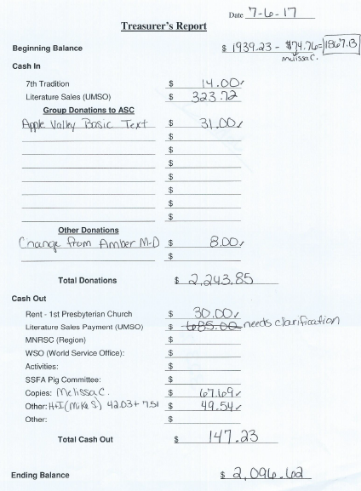

GSR Reports

Woodbury Freebirds |  | 6:00pm Sunday
GSR: NOT PRESENT |  | Status:
Avg. Attendance |  |  | Avg. Newcomers
ASC Donation
H&I Activities
Scheduled Activities
Other

Step by Step |  | 7:00pm Sunday
GSR: NOT PRESENT |  | Status:
Avg. Attendance |  |  | Avg. Newcomers
ASC Donation
H&I Activities
Scheduled Activities
Other

Never Alone |  | 7:00pm Sunday
GSR: Nicole M. |  | Status: Stable
Avg. Attendance | 20 – 30 |  | Avg. Newcomers | 2 – 5
ASC Donation
H&I Activities |  | Announced
Scheduled Activities |  | Announced
Other

Ties That Bind Us |  | 7:00pm Monday
GSR: Eric B. |  | Status: Stable
Avg. Attendance | 15 |  | Avg. Newcomers | 1.5
ASC Donation
H&I Activities
Scheduled Activities |  | 1st & 3rd mtg by the river
Other

Seeking Solutions |  | 7:00pm Monday
GSR: Rachel M. |  | Status: Stable
Avg. Attendance | 10 – 15 |  | Avg. Newcomers | 1 – 2
ASC Donation
H&I Activities |  | Announced
Scheduled Activities
Other |  | Announced flyer competition

Monday Night Round Robin |  | 7:00pm Monday
GSR: NOT PRESENT |  | Status:
Avg. Attendance |  |  | Avg. Newcomers
ASC Donation
H&I Activities
Scheduled Activities
Other

Addicts in Recovery |  | 7:00pm Tuesday
GSR: Amber M-D |  | Status: Stable
Avg. Attendance | 20 – 35 |  | Avg. Newcomers | 2 – 5
ASC Donation
H&I Activities |  | Announced
Scheduled Activities |  | Every 5th Tuesday Potluck
Other

TNT: Tues. Nights Together |  | 7:00pm Tuesday
GSR: OPEN |  | Status: Stable
Avg. Attendance | 15 |  | Avg. Newcomers | 1
ASC Donation
H&I Activities |  | Announced
Scheduled Activities
Other

Tuesday Night Serenity |  | 7:00pm Tuesday
GSR: NOT PRESENT : |  | Status:
Avg. Attendance |  |  | Avg. Newcomers
ASC Donation
H&I Activities
Scheduled Activities
Other

Midweek NA |  | 7:00pm Wednesday
GSR: OPEN |  | Status: Stable
Avg. Attendance | 21 |  | Avg. Newcomers | 2
ASC Donation
H&I Activities |  | Announced
Scheduled Activities |  | Announced
Other |  | PIG Donation $24.00

Rock Solid NA |  | 7:00pm Wednesday
GSR: NOT PRESENT : |  | Status:
Avg. Attendance |  |  | Avg. Newcomers
ASC Donation
H&I Activities
Scheduled Activities
Other

Stillwater NA |  | 7:30pm Wednesday
GSR: Grant |  | Status: Stable
Avg. Attendance | 24 – 27 |  | Avg. Newcomers | 4 – 5
ASC Donation
H&I Activities |  | Announced
Scheduled Activities |  | None
Other

GSR Reports (continued)

Serenity Sisters |  | 7:00pm Thursday
GSR: Anne R. |  | Status: Stable
Avg. Attendance | 15 |  | Avg. Newcomers | 2 – 3
ASC Donation
H&I Activities |  | Announced
Scheduled Activities
Other

No Name NA |  | 7:00pm Thursday
GSR: Mike M. |  | Status: Stable
Avg. Attendance | 19 – 20 |  | Avg. Newcomers | 2
ASC Donation
H&I Activities |  | Announced
Scheduled Activities |  | None
Other |  | None

Gaylord Serenity Seekers |  | 7:30pm Thursday
GSR: NOT PRESENT |  | Status:
Avg. Attendance |  |  | Avg. Newcomers
ASC Donation
H&I Activities
Scheduled Activities
Other

Peace of Mind |  | 7:30pm Friday
GSR: Tim N. |  | Status: Stable
Avg. Attendance | 30 |  | Avg. Newcomers | 3
ASC Donation
H&I Activities |  | Announced
Scheduled Activities |  | Announced
Other

NA Day |  | 7:30pm Friday
GSR: NOT PRESENT |  | Status:
Avg. Attendance |  |  | Avg. Newcomers
ASC Donation
H&I Activities
Scheduled Activities
Other
Friday Night Outsiders NA |  | 8:00pm Friday
GSR: NOT PRESENT |  | Status:
Avg. Attendance |  |  | Avg. Newcomers
ASC Donation
H&I Activities
Scheduled Activities
Other

From Darkness Into Light NA |  | 6:30pm Saturday
GSR: Marissa M. |  | Status: Stable
Avg. Attendance | 20 – 25 |  | Avg. Newcomers | 2
ASC Donation
H&I Activities |  | None
Scheduled Activities |  | None
Other |  | Did not like the coin vote

NA 101 |  | 7:00pm Saturday
GSR: John M. |  | Status: Stable
Avg. Attendance | 8 |  | Avg. Newcomers | 1
ASC Donation
H&I Activities
Scheduled Activities
Other

Apple Valley Basic Text Study |  | 9:00pm Saturday
GSR: Dan K. |  | Status: Stable
Avg. Attendance | 15 |  | Avg. Newcomers | 2
ASC Donation |  | $31.00
H&I Activities
Scheduled Activities
Other

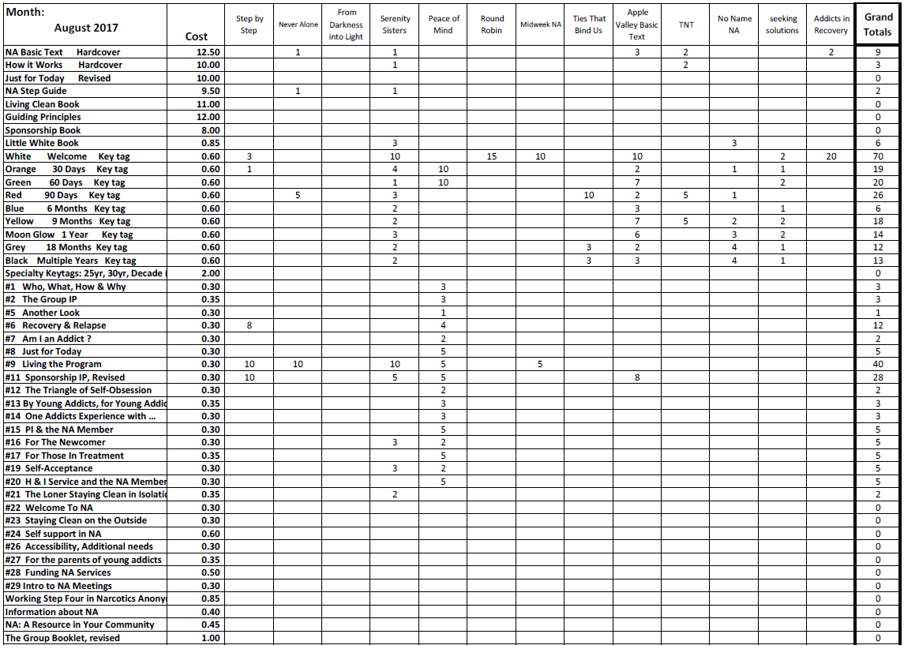
Literature Sales Report

Literature Sales Report (continued)
