
Area Service Committee Meeting Minutes
April 6, 2017

Meeting opened at 7:10 PM by Area Chair Brad S.

Introductions: 19 members in attendance, with no newcomers.

Readings: 12 Steps read by John M.; 12 Traditions read by Amber M-D.; 12 Concepts read by Rachel M.

Call for quorum: 12 voting members present (minimum for quorum is 7). With 12 voting members present, motions require 7 votes to pass.

Approval of Minutes: Approval of the minutes was tabled due to copies not being available at the ASC meeting. March minutes were emailed, but not mailed out.

7th Tradition: Collected (see Treasurer’s Report, p. 4).

Subcommittee Reports
Meetings for the Activities, Hospitals & Institutions, Outreach, and Public Relations Subcommittees are held at 7:00pm on the 2nd Thursday of each month at Faith Methodist Church, 1530 Oakdale Ave., West St. Paul, MN.

Vice-Chair: (open – no report)

Region: (RCM: open – no report)

Activities: (open – no report)

Public Relations: (Chair: Amber M-D. reported)
- There will be a friendly competition between the groups within the three areas (Twin Cities Area, Area of Hope, & South Suburban Area) to see which group can post and/or distribute the most NA Hotline flyers. There will be three free registrations to MNNAC given away to the group that produces the most interest or support to the hotline. There will be more information to come as this develops.
- She was able to obtain PR Handbook from the file cabinet.

Hospitals & Institutions: (Chair: James M. reported)
- The signup sheets generated 56 willing participants to go to commitments. The names will be combined into one spreadsheet and given to each panel leader to use when fulfilling our obligations. Thank you ALL for your willingness and please have patience if you are not called right away, you will be called eventually.
- Meeting of the Month for May is Seeking Solutions
- Current H&I commitments:
Every Saturday: Dakota Co. Jail (Hastings) 1:00pm
(no more volunteers needed at this time due to background check)
Contact: Jason C. 612-353-7958
2nd Saturday of every month: Cochran Recovery Program (Hastings) 2:00pm
Contact: Kierstin K. 651-347-7032
4th Tuesday of every month: Cochran Recovery Program (Hastings) 8:00pm
Contact: Todd V. 651-285-1789
4th Thursday of every month: Dakota County Detox. (Hastings) 7:00pm
Contact: Rachel M. 612-384-4695

Webmaster: (open – no report)

Treasurer: (Chair: Erica D. reported) [See Treasurer report, p. 4.]
- Opening balance is $1318.36
- Balanced the checkbook and the account was over by $0.11.
- Steve still has the check for the bus passes, the area might want to consider reissuing a new check.
- The UMSO was very appreciative of our donation to the Service Office, the wanted to pass along a big THANK YOU to all of the groups who voted to support them.

Outreach: (open – no report)

PIG: (Chair: Melissa C. reported)
- Newcomer key tags continue to visit SSF Area meetings
- Merchandise and preregistrations were sold at the following events: Valentines Dance, Chili Feed, MNNAC, & Spring Thaw
- This year the committee has voted to change the format of the workshops
- The PIG committee voted in Steely as the Gate Co-chair, he still needs the ASC passing vote.
- We are accepting recovery related raffle items – give them to anyone on the PIG committee or bring them to the PIG meeting or Area.
- Open positions:

  - Co-Chair
  - Merchandise Co-Chair
  - Dinner Chair
  - Adult Activities Chair
  - Volunteer Coordinator

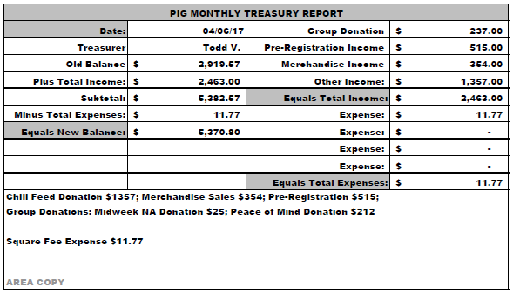

Literature: (Chair – Kierstin K. reported). [See Literature Order report, pp. 7-8.]
- We are in need of a literature Co-Chair.
- Spent $400 on supplies to replenish stock, gave invoice to treasurer.
- Please e-mail orders ahead of time if possible, address is ssfalit@gmail.com

Ad Hoc: (Chair – Brad S. reported)
- Will have by-law revisions out soon, hopefully

Group Concerns & Announcements

[Note: written GSR reports are now at the end of the ASC minutes.]

- Seeking Solutions – Needs support, attendance is low.
- NA 101 – Need more addicts

Open Forum

- Mike S. – Bags supplied to literature were from Cub Foods and that could possibly go against our traditions by sending NA literature to the groups in a bag with a logo on it. There was also concern about the bags being unused

Elections

- Kierstin K. nominated Gina C. as Literature Co-Chair; nomination seconded by Rachel M.
Vote: Support - 10, Opposed - 0, Abstentions – 1; nomination accepted.
- Melissa C. nominated Rachel M. as Vice Chair; nomination seconded by Tim N.
Vote: Support - 8, Opposed - 2, Abstentions – 1; nomination accepted.
- James M. nominated Mike S. as H & I Co-Chair; nomination seconded by Amber M-D.
Vote: Support - 10, Opposed - 0, Abstentions – 1; nomination accepted.

Elections

GSRs, please announce open positions at your meetings.
Officers/Committees | Chair | Elected | Co-Chair | Elected
Area Chair (2 Yrs, 1 Yr) | Brad S. | 9/2016 | Rachel M | 4/2017
Secretary (1 Yrs, 1 Yr) | --open-- |  | --open--
Treasurer (3 Yrs, 2 Yrs) | Erica D. | 2/2017 | --open--
RCM (2 Yrs, 1 Yr) | --open-- |  | --open--
Literature (3 Yrs, 2 Yrs) | Kierstin K. | 9/2016 | Gina C. | 4/2017
Activities (2 Yrs, 1 Yr) | --open-- |  | --open--
Hospitals & Institutions (2 Yrs, 1 Yr) | James M. | 3/2017 | Mike S. | 4/2017
Outreach (1 Yr, 6 Mo) | --open-- |  | --open--
Public Relations (2 Yrs, 1 Yr) | Amber M-D | 3/2017 | --open--
Webmaster (1 Yr) | --open-- |  | NA
PIG (2 Yrs, 1 Yr) | Melissa C. | 9/2016 | --open--
PIG Treasurer (3 Yrs, 2 Yrs) | Todd V. | 9/2016 | Tim N. | 11/2016
PIG Merchandise Chair (2 Yrs, 1 Yr) | Steve H. (2) | 12/2016 | --open--
PIG Gate Chair (2 Yrs, 1 Yr) | Matt K. | 9/2016 | Steely (pending) | 4/2017
PIG Secretary | Kris B. | 9/2016 | NA
PIG Food Chair (1 Yr) | Mary M. | 9/2016 | NA
PIG Dinner Coordinator | --open-- |  | NA
PIG Adult Activities | --open-- |  | NA
PIG Children Activities | Rob R. |  | NA
PIG Volunteer Coordinator | --open-- |  | NA
(2) Denotes election is to a second consecutive term in the same position.

Old Business
None.

New Business
None.

Motion to close made by “unknown”, seconded by “unknown”; meeting closed with the Gratitude Statement at unknown time.

Treasurer’s Report

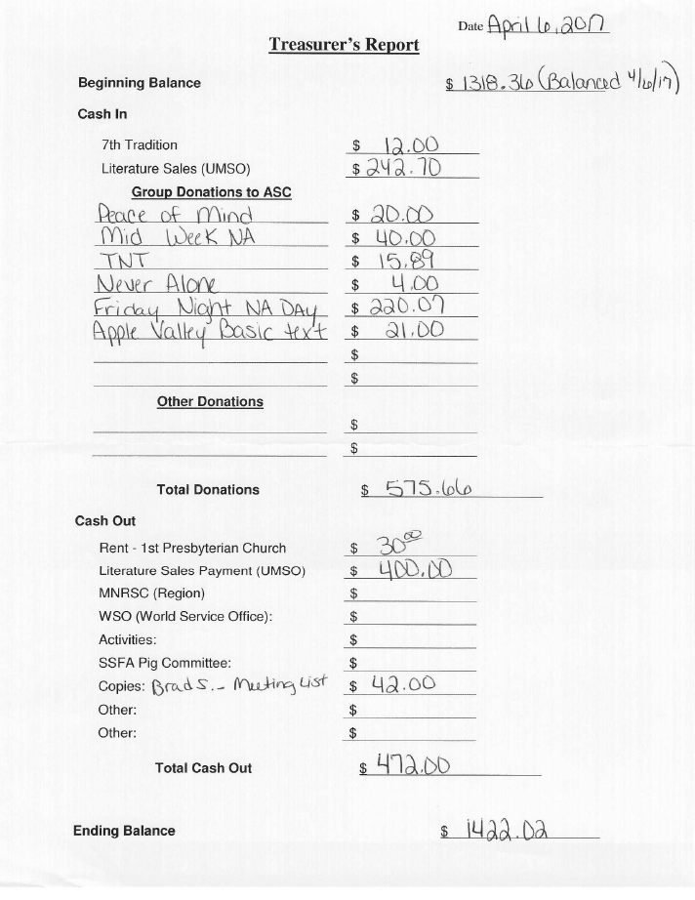

GSR Reports

Woodbury Freebirds |  | 6:00pm Sunday
GSR: NOT PRESENT : |  | Status: Stable
Avg. Attendance |  |  | Avg. Newcomers
ASC Donation
H&I Activities
Scheduled Activities
Other

Step by Step |  | 7:00pm Sunday
GSR: NOT PRESENT |  | Status: Stable
Avg. Attendance |  |  | Avg. Newcomers
ASC Donation
H&I Activities
Scheduled Activities
Other

Never Alone |  | 7:00pm Sunday
GSR: Nicole M. |  | Status: Stable
Avg. Attendance | 20 – 30 |  | Avg. Newcomers | 3 – 5
ASC Donation |  | $4.00
H&I Activities |  | Announced
Scheduled Activities |  | Announced
Other |  | None

Ties That Bind Us |  | 7:00pm Monday
GSR: NOT PRESENT : |  | Status: Stable
Avg. Attendance |  |  | Avg. Newcomers
ASC Donation
H&I Activities
Scheduled Activities
Other

Seeking Solutions |  | 7:00pm Monday
GSR: Rachel M. |  | Status: Stable
Avg. Attendance | 8 – 9 |  | Avg. Newcomers | 1 – 2
ASC Donation
H&I Activities |  | Announced
Scheduled Activities |  | Announced
Other |  | Support – Attendance is low

Monday Night Round Robin |  | 7:00pm Monday
GSR: NOT PRESENT : |  | Status: Stable
Avg. Attendance | 20 – 30 |  | Avg. Newcomers
ASC Donation
H&I Activities
Scheduled Activities
Other

Addicts in Recovery |  | 7:00pm Tuesday
GSR: Amber M-D |  | Status: Stable
Avg. Attendance | 25 – 40 |  | Avg. Newcomers | 3 – 5
ASC Donation
H&I Activities |  | Announced during meeting
Scheduled Activities |  | Every 5th Tuesday Potluck
Other

TNT: Tues. Nights Together |  | 7:00pm Tuesday
GSR: open (James M.) : |  | Status: Stable
Avg. Attendance | 15 |  | Avg. Newcomers | 1
ASC Donation |  | $15.89
H&I Activities |  | Announced
Scheduled Activities
Other

Tuesday Night Serenity |  | 7:00pm Tuesday
GSR: NOT PRESENT : |  | Status: Stable
Avg. Attendance |  |  | Avg. Newcomers
ASC Donation
H&I Activities
Scheduled Activities
Other

Midweek NA |  | 7:00pm Wednesday
GSR: open (Tim M.) |  | Status: Stable
Avg. Attendance | 21 |  | Avg. Newcomers | 3
ASC Donation |  | $40.00
H&I Activities |  | Announced
Scheduled Activities |  | None
Other

Rock Solid NA |  | 7:00pm Wednesday
GSR: NOT PRESENT : |  | Status: Stable
Avg. Attendance |  |  | Avg. Newcomers
ASC Donation
H&I Activities
Scheduled Activities
Other

Stillwater NA |  | 7:00pm Wednesday
GSR: NOT PRESENT : |  | Status: Stable
Avg. Attendance |  |  | Avg. Newcomers
ASC Donation
H&I Activities
Scheduled Activities
Other

GSR Reports (continued)

Serenity Sisters |  | 7:00pm Thursday
GSR: Anne R. |  | Status: Stable
Avg. Attendance | 12 – 15 |  | Avg. Newcomers | 2 – 3
ASC Donation
H&I Activities |  | Announced
Scheduled Activities
Other

No Name NA |  | 7:00pm Thursday
GSR: Gina C. |  | Status: Stable
Avg. Attendance | 20 |  | Avg. Newcomers | 1 – 2
ASC Donation
H&I Activities |  | Announced at every meeting
Scheduled Activities |  | None
Other

Gaylord Serenity Seekers |  | 7:30pm Thursday
GSR: NOT PRESENT : |  | Status: Stable
Avg. Attendance |  |  | Avg. Newcomers
ASC Donation
H&I Activities
Scheduled Activities
Other

Peace of Mind |  | 7:30pm Friday
GSR: Tim N. |  | Status: Stable
Avg. Attendance | 15 |  | Avg. Newcomers | 2
ASC Donation |  | $20.00
H&I Activities |  | Announced
Scheduled Activities |  | Roadside Cleanup, 4/22 @
Other |  | 9:00 am / Farmington

NA Day |  | 7:30pm Friday
GSR: Phil C. |  | Status: Stable
Avg. Attendance | 20 |  | Avg. Newcomers | 3
ASC Donation |  | $220.07
H&I Activities |  | None
Scheduled Activities |  | None
Other
Friday Night Outsiders NA |  | 8:00pm Friday
GSR: Mary M. |  | Status: Stable
Avg. Attendance | 10 – 15 |  | Avg. Newcomers | 1 – 3
ASC Donation
H&I Activities |  | Announced during meeting
Scheduled Activities
Other

From Darkness Into Light NA |  | 6:30pm Saturday
GSR: Unknown |  | Status: Stable
Avg. Attendance | 23 – 25 |  | Avg. Newcomers | 1 – 2
ASC Donation
H&I Activities |  | Announced at all meetings
Scheduled Activities
Other

NA 101 |  | 7:00pm Saturday
GSR: John M. |  | Status: Stable
Avg. Attendance | 8 – 10 |  | Avg. Newcomers | 1
ASC Donation
H&I Activities
Scheduled Activities
Other |  | Need more addicts

Apple Valley Basic Text Study |  | 9:00pm Saturday
GSR: Melissa C. |  | Status: Stable
Avg. Attendance | 21 |  | Avg. Newcomers | 2
ASC Donation |  | $21.00
H&I Activities |  | Announced
Scheduled Activities |  | Announced
Other

Literature Sales Report
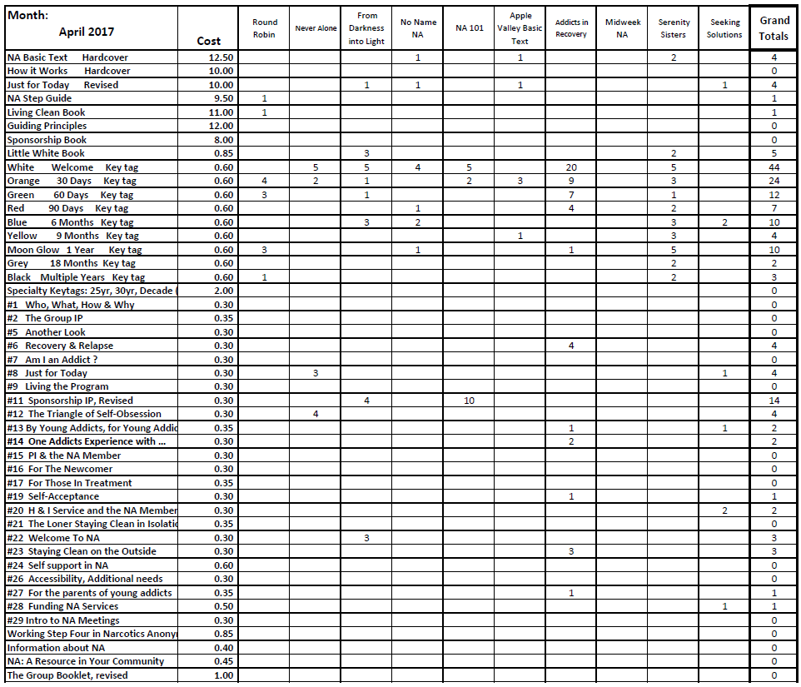

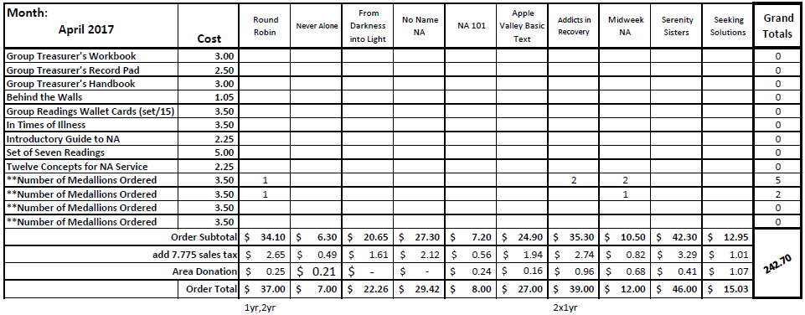
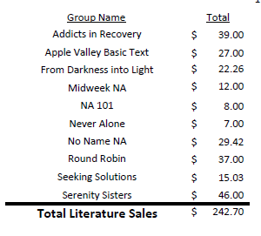
Literature Sales Report (continued)

