

Area Service Committee Meeting Minute

DECEMBER 2, 2016

Meeting opened at 7:10 PM by Area Chair Brad S.

Introductions: 25 members in attendance,. 13 GSRs Presents, 1 new comers

7th Tradition: Collected [see Treasurer’s Report on page 10]

Readings: 12 Steps read by not record; 12 Traditions read by not recorded ; 12 Concepts read by not recorded.

Call for Quorum: 13 voting members present (minimum for quorum is 7). motions require 7 votes to pass.

Approval of Minutes – Minutes Tabled.

Subcommittee Reports
Meetings for the Activities, Hospitals & Institutions, Outreach, and Public Relations Subcommittees are held at 7:00pm on the 2nd Thursday of each month at Faith Methodist Church, 1530 Oakdale Ave., West St. Paul, MN.

Vice-Chair: (open) Not Present.
Region: (RCM: not present)

Activities:
(Rick H, Reports)
- Christmas Cookie Exchange – Dec 17 11 am – 3 p.m. First Pres Church.
•Tubing event to be planned for January.
Public Relations: (Open) No Report
Hospitals & Institutions: (Steve P. Chair- reports)
- Trying to get people to sign up if interested.

Current H&I commitments:

Every Saturday: Dakota Co. Jail 1:00pm
(Need pre-approval to participate, call contact for information) Contact: Jason C. 612-353-7985
4th Tuesday of every month: Cochran Recovery Program (Hastings) 7:30pm Contact: Todd V.
651-285-1789
4th Thursday of every month: Dakota County Detox. 7:00pm Contact: Steve P. 651-493-3537

Outreach: (open)
- Open report.

PIG: (Chair: Melissa C.Reported) Balance $3,794.31
- Reviewed and renew storage lock contract with one change to date payment is due.
- voted on proposed by changes to by-laws, track change, copies will be brought to ASC in November.
- Open positions
  - Co-chair, Co-Treasurer, Merchandise chair, Co-Merchandise chair, Co-Gate Chair, Adult & Children Activities Chair, Coffee chair, Dinner Coordinator, Volunteer Coordinator.

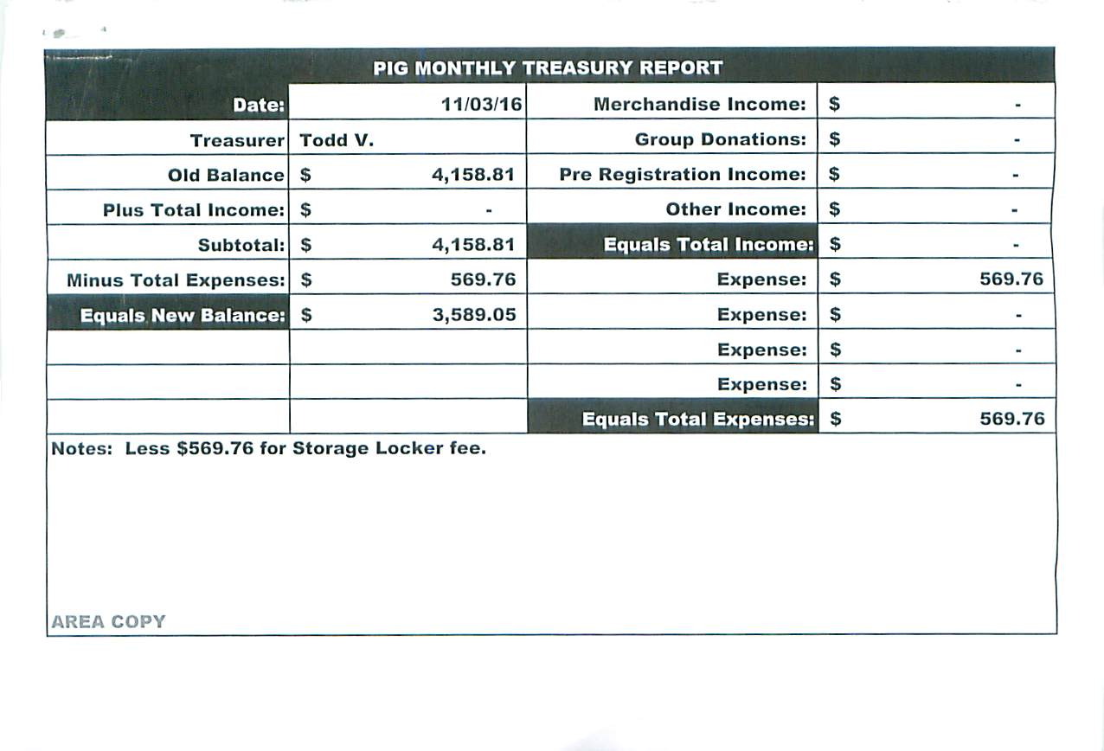

Literature: .(Chair - Kierstin K. present). [see report on page 11]

•Created literature email address ssfalit@gmail.com for orders and questions
•Has ordered plenty of new Traditions Workbooks. See Kiersten to purchase.

Group Concerns & Announcements
[Note: GSR reports are now at the end of the ASC minutes.]

Open Forum
• Brad S noted that we will be revising the by-laws, Meeting dates to come
• Subcommittee needs people, GSR’s need to bring those interested to the AREA meeting to get more involved. subcommittee held every 2nd Thursday of the month at 1530 Oakdale Avenue WSP at 7:00 p.m.

Break 8:00
back 8:08
Elections and Motions
  - Motion to give $100.00 for bus card placards by Rick and seconded by Tom J.
    - Support - 10 ; Oppose - 0; Abstentions - 1 Motion PASSED

  - Motion to donate to USMO for $100.00 by Garrett, and seconded by Tim
    - Support - 10 ; Oppose - 0; Abstentions - 1 Motion PASSED

  - Motion to give Seeking Solutions (new group) $50.00 in literature by Chris H, and seconded by John.
    - Support - 10 ; Oppose - 0; Abstentions - 1 Motion PASSED

  - Motion to pass amendments to Pig By-laws by Melissa and seconded by Brad.
    - Support - 10 ; Oppose - 0; Abstentions - 1 Motion PASSED

Open Positions — Announced with clean time requirements
Officers/Committes | Chair | Elected | Co-Chair Elected
Area Chair (2 Yrs,1 Yr) | Brad S. | 9/01 | open
Secretary (2 Yrs, 1 Yr) | Amber . | Temp – fill in | open
Treasurer (3 Yrs, 2 Yrs) | Tim. | ____ | Erica D. | 4/16
RCM (2 Yrs, 1 Yr) | Nick P. | 12/15 (2) | open
Literature (3 Yrs, 1 Yr) | Kierstin K. | 9/16
Activities (2 Yrs, 1 Yr) | Rick H. | 9/16
H&I (2 Yrs, 1 Yr) | Steve. P | 3/16 | James M. | 3/16
Outreach (1 Yr, 6 M) | open |  | open
Public Relations (2 Yr, 1Yr) | open |  | open
Webmaster (1 Yr) | Tom |  | N/A
PIG (2 Yrs, 1 Yr) | Melissa C. | 10/16 | open
PIG Treasurer (3 Yrs, 2 Yrs) | Todd V. | 10/16
PIG Merch. Chair (2 Yrs, 1 Yr) | Steve H. | 1/16 | open
PIG Gate Chair (2 Yrs, 1 Yr) | Matt. K. | 10/16 | open
(2) Denotes election is to a second consecutive term in the same position.

Old Business
- Motion to donation USMO instead of donating to region and world. —TABLED
- Minutes for last meeting - TABLED

New Business
  - Motion to close made by Tim, seconded by Amber R.

GSR Report

Woodbury Freebirds | 7:00pm Sunday Stable
GSR | Garrett L. PRESENT
Avg. Attendance | 15
Avg. Newcomers | 3
H&I Activities | announced
ASC Donation | none
Scheduled Activities | none
Other

Step by Step | 7:00pm Sunday
GSR | Rick H. NOT PRESENT
Avg. Attendance | 15-20
Avg. Newcomers | 2-3
H&I Activities
ASC Donation | $0.00
Scheduled Activities | Cookie Exchange
Other

Never Alone | 7:00pm Sunday Stable
GSR | Nicole PRESENT
Avg. Attendance | 20
Avg. Newcomers | 6
H&I Activities | announced
ASC Donation | $0.00
Scheduled Activities
Other

Ties That Bind Us | 7:00pm Monday
GSR | NOT PRESENT.
Avg. Attendance
Avg. Newcomers
H&I Activities | announced
ASC Donation
Scheduled Activities
Other

Monday Night Round Robin | 7:00pm Monday Stable
GSR | Thomas PRESENT
Avg. Attendance | 17-25
Avg. Newcomers | 2-3
H&I Activities
ASC Donation | $12.00
Scheduled Activities
Other | more members w/clean time, and sponors

Addicts in Recovery | 7:00pm Tuesday Stable
GSR | Angie F. PRESENT
Avg. Attendance | 20-30
Avg. Newcomers | 2
H&I Activities | announced
ASC Donation | $26.11
Scheduled Activities | 5th Tuesday is pot luck meeting
Other

TNT: Tues. Night Together | 7:00pm Tuesday Stable
GSR | Steve P.
Avg. Attendance | 20
Avg. Newcomers | 2
H&I Activities
ASC Donation | $100.00
Scheduled Activities
Other

Tuesday Night Serenity | 7:00pm Tuesday
GSR | NOT PRESENT
Avg. Attendance
Avg. Newcomers
H&I Activities
ASC Donation
Scheduled Activities
Other

Rock Solid NA | 7:00pm Wednesday
GSR | NOT PRESENT
Avg. Attendance
Avg. Newcomers
H&I Activities
ASC Donation
Scheduled Activities
Other

Midweek NA | 7:00pm Wednesday
GSR | Amber R. PRESENT
Avg. Attendance | 15-18
Avg. Newcomers | 3-4
H&I Activities
ASC Donation | $15.00 pig
Scheduled Activities
Other | Changed our meeting to open meeting

No name NA | 7:00pm Thursday Stable
GSR | Gina PRESENT
Avg. Attendance | 20-25
Avg. Newcomers | 1-3
H&I Activities
ASC Donation | $0.00
Scheduled Activities
Other | Need more female sponors

Serenity Sisters | 7:00pm Thursday Stable
GSR | Anne R. PRESENT
Avg. Attendance | 1--12
Avg. Newcomers | 2
H&I Activities
ASC Donation | 0.00
Scheduled Activities
Other

Serenity Seekers  GSR | 7:30pm Thursday  NOT PRESENT
Avg. Attendance
Avg. Newcomers
H&I Activities
ASC Donation
Scheduled Activities
Other

Peace of Mind | 7:30pm Friday Stable
GSR | Tim N. PRESENT
Avg. Attendance | 11
Avg. Newcomers | 2
H&I Activities
ASC Donation
Scheduled Activities
Other

Na Day | 7:30pm Friday
GSR | Luke C PRESENT
Avg. Attendance | 20-25
Avg. Newcomers | 1-3
H&I Activities
ASC Donation
Scheduled Activities | NA Day Chili Feed Sat in Feb or 1st Sat in March- tentative dates
Other

Outsiders NA | 8:00pm Friday
GSR | Tom J. PRESENT
Avg. Attendance | 10-12
Avg. Newcomers | 2
H&I Activities
ASC Donation | $0.00
Scheduled Activities
Other

From Darkness into Light | 6:30pm Saturday Stable
GSR | Chris H.
Avg. Attendance | 15-20
Avg. Newcomers | 1-2
H&I Activities
ASC Donation | $18.00
Scheduled Activities
Other

NA 101 in Hastings | 7:00pm Saturday Stable
GSR | John M. PRESENT
Avg. Attendance | 8
Avg. Newcomers | 1
H&I Activities
ASC Donation
Scheduled Activities
Other | Need ore addicts w/clean time fill svc positions

Apple Valley Basic Text Study | 9:00pm Saturday Stable
GSR | Melissa C.
Avg. Attendance | 17
Avg. Newcomers | 2
H&I Activities | Announced
ASC Donation | $5.00
Scheduled Activities
Other | Voted to accept changes to pig bylaws

