Registration | Quantity | Subtotal
Adult / Teen |  | $
Children 0 – 12 yr |  | FREE
Saturday Night |  | $
T-Shirt Size _____
Newcomer Donation |  | $
GRAND TOTAL |  | $
Registration | Before June 15, 2017 | After June 15, 2017
Adult / Teen 13 and up | $25 | $30
Children 0 – 12 years | FREE | FREE
Saturday Night Only* | $20 | $25
*Saturday Night registration is valid starting on Saturday morning at 7 am. Saturday night includes one night of camping and the Pig Roast picnic meal. Gates open Friday at noon. All PIG registrations are non-refundable. Please make checks payable to: SSFA PIG COMMITTEE
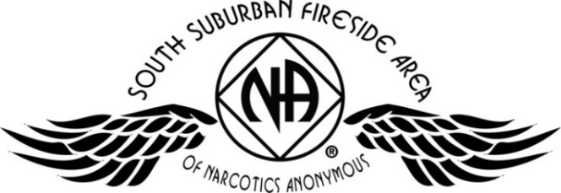
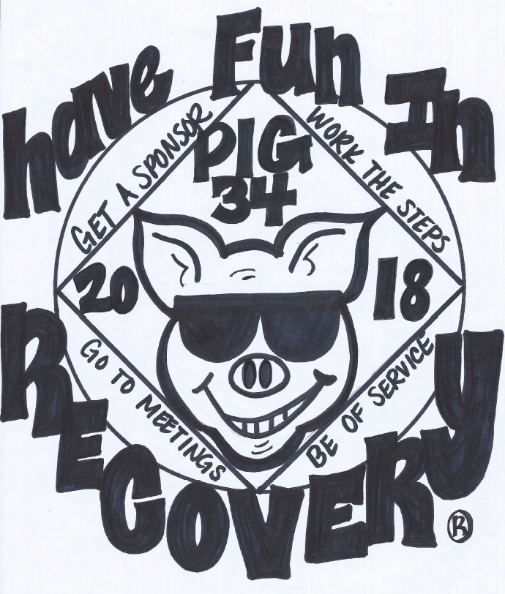
July 20, 21, & 22nd 2018
Register
online at naminnesota.org/pig

Apple River Family Campground
345 Church Hill Road,
Somerset, WI
- Electrical / Water Hookups
- Onsite Showers (only $1.00 for hot water)
- Swimming Pool
- Playground
- Frisbee Golf Course (bring your own discs)
- Tubing (additional cost)
NO PETS OR FIREWORKS PERMITTED

- Pig Roast Meal
- Inspiring Speakers
- Recovery & Service Workshops
- Fireside Hug-Up Meeting
- Dancing & Campfire Fellowship
- Adult & Children’s Activities

Somerset, WI
PIG CAMPOUT 34
Mailing Address:
SSFA PIG Committee
PO Box 303
Cottage Grove, MN 55016
Call with any questions:
Amber M-D 612-867-5065 Brad S. 612-868-5818
All PIG registrations are non-refundable. Please make checks payable to:
SSFA PIG COMMITTEE
Name: Phone:
Email: Clean Date:
Home Group: Register online at naminnesota.org/pig

