Registration | Quantity | Subtotal
Adult / Teen |  | $
Children 0 – 12 yr |  | FREE
Saturday Night |  | $
T-Shirt Size _____
Newcomer Donation |  | $
GRAND TOTAL |  | $

Registration | Before June 15, 2017 | After June 15, 2017
Adult / Teen 13 and up | $25 | $30
Children 0 – 12 years | FREE | FREE
Saturday Night Only* | $20 | $25
*Saturday Night registration is valid starting on Saturday morning at 7 am. Saturday night includes one night of camping and the Pig Roast picnic meal. Gates open Friday at noon. All PIG registrations are non-refundable. Please make checks payable to: SSFA PIG COMMITTEE
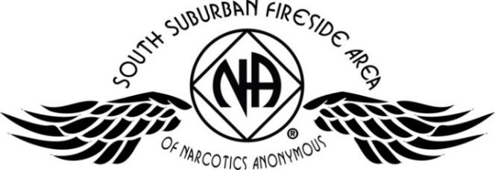
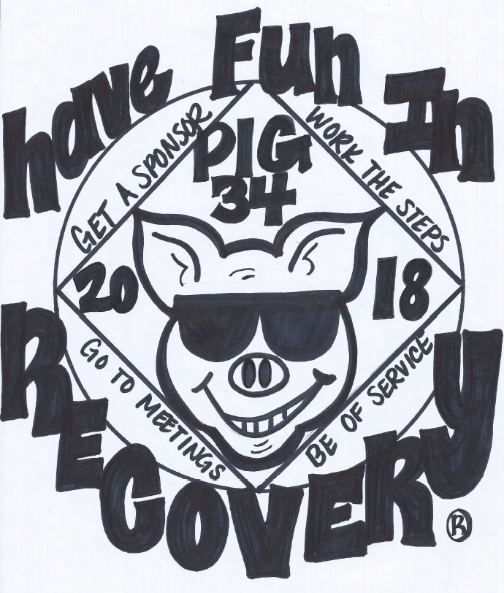
Name: Phone:
Email: Clean Date:
Home Group: Register online at naminnesota.org/pig
Mailing Address:
SSFA PIG Committee
PO Box 303
Cottage Grove, MN 55016
Call with any questions:
Amber M-D 612-867-5065 Brad S. 612-868-5818
All PIG registrations are non-refundable. Please make checks payable to:
SSFA PIG COMMITTEE
Pig Roast Meal
Inspiring Speakers
Recovery & Service Workshops
Fireside Hug-Up Meeting
Dancing & Campfire Fellowship
Adult & Children’s Activities

Electrical / Water Hookups
Onsite Showers (only $1.00 for hot water)
Swimming Pool
Playground
Frisbee Golf Course (bring your own discs)
Tubing (additional cost)
NO PETS OR FIREWORKS PERMITTED

Apple River Family Campground
345 Church Hill Road,
Somerset, WI
PIG CAMPOUT 34
July 20, 21, & 22nd 2018
Somerset, WI
Register
online at naminnesota.org/pig

