PIG CAMPOUT 33
July 14, 15, & 16 – Somerset, WI
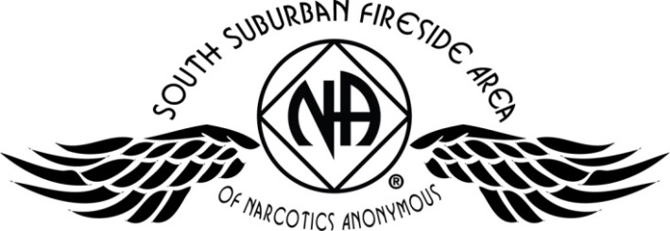
Register online at naminnesota.org/pig

Registration | Quantity | Subtotal
Adult / Teen |  | $
Children 0 – 12 yr |  | FREE
Saturday Night |  | $
Newcomer Donation |  | $
GRAND TOTAL |  | $
Registration  Join in the fun at the  Apple River Family Campground  345 Church Hill Road,  Somerset, WI | Before June 15, 2017 | After June 15, 2017
Adult / Teen 13 and up | $25 | $30
Children 0 – 12 years | FREE | FREE
Saturday Night Only* | $20 | $25
*Saturday Night registration is valid starting on Saturday morning at 7 am. Saturday night includes one night of camping and the Pig Roast picnic meal. Gates open Friday at noon. All PIG registrations are non-refundable. Please make checks payable to: SSFA PIG COMMITTEE

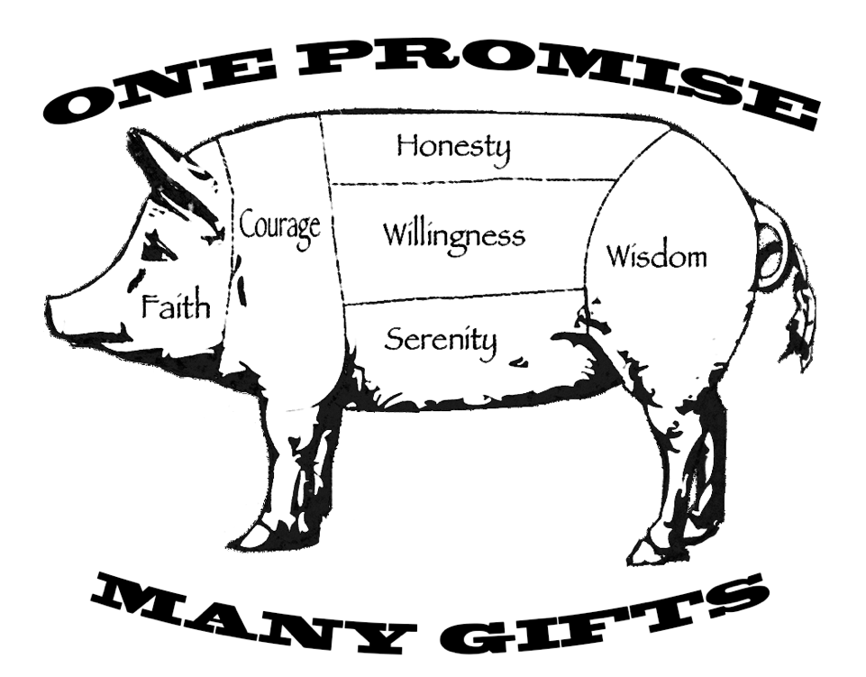
d
- Pig Roast Meal
- Inspiring Speakers
- Recovery & Service Workshops
- Fireside Hug-Up Meeting
- Dancing & Campfire Fellowship
- Adult & Children’s Activities
- Electrical / Water Hookups
- Onsite Showers
(only $1.00 for hot water)
- Swimming Pool
- Playground
- Frisbee Golf Course
(bring your own discs)
- Tubing (additional cost)

NO PETS OR FIREWORKS PERMITTED
Mailing Address:
SSFA PIG Committee
PO Box 303
Cottage Grove, MN 55016
Call Melissa M.
(651) 675-8985
All PIG registrations are non-refundable. Please make checks payable to: SSFA PIG COMMITTEE

Name: Phone:
Email: Clean Date:
Home Group: Register online at naminnesota.org/pig

