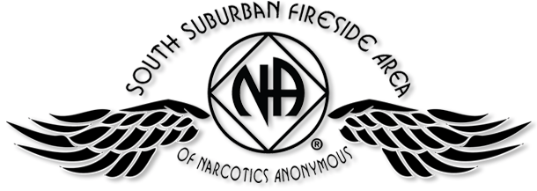

PIG CAMPOUT 2017
Tournament Winner
JULY 14, 15, & 16 - SOMERSET, WI

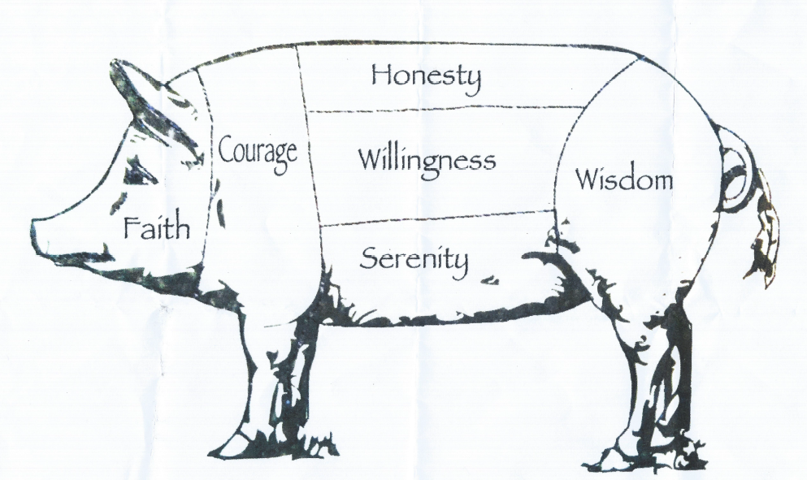

2017 Free Registration
Chair: (Melissa C.) Date:
Event:

