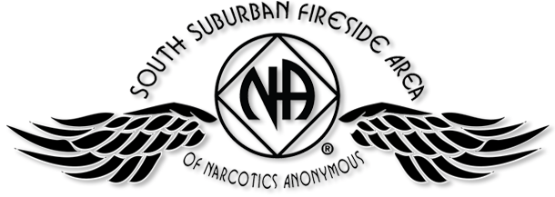

PIG CAMPOUT 2017
Raffle Winner
JULY 14, 15, & 16 - SOMERSET, WI
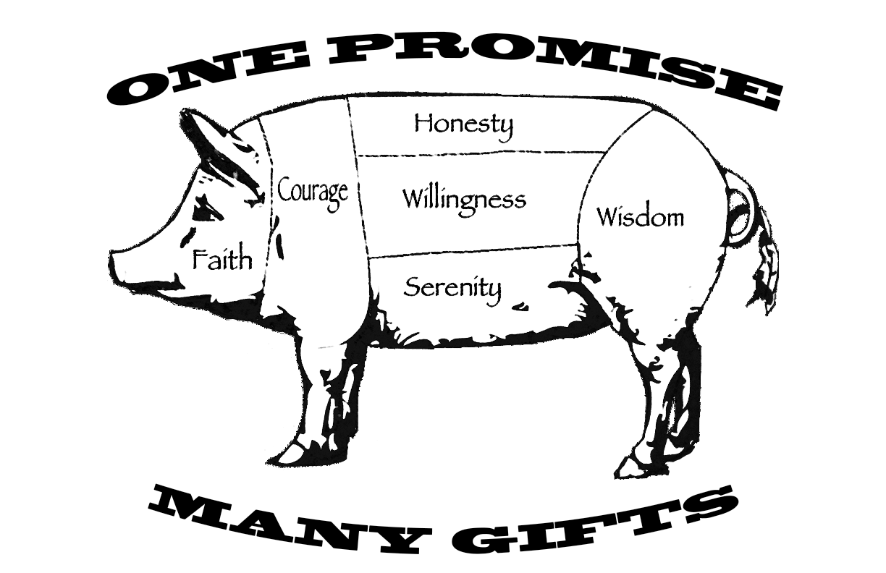
2017 Free Registration

Chair: (Melissa C.) | Date: 3/25/17
Event: TCASC Spring Thaw Raffle

