PIG CAMPOUT 32
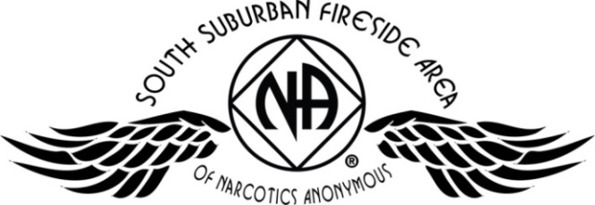
July 15, 16, & 17 – Somerset, WI
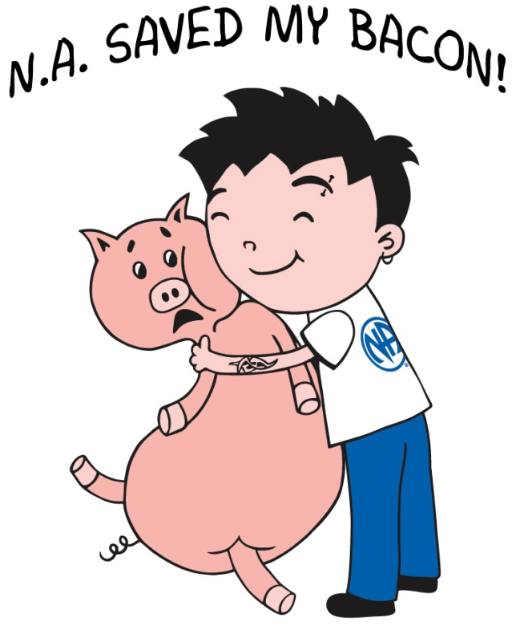

Registration | Quantity | Subtotal
Adult / Teen |  | $
Children 0 – 12 yr |  | FREE
Saturday Night |  | $
Newcomer Donation |  | $
GRAND TOTAL |  | $
Registration | Before June 15, 2016 | After June 15, 2016
Adult / Teen 13 and up | $25 | $30
Children 0 – 12 years | FREE | FREE
Saturday Night Only* | $15 | $20
*Saturday Night registration is valid starting on Saturday morning at 7 am. Saturday night includes one night of camping and the Pig Roast picnic meal. Gates open Friday at noon. All PIG registrations are non-refundable. Please make checks payable to: SSFA PIG COMMITTEE

NO PETS OR FIREWORKS
are permitted on
campground

- Pig Roast Meal
- Inspiring Speakers
- Recovery & Service Workshops
- Fireside Hug-Up Meeting
- Dancing & Campfire Fellowship
- Adult & Children’s Activities
- Electrical / Water Hookups
- Onsite Showers (only $1.00 for hot water)
- Swimming Pool
- Playground
- Frisbee Golf Course
- Tubing (additional cost)
Join in the fun at the
Apple River Family Campground
345 Church Hill Road, Somerset, WI
Register online at naminnesota.org/pig

No addict will be turned away. In the spirit of carrying the message to the addict who still suffers, no addict will be turned away from PIG. Those who cannot afford registration fees are encouraged to volunteer support for any of PIG's ongoing activities.

Mailing Address:
SSFA PIG Committee
PO Box 303
Cottage Grove, MN 55016
Call Brian F: (612) 209-6358
Melissa C. (651) 675-8985
All PIG registrations are non-refundable. Please make checks payable to: SSFA PIG COMMITTEE
Name: Phone:
Email: Clean Date:
Home Group: Register online at naminnesota.org/pig

