PIG CAMPOUT 32
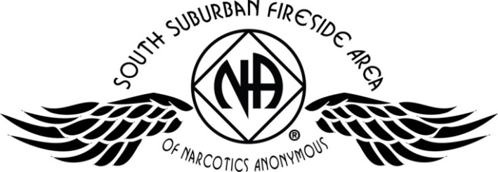
July 15, 16, & 17 – Somerset, WI
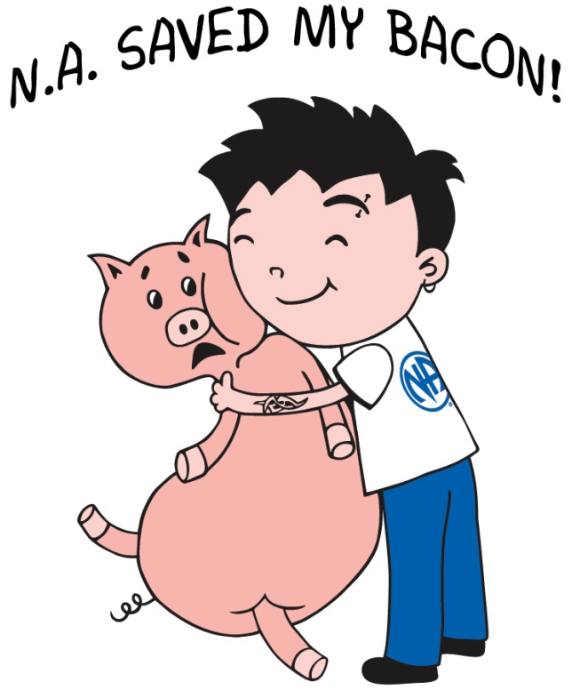

Registration | Quantity | Subtotal
Adult / Teen |  | $
Children 0 – 12 yr |  | FREE
Saturday Night |  | $
Newcomer Donation |  | $
GRAND TOTAL |  | $
Registration | Before June 15, 2016 | After June 15, 2016
Adult / Teen 13 and up | $25 | $30
Children 0 – 12 years | FREE | FREE
Saturday Night Only* | $15 | $20
*Saturday Night registration is valid starting on Saturday morning at 7 am. Saturday night includes one night of camping and the Pig Roast picnic meal. Gates open Friday at noon. All PIG registrations are non-refundable. Please make checks payable to: SSFA PIG COMMITTEE

d
Mailing Address:
SSFA PIG Committee
PO Box 303
Cottage Grove, MN 55016
Call Brian F: (612) 209-6358
Melissa C. (651) 675-8985
All PIG registrations are non-refundable. Please make checks payable to: SSFA PIG COMMITTEE

NO PETS OR FIREWORKS
are permitted on
campground

- Pig Roast Meal
- Inspiring Speakers
- Recovery & Service Workshops
- Fireside Hug-Up Meeting
- Dancing & Campfire Fellowship
- Adult & Children’s Activities
- Electrical / Water Hookups
- Onsite Showers (only $1.00 for hot water)
- Swimming Pool
- Playground
- Frisbee Golf Course
- Tubing (additional cost)
Join in the fun at the
Apple River Family Campground
345 Church Hill Road, Somerset, WI
Register online at naminnesota.org/pig

Name: Phone:
Email: Clean Date:
Home Group: Register online at naminnesota.org/pig

