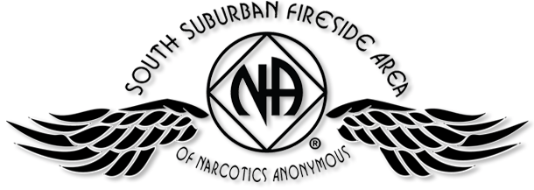

PIG CAMPOUT 2016
JULY 15, 16, & 17
SOMERSET, WI
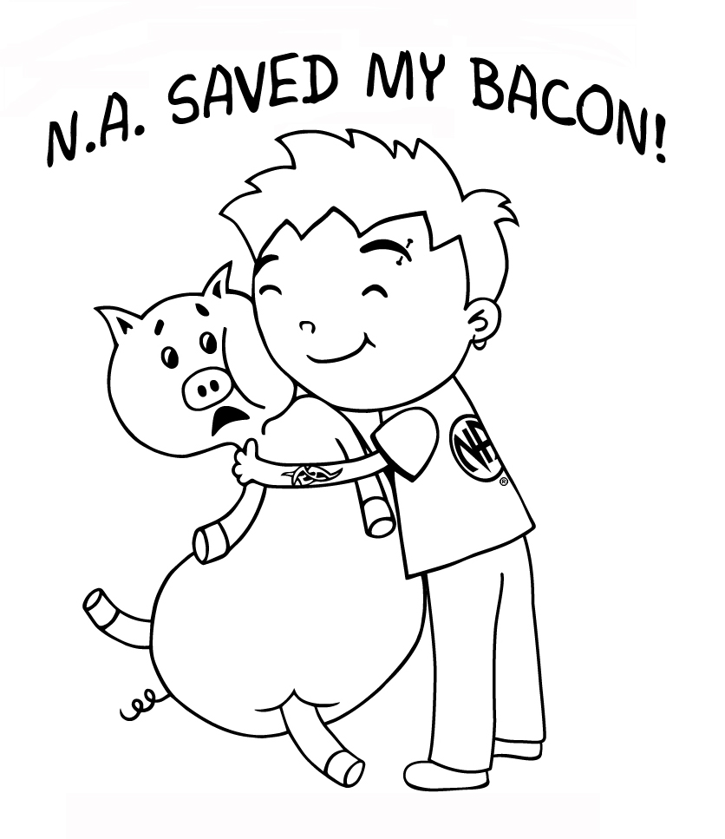
Free Registration Form
Chair: (Brian F.) Date:
Co-Chair (Melissa C.) Event:

