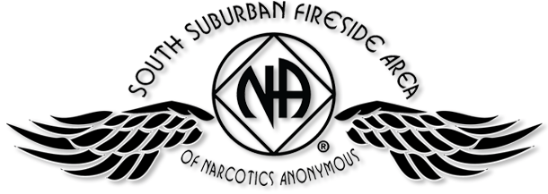

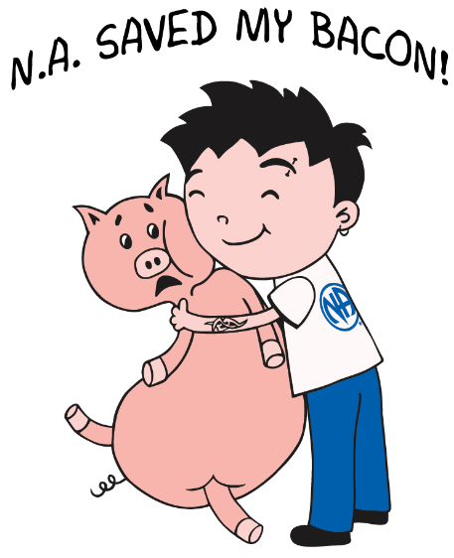
2016 PIG CAMPOUT

JULY 15, 16 & 17

SOMERSET, WI

Free Registration Form
Winner: Event:
Chair: (Brian F.) Date:
Co-Chair (Melissa C.) Date:

