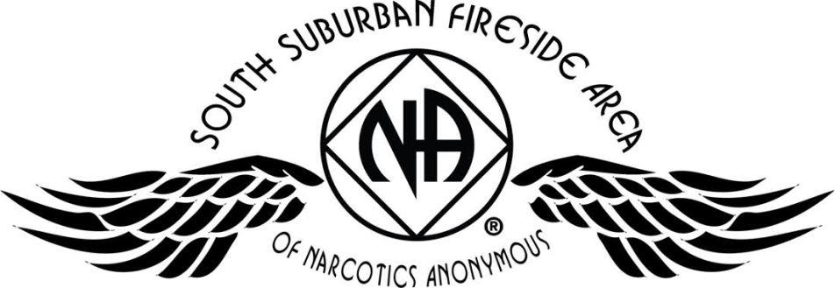
Updated 4/8/2017
NA World: www.na.org
Minnesota Region: www.naminnesota.org
PIG (SSFA annual camp-out): www.naminnesota.org/pig
South Suburban Fireside Area: www.ssfa.naminnesota.org
NA websites
April 2017
World Service Office
PO Box 9999
Van Nuys, CA 91409
Narcotics Anonymous World Service Office
SSFA e-mail:
info.ssf@naminnesota.org
ssfalit@gmail.com
SSFA Literature e-mail:
SSFA mailing address:
South Suburban Fireside Area
PO Box 241893
Apple Valley, MN 55124
PIG Chair
Melissa C.
651-675-8985
PIG Co-Chair
open
open
Outreach Co-Chair
952-715-7025
Outreach Chair
open
612-860-0274
612-716-4449
Hospitals & Institutions Co-Chair
Mike S.
Hospitals & Institutions Chair
James M.
open
Webmaster
open
Public Relations Co-Chair
open
open
Activities Co-Chair
952-797-3695
651-347-7032
Kierstin K.
Gina
Literature Co-Chair
RCM - Alternate
open
open
Co-Treasurer
Area Vice Chair
Co-Secretary
612-867-5065
Amber M-D
Public Relations Chair
Activities Chair
Amber R.
612-219-0876
Secretary temporary
open
Rachel M.
612-384-4695
Literature Chair
Regional Committee Member
Erica D.
open
952-393-4812
Treasurer

Area Officers and Subcommittee Contacts
O

Area Service Committee Meeting (SSFASC)
First Thursday of every month, 7pm
First Presbyterian Church
535 20
th
Ave. N.
South St. Paul, MN 55075
PIG Subcommittee (SSFA annual camp-out)
First Thursday of every month, 6pm
First Presbyterian Church
535 20
th
Ave. N.
South St. Paul, MN 55075
Area Subcommittees
(Hospitals & Institutions,
Public Relations, Activities, Outreach, Literature)

Second Thursday of every month, 7pm
Faith United Methodist Church
1530 Oakdale Ave.
West St. Paul, MN 55118
Minnesota Regional Service Conference (MNRSC)

February: At Creating Our Common Welfare
May, August, November – Second Saturday,
Noon-4pm:
Sebathani Community Center
Conference Room J (3
rd
Floor)
310 38
th
St. East
Minneapolis, MN 55409
Upper Midwest Service Office
Sebathani Community Center
310 38
th
St. East, Suite 224
Minneapolis, MN 55409
612-822-9472
Hours:
Mon: 6:30pm – 8:30pm
Thurs: 6:30pm – 8:30pm

Sat: 10:00am – noon (2pm for MNRSC or TCASC)

Sun, Mon, Wed, Fri: closed

Area Chair

Brad S.

612-868-5818

Helpline 877-767-7676

TOLL FREE
Call the Helpline to find meetings not listed here,
NA events, or help with addiction.

