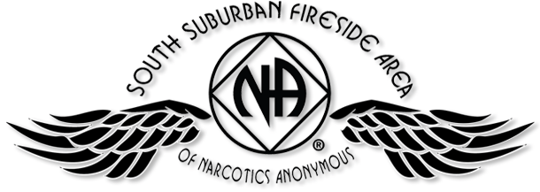
Why is an H&I meeting/presentation needed?
The purpose of an H&I meeting is to carry the message of recovery to addicts who do not have full access to regular Narcotics Anonymous meetings.

“We can only keep what we have by giving it away.”

Every Saturday: Dakota Co. Jail (Hastings) 1:00PM (Need pre-approval to participate, call contact for info.)
Contact: Jason C. 612-353-7958

- 2nd Saturday of every month: Cochran Recovery Pgm. (Hastings) 2:00PM Contact: Kierstin K. 651-347-7032

- 4th Tuesday of every month: Cochran Recovery Pgm. (Hastings) 8:00PM Contact: Todd V. 651-285-1789

- 4th Thursday of every month: Dakota County Detox. (Hastings) 7:00PM Contact: Rachel M. 612-384-4695

Please call the contact if you are interested in carrying the message to any of our commitments. You will need at least six months continuous clean time to speak (some require more), or three months to attend and listen; other stipulations may apply for specific commitments. We suggest that you consider attending an H&I Subcommittee meeting before going to a commitment to speak.

SSFA H&I Subcommittee:
Meets the 2nd Thursday of each month at 7:00PM
Faith United Methodist Church
1530 Oakdale Ave.
West St. Paul, MN 55118

