Southwest Minnesota Area Narcotics Anonymous Cordially invites you to our First Annual

Put your heart into NA Dance and Potluck
Tickets: $10 per person, $5 Discount if you bring a dish. Kids 10 and under free. Teenagers $5
Doors open at 12 PM for setup. Fellowship starts at 3 PM. Supper at 5. Matt M from Pipestone speaking at 6 PM. Dance 7 PM to 10 Pm.

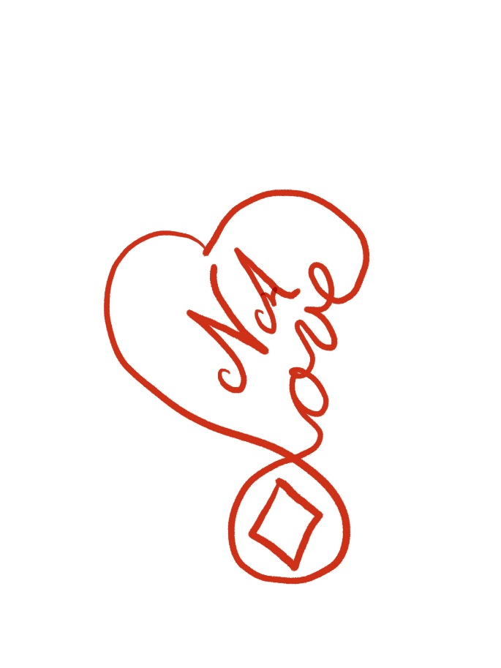
February 16th
3 pm to 10 pm
116 No Main street
Sherburn MN to the left of the Theater downstairs
Hotdogs and snacks will be provided. Check out the Chocolate Fountain!
SWMNNA ASC Activities Committee
Chad 507-432-5136
Louise 605-838-6705
Jess 507-476-2274
Joel 507-829-0174
Barrie 507-848-8517
Steve 507-525-8248

