- Activities Committee Agenda:
  - Cannonball Run
    - Camping @ Garvin Park Arrive 10-11 AM
    - Costs
      - $10 Meal
      - $10 Admission
      - $ 10 Poker hand
        - Prize full package registration for MNNAC April 17th -19th 2020 in Bloomington
      - Camping costs: 10-15 Daily Camping Rate
        - 1 mile north of the intersection of Hwys 14 and 59 on Hwy 59
  - Sponsorship Inservice:
    - What do we need yet?
      - More info later
  - December is our 5th Birthday as an Area.
    - Sledding/Tubing Party in January with Pipestone NA
  - August Area Meeting be a Campout at Anderson Park.
      - Not an official campout, can camp if you want to
      - Taco Cookoff
        - Note: Please Mark your submission for allergens and heat level
          - Low
          - Medium
          - Hot
          - You’re Stupid if you try
      - Everyone pays for their own camping
      - Potluck as well.
      - Fishing, games, modern plumbing and electric camping sites available
      - Flyer will be sent out
  - Halloween Dance-to be October 26th. October ASC meeting starts at Sherburn at 12PM
    - DJ is arranged
    - Flyers available
    - October ASC meeting needs to be held that day. After Area meeting, help with the dance set up.
    - Chili Cookoff to be the meal
      - Categories Regular, Medium and Hot and you’re stupid if you try- Prizes provided for the best chili
    - Prizes also for the best costume
- ASC Meeting
  - Call to Order:
  - Service Prayer:
    - “God, grant us knowledge that we may act according to your Divine precepts, instill in us a sense of your purpose, make us a bond of selflessness, that this may truly be your work, not ours, in order that no addict anywhere need die from the horrors of addiction.”

  - Twelve Traditions read by: Craig
  - Twelve Concepts read by: Jess

- Roll Call
  - Officers
    - Chair: Al J -yep
    - Alt Chair: Joel D -yep
    - Treasurer: Matt M -family commitment nope
    - Alt Treasurer: Chad -yep
    - H&I: Jess -yep
    - PI: Craig -yep
    - RCM: Darren -yep
    - Alt RCM: Mike -family commitment nope
    - Activities: Chad -yep
    - Secretary: Louise -yep
    - Literature: NA Louise, Jess and Craig yep
  - Groups
    - Worthington NA -yep
    - Lakefield NA -yep
    - Hope Haven Redwood Falls- nope
    - Winnebago NA- gave report
    - Pipestone NA- yep
    - Better Late than Never Slayton- yep
    - Wednesday NA Redwood Falls- nope
    - Windom NA- yep
    - Woodstock Women’s- nope
    - Just for Today, Montevideo- nope
    - Friends in Recovery Montevideo- nope
    - Always Teachable Woodstock- nope
    - Blue Earth- gave report
    - Visiting Groups- Marshall

- # of Groups. 6+1 Quorum established? Yes

- Minutes of Previous ASC Meeting: Notes to be Read,
  - Motion to accept by: Jess
  - 2nd by Gordy
  - Passed: Yes

- Reports
  - Officers

    - Chair Report: Will discuss in open forum

    - Secretary’s Report: Work got done
    - Treasurer’s Report: Previous 656.23 Current 497.67

    - PR Report: Not much to tell, a few questions on upcoming events

    - RCM Report: Attached at the end

    - Activities Report: See Activities Minutes, Addendum: Steps and Traditions Inservice went well, lots was learned, and fun was had. Thank You Winnebago and Blue Earth NA
    - H/I Report: Books for Lakefield were paid for. All else is well. Louise will get a list for H/I to use. May be a PI/HI event in a year or so. Louise will help with a letter for Redwood falls
    - Literature Report:
        - N/A

  - Groups Reports:
    - Worthington NA: May have to cut a meeting due to poor attendance. May have fresh members in the fall.
    - Lakefield NA: 10-20 Attending, need flyers and schedules
    - Winnebago NA- sent report no needs
    - Pipestone NA – 10-20 no needs
    - Better Late than Never Slayton NA – 4-6 attending Tues 7:30 PM
    - Windom NA- No Changes, Steady and Strong, need a group conscience, are informal right now. Open format 2nd meeting may be added
    - Friends in Recovery Montevideo- Sent $80 donation
    - Blue Earth- No Needs
    - Visiting Group – Marshall NA four meetings, Shantelle secretary, another sit-down to decide if joining our area. Friday and Saturday nights are lower in attendance. Doing okay.

- Break

- Old Business
  - Brian E and theft of NA Camping equipment or funds
    - Gave Louise B Money Order on April 28th in amount of $200
    - Motion: Report the theft to Nobles County Sheriff
    - Tabled until May 19th ASC meeting
    - Check for $140 presented. Financial amends have been made.
    - Will meet with Secretary to provide Camping equipment.
  - PR Event June 3-9:
    - Flyers Contest.
      - GSR’s picked up flyers. Post them to public places in your towns with permission.
        - Most places posted will get a prize. Send photos to ASC secretary via text or email to qualify.
  - HI Speakers for treatment centers:
    - GSR’s please get speakers list to Secretary asap.

- Open Floor – 20 Minutes
  - From Region: All future thefts of funds are to be referred to local police asap.
    - Note: For group safety, please have two signers for all checks on your accounts. Please see your treasurer’s handbook.
    - Note: If you do not yet have a treasurer’s handbook, please contact secretary.
  - Who to invite to Region:
    - GSR’s and groups are encouraged to attend.
  - Letter to be written to the treatment centers and groups about SWMNNA ASC.
    - Louise will work on the letter with Darren.
  - Motion 470: Region: To hold UMSO accountable to NAWS and region.
    - Motion Made, 2nd, and Passed to have Darren propose this motion to Region.
  - Fairmont NA: Not part of our Area, but in spirit of cooperation, they are looking for volunteers to help with Holiday Rocks. Please contact Al J, if you can help.
  - Check for $219.00 to complete amends to B2B area. Motion Made, 2nd and Passed to send the funds.

- New Business:
  - No longer requiring the Secretary to read the minutes.
    - Motion proposed by Darren prior to meeting.
    - 2nd and Passed
  - No longer having print outs of the minutes except for one for the archives.
    - The minutes are available on the website and are to be read prior to the meeting.
    - The minutes are also sent out by the Secretary, available on the Tundra Group, and available upon request.
    - Would save the Area roughly $50 per year in printing costs.
    - Motion made, 2nd and Passed.
  - No longer printing out the Area agenda each month except for chairman and secretary copy for archives.
    - Would be emailed out the week before Area meeting
    - Is always available via Drop box
    - Can be made available via the website.
    - Would save roughly $50 per year in printing costs
    - Amended to:
      - Only 10 copies to be printed for ASC
        - Motion made, 2nd and passed. Secretary will print only 10 copies for ASC meetings. Agenda will be sent out prior to ASC meeting.

- Out Reach:
      - Visiting Schedule this month.
        - New fellowship building and outreach idea. GSRs and Officers come to the groups to build fellowship and friendships between the groups. We will be attending as members only, not as trusted servants. There will be two groups picked per month. The dates will be chosen at the ASC meetings. The following groups will be visited in June.
        - More out of Life: Marshall MN
          - Friday the 14th, 7 PM Christ United Presbyterian Church, 400 West Lyon Street, Marshall MN
          - Please announce at your groups. Carpool to the meeting. Officers and GSR’s are encouraged to come.
        - Blue Earth NA
          - Wednesday June 19th Night 7 PM Senior Center, 118 West 7th Street, Blue Earth

- Bring back to the groups:
  - Hosting the Area Service Committee Meeting
    - 2020 Dates open for Hosting
      - June 2019 is Lakefield NA
      - July is in Worthington
      - August is at Anderson Park
      - September possibly Marshall
  - Hosting a possible Event from the ASC either an Inservice, Workshop or Activity
  - Need volunteers to be on an area wide phone list. Forms handed out at March Inservice. This list will be used when the ASC is contacted for sponsorship requests, 12 step calls, 5th step requests. Please mark if the person is willing to sponsor outside of your community. Please also mark if people are willing to be called on as speakers.
  - At the June ASC, normal printing will resume of ASC schedules, flyers, IPS, and service manuals. Those of you who need extra materials, please text or email the secretary with your needs.
    - My apologies, I ran out of toner this month during printing for the ASC. Hopefully, the cost saving measures at the ASC level will make resources more available to the groups. See new business.

- Notes:
  - Area Website has tools for the GSRs and Officers to use. Check it out at https://www.naminnesota.us/swmn/trusted-servants-corner/
  - Our Area Meeting Minutes will be found there in pdf format
  - A Huge Thank You to all the GSR’s for attending the ASC!
    - More files will be available to you in dead tree format for the ASC. Please find the Secretary, sign in, and you will receive the files.
    - If you need books in pdf format, please contact Louise, she can email you the books, the files, as well as back minutes
      - Books that are available are the Basic Text, It Works, How and Why, and the Step Working Guide these are in PDF form, easily readable on a smart phone or tablet, and free of charge.
      - User Manuals, manuals that are available as Printouts and other information are also available as a PDF. They are available on our website via NAWs. The main link is here. https://www.naminnesota.us/swmn/useful-things/
      - Also, an area wide emergency phone list for those willing to do twelve step work is needed. Please ask your groups for volunteers.
https://www.na.org/?ID=subscribe
https://www.naminnesota.us/na-subscriptions/
- Email these people to subscribe to the Region Google Group: mnrsc+subscribe@googlegroups.com
- Fundraising:
  - T-shirts for events:
    - Chad and Louise will investigate prices
  - Bracelets
    - Louise will investigate prices
  - Lighted up NA Sign
    - Will raffle off at a future campout
  - Prizes
    - Bumper Stickers

- Volunteer opportunities with Region
  - Bridging the Gap
    - https://www.naminnesota.us/community/groups/bridging-the-gap-2012397073/

  - Phone Line
    - https://www.naminnesota.us/community/groups/helpline/

  - HI
    - https://www.naminnesota.us/community/groups/hospitals-institutions/

  - PI
    - https://www.naminnesota.us/community/groups/public-relations/
Announcements
    - Activities Committee needs to meet 1 hour before Area meetings at 12 PM
      - Officers and GSRs please attend.
    - While an Alternate Secretary is needed at the ASC level. The current secretary is unable to train one in due to medical issues until maybe in the fall. This does not stop the need for an alternate secretary. In your groups, if there is a person who has computer ability, and the ability to donate 20-40 hours to the ASC, Wi-Fi, laptop, printer, and office software. This is an unpaid position. The alternate secretary must be able to take calls from officers and GSRs, answer questions, and provide documents as needed on request. There are more qualifications, but that is the short list.
    - The Region Minutes are available and will be sent out to officers and GSRs.
    - Volunteers needed who can produce flyers for ASC events. Please email the secretary if you are interested.
    - Singleness of Purpose:
      - When speaking officially for the ASC, please as officers and GSRs keep in mind the primary purpose of Narcotics Anonymous. We are here to carry the message of recovery to the addict who still suffers. All our efforts as a service body are to help addicts in our communities.

Next Meeting Date, Time and Location: 12 PM June 23rd, 2019 Location TBA

RCM Report

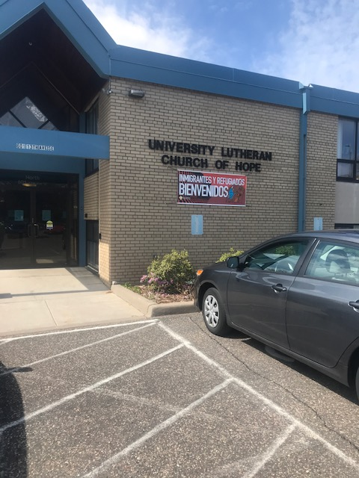RCM-SWMNNA
I think I can speak for both me and Mike that we learned much while at the Regional service Conference in the cities this time. It was Mikes first time going but he did a great job of keeping me calm at times... lol. Anyway, we voted on the fate of the UMSO which is the (NA bookstore) after a motion had to been brought to dissolve the service office as a separate non-profit and closes its doors. The background (in my opinion) is that it has been losing money and its books are not up to date and the NA Minnesota Regional Chair and other heads seemed to feel that it hasn't been handling itself as a part of NA and is putting the rest of NA in danger due if it was audited by the government. (Briefly explain)
After a heated at times discussion it was finally put to a vote and 15 people wanted it to stay open and 9 people wanted it closed.
I personally tried to file a motion that (the bookstore) be given 6 months to get his books in order and hire a professional to get this done or else be closed down but I can't do that until the next Regional service conference and so I would like to get everyone's thoughts about this.
We also had discussions on the following:
Motion 470: To dissolve the Upper Midwest Service Office (UMSO) as a standalone Non-profit corporation by 12/31/2019. After some long discussion we voted, and the motion did not pass. I personally think someone should file a motion to have them hire a professional bookkeeper to keep their books in order.
We also discussed and voted on:
Motion 470 – To approve the disbursement of 1,500 divided evenly among any MN Region members who attend and write reports on their experience at the Western States Learning Days (Nov 8th-10th in Seattle Washington)\

I have brought him some Bridging the Gap flyers and here are some opportunities to serve for all of us on the NA phone lines. Here is how it works (look at the picture)!
Thanks, you for paying more gas to attend this event (if you did) and I had a great time at this one and can’t wait for the next one!
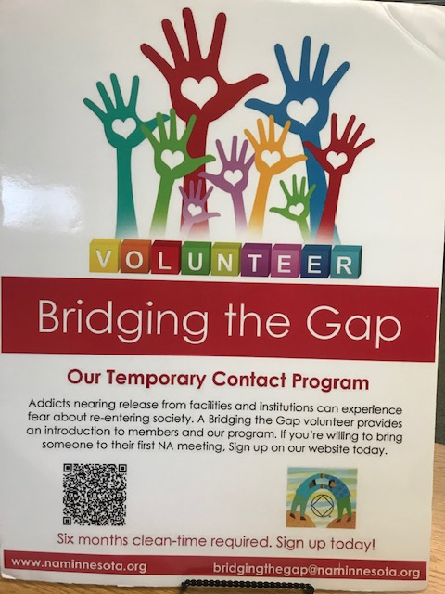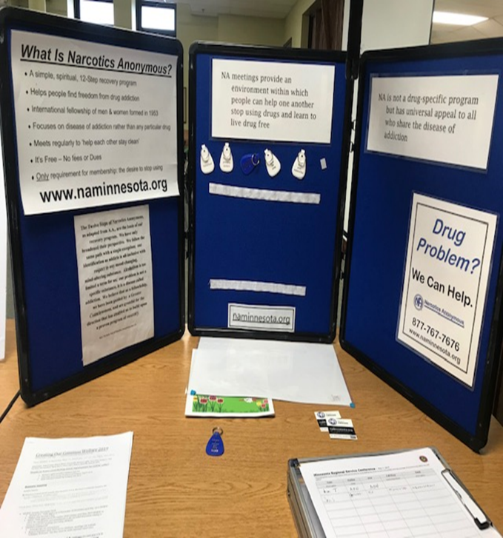
Bridging the Gap Volunteer.
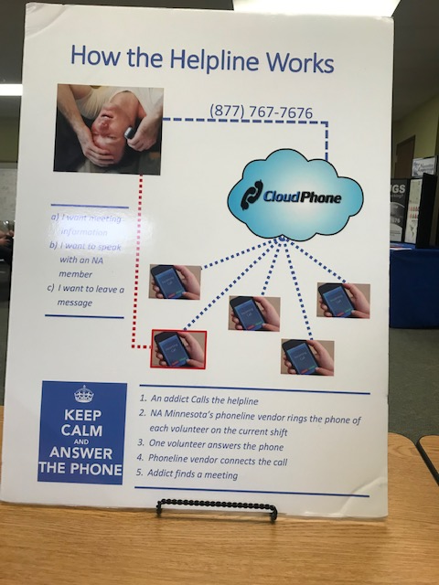
Help line Volunteer
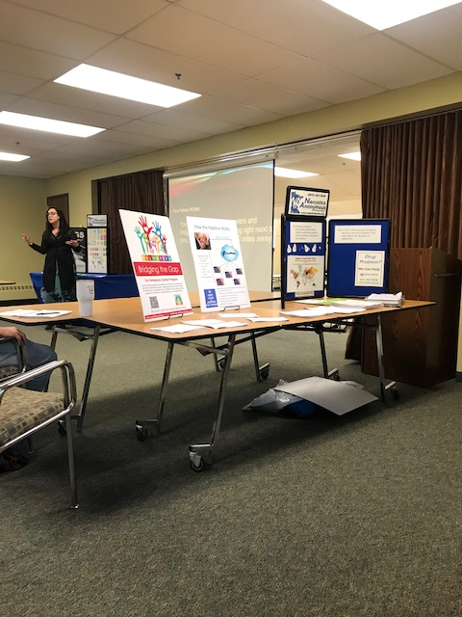
Jessie N she is I think…secretary?

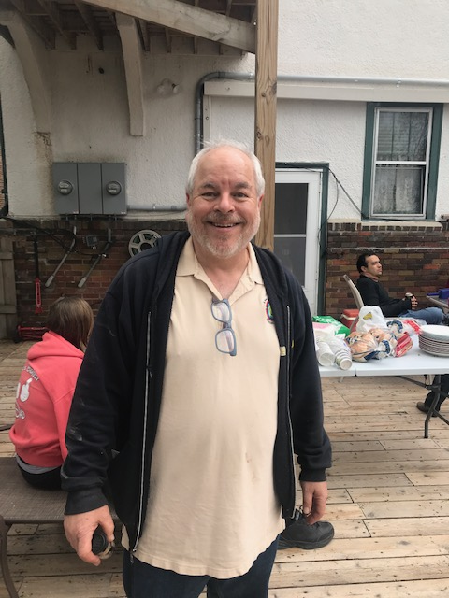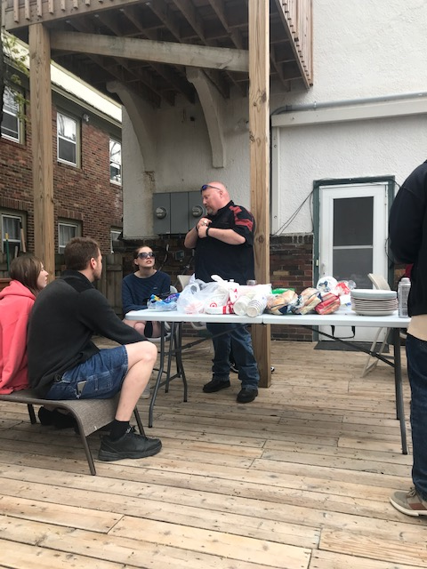
Jeff S stepped down from running the website for NA (webmaster) and we ate at his house after this event…awesome time!

