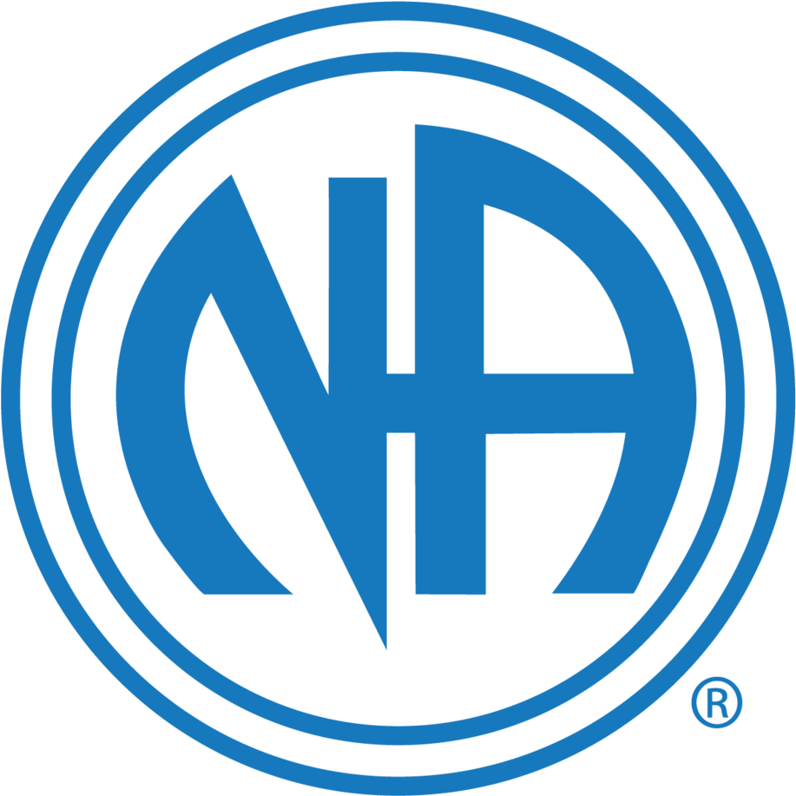
SWMNNA PRESENTS
The Twelve Steps inservice Training
March 14th 2020 * 920 Diagonal Road, Worthington 12PM – 4PM
Please Join us, All are welcome

