Southwest Minnesota Area Narcotics Anonymous
Second Annual
Put your heart into NA
Dance and Potluck
“The heart of NA beats when two addicts share their recovery.”
Tickets: $10 per person,
$5 Discount if you bring a
dish.
Kids 10 and under free.
Teenagers $5
Doors open at 12 PM for setup.
Fellowship starts at 3 PM.
Supper at 5.
Speaker Shannon p from nicolett
Will be speaking
Dance 8 PM to 10 Pm.
February 15th
3 pm to 10 pm
116 No Main street
Sherburn MN to the left
of the Theater downstairs
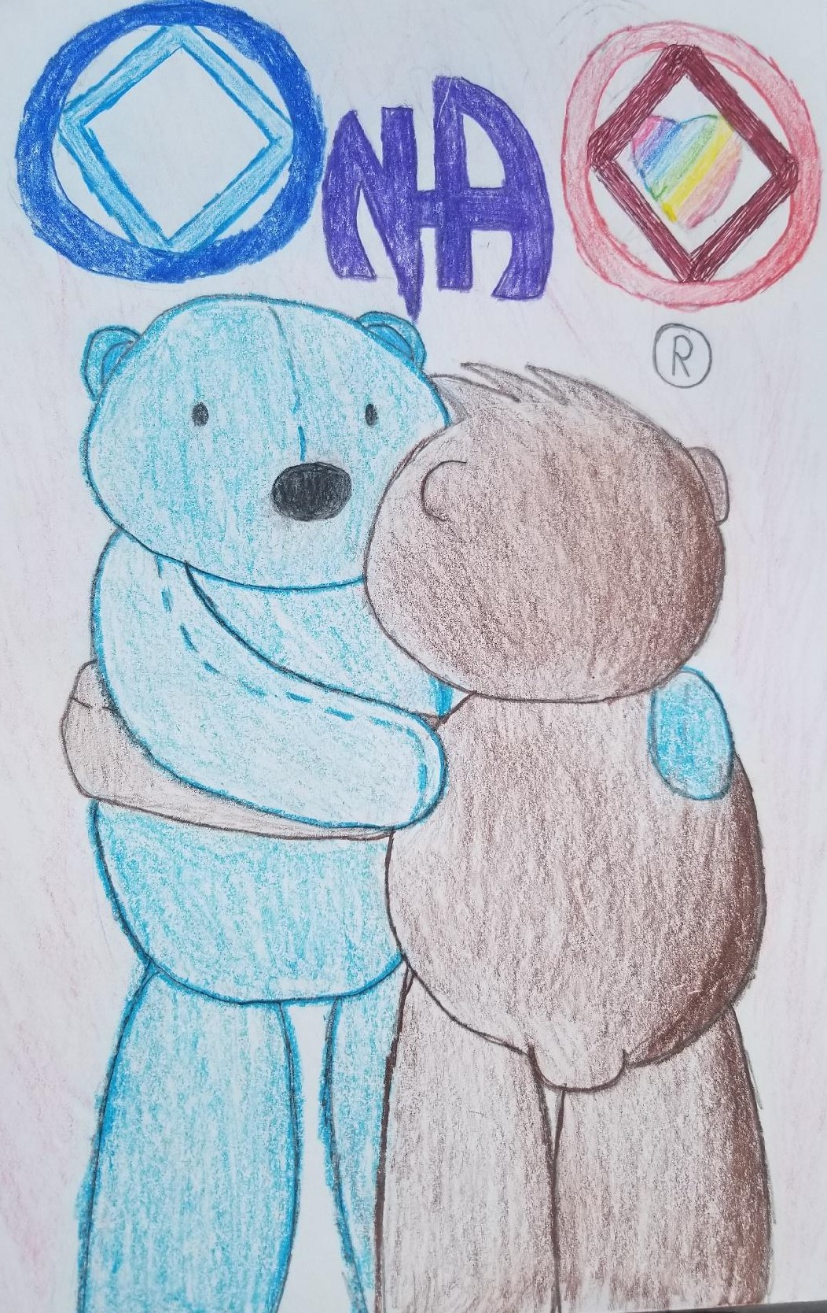
SWMNNA ASC
Activities Committee

