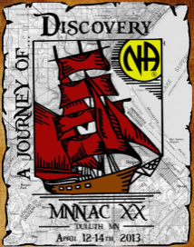
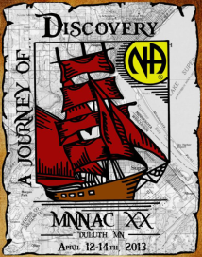
The memory of addicts lost will light our way as
we carry the message to the addict who still suffers.

Saturday Luminary Memorial Walk

WE ASK EVERYONE ~ to join together for a luminary memorial walk from the Holiday Inn to the Duluth Entertainment and Convention Center where the Main Speaker meeting will be held in Symphony Hall.

We will be leaving in groups of 100 every 5 minutes beginning at 5:20 pm. Sign-up sheets can be found on the table next to the MNNAC XX Marketplace entrance to reserve your departure time. We will meet on the 2nd floor of the Holiday Center (above the escalators) and begin our walk with the Third Step Prayer.

BANQUET TICKET HOLDERS ~ beginning at 4:30 we will also meet on the 2nd floor of the Holiday Center (above the escalators) and begin our Memorial Walk with the Third Step Prayer.

MEMORIAL RIDE/ SPECIAL NEEDS TRANSPORT ~ Limited transportation is available for those who are unable to walk the few blocks from the Hotel to the DECC. Reservation sheets and departure times can be found on the table next to the MNACC XX Marketplace entrance.

We will board the transport at the Superior Street entrance of the Holiday Center and begin our ride with the Third Step Prayer.

MEMORIAL LUMINARIES AVAILABLE
$1 in the MNNAC XX Marketplace
~ Quantities Limited ~


MEMORIAL CARDS
In remembrance of those addicts lost to us: Please print their name on the index cards provided and drop it in the Memorial box located in the MNNAC XX Marketplace no later than 1:00 pm on Saturday. These names will be included in a special part of our Saturday night program.

