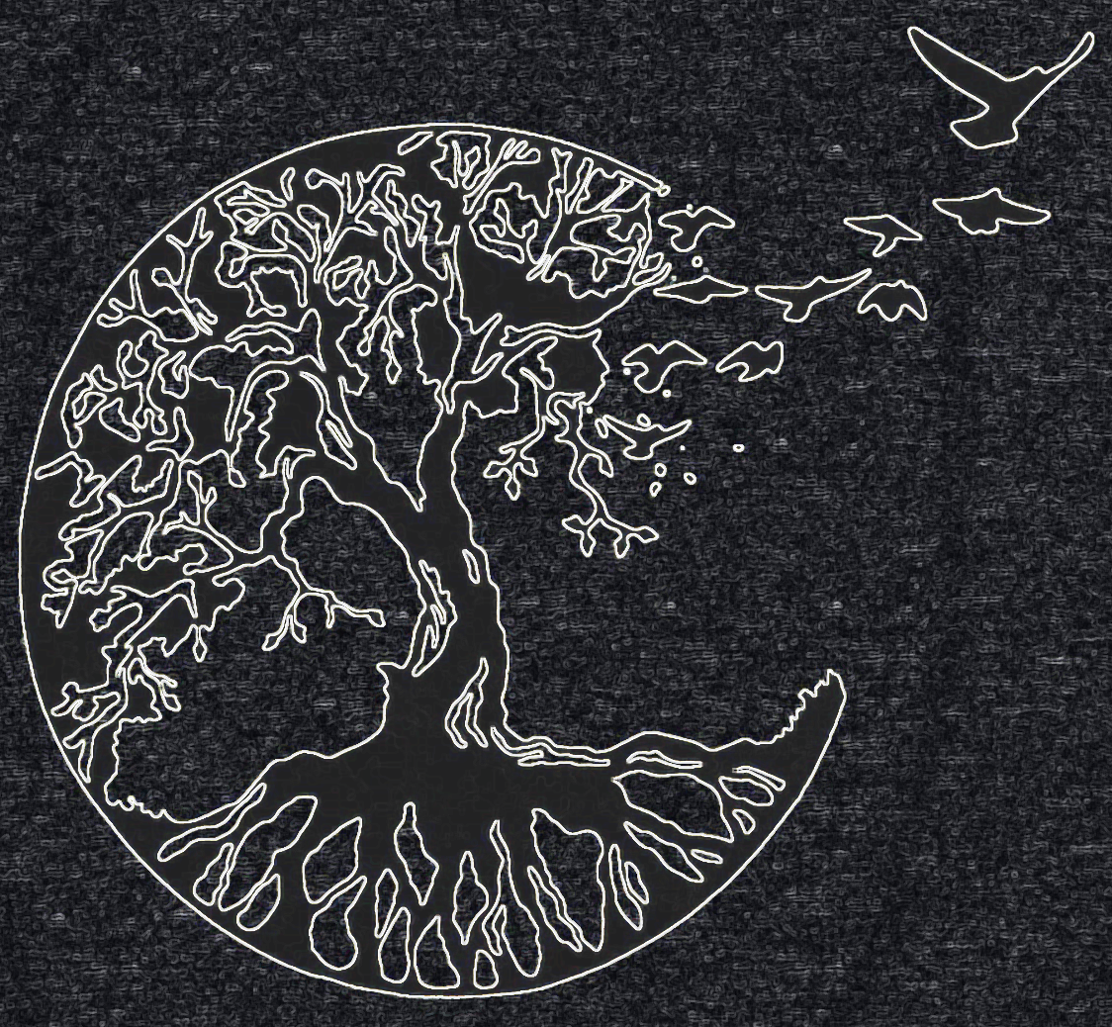
NA is like the air we breathe; it surrounds us when we share recovery. It flows between us, constantly changing. We can no more keep recovery by holding it to ourselves than we could keep oxygen by holding our breath.
Guiding Principles: The Spirit of Our Traditions (p. 171).

