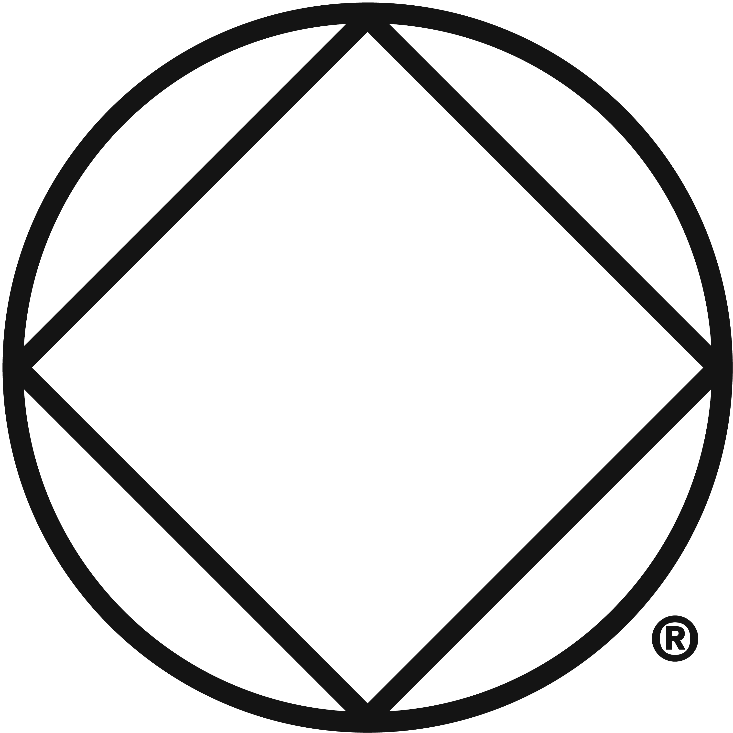
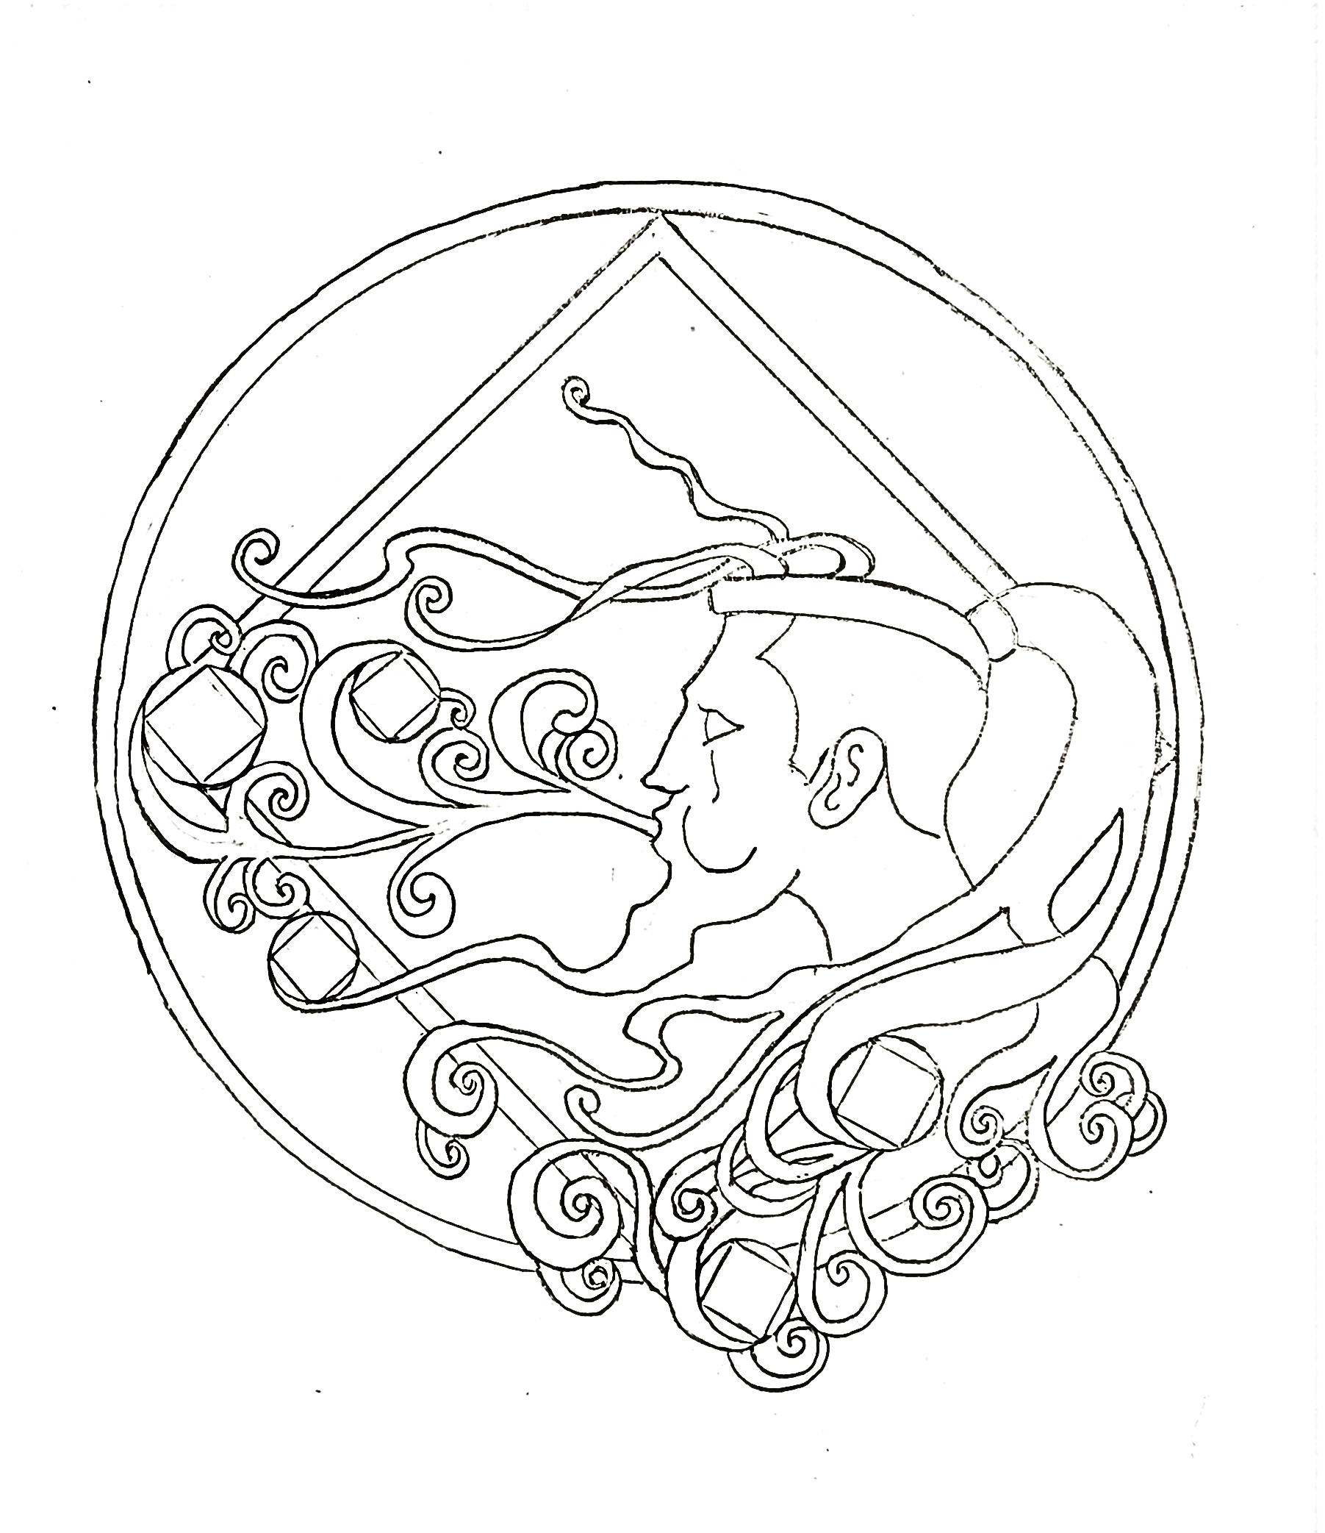
NA is like the air we breathe: It surrounds us when we share recovery.
®
Vermilion 2022 Sept 9,10,11

