The Northern Lights Area
Invites you to our 30th Annual

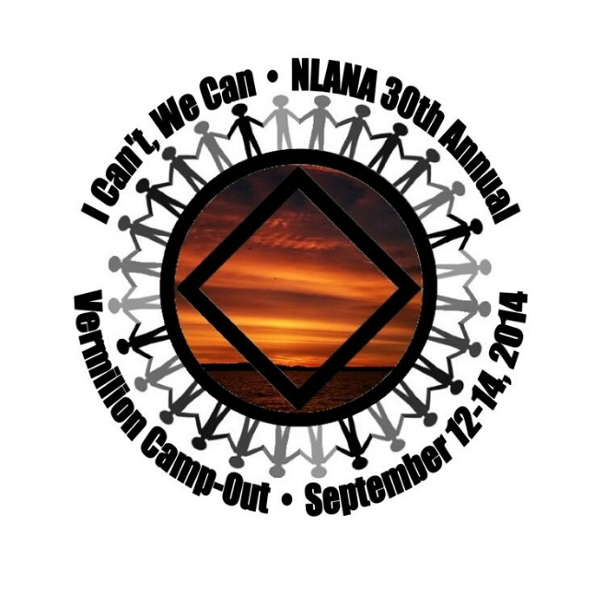

Vermilion Camp-out
September 12, 13, & 14, 2014

There is something for everyone.

ABOUT LAKE VERMILION
With its 40,000 acres of water, 365 islands and 1200 miles of shoreline, Lake Vermilion stretches 40 miles across the heart of Minnesota’s Arrowhead Region.

Bakk House: (Adults only) (No discounts) Sleeps 30, Heated, 3 Bathrooms, Sauna, Kitchen, Living Room, Pool Table, TV w/VCR and DVD.
Priest House: (No discounts) Sleeps 12, Fireplace, Kitchen, Living Room, Next to outdoor Sauna.
Cabins: Varies. Sleeps 6-12 people; some with electricity and water; NO Bathrooms.
Camping w/electric: Only 3 sites available; includes fire ring (1ST PAID, 1ST RESERVED BASIS)
Camping: Mown Grass Field. NO FIRES.

Bring your tent or stay in one of the many cabins. Fun for the entire family. Bring your own bedding or sleeping bag (mattress provided). Bring your boat, canoe, kayak, & fishing gear (& MN fishing license). A shared cabin will be available for use by day pass users.

Don’t forget your flashlight & bug spray!

BE PREPARED FOR RAIN OR SHINE
Sorry NO pets allowed.

DIRECTIONS:
Take US #53 to Cook, and then turn right on County Road 24. Go 3 miles. Turn right at the big resort directional sign onto County Road 78 (Beatty Road) and go 2¼ miles. Take a left onto Luthey Road (watch for the Camp Vermilion sign and go 1¼ miles.) Turn left under the camp archway and go ¾ miles to camp.

For questions or comments:
Val D. (Registration) 218-428-4801
Sue J. (Chair) 218-355-0949
Mail payment & registration to: NLANA, Vermilion 2013, PO Box 16934, Duluth, MN 55816
Make checks payable to: NLANA
Please list the FIRST and LAST names of ALL people on this registration (Use separate sheet if necessary)
Names: ___________________________________
___________________________________
Street: ________________________________________ Phone: (_____) __________________

City St Zip ______________________________________
Email: _________________________________________________________________________
Clean Dates: ____________________________________________________________________
ADULTS (Age 17 and older)
Price includes ALL events and meals. Saturday Day Pass includes lunch and dinner.
We cannot accommodate special dietary requests.

BAKK #___ @ $105.00 $
PRIEST #___ @ $ 95.00 $
CABIN #___ @ $ 90.00 $
CAMP (Elec) #___ @ $ 75.00 $
CAMP #___ @ $ 65.00 $
We offer the following discount for those in need:
(Cabin or Camping Only)
0 – 90 DAYS CLEAN
50% Off Registration
Those who receive discounted pricing are requested to donate their time in service at the event.
Please complete a registration form and fill in the appropriate discount amount.

DAY PASS #___ @ $ 25.00 $
KIDS
5 & Under #___ @ No Chg $ FREE
AGES 6 – 16:
PRIEST #___ @ $ 48.00 $
CABIN #___ @ $ 45.00 $
CAMP #___ @ $ 33.00 $
DAY PASS #___ @ $ 5.00 $
SUB-TOTAL $
NO EARLY ARRIVALS
Campers arriving before noon on Friday will be asked to leave and come back Friday after 12 p.m.

Newcomer Donation $
Subtract Discounts ($ )
GRAND TOTAL $

WHAT IS THERE TO DO?
*Some events may change

FRIDAY NIGHT
4:00 Workshop
Hug-Up Meeting
Open Mic (Share your talents)

SATURDAY
Morning and Afternoon Workshops
Kid and Adult Games
Crafts for Kids
Volleyball and Basketball
Swimming and Sauna
Nature Walk
Fellowship
Clean Time Countdown
Main Speaker
Merchandise Auction/Raffle
Celebrity Themed Dance
(Dress up as your favorite celebrity)
Hug-Up Meeting

SUNDAY
Farewell Meeting at the Chapel

Vermilion Camp-out
September 12, 13, & 14, 2014

Whether you have been
showing up since 1984 or it’s
your first time…

Come and join us as we celebrate 30 years at beautiful Camp Vermilion!

Register Online @
www.naminnesota.org
NLANA VERMILION COMMITTEE
PO BOX 16934
Duluth, MN 55816

“We’ve begun to see that God’s will for us is the ability to live with dignity, to love ourselves and others, to laugh, and to find great joy and beauty in our surroundings.” (IWHW pg. 81)

