The Northern Lights Area
Invites you to our 32nd Annual
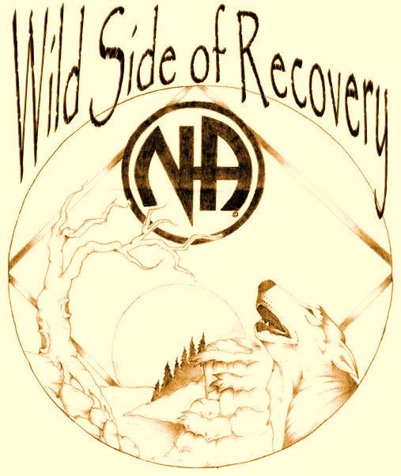
Vermilion Camp-out
September 9, 10, & 11, 2016

There is something for everyone

Brand New Grand Hall

The new building we have all been waiting for has opened! Come check out the new dining hall with screened outside seating available, high tech kitchen with catered meals!4 new sleeping quarters with private bathrooms and luxurious entertaining room!

For questions or comments:
Caitlin M. (Registration) 218-390-9747
Dean C. (Chair) 218-428-8642

Register online www.naminnesota.org
Grand Hall: (ADULTS ONLY) (No discounts) Four Suites (ranging from 8 to 12 beds), each with PRIVATE bathroom and shared large living room!
(1ST PAID, 1ST RESERVED BASIS)
ADA suite available, please note if needed with description, call ahead by 08/15 to reserve ADA.

Bakk House: (Adults only) (No discounts) Sleeps 30, Heated, 3 Bathrooms, Sauna, Kitchen, Living Room, Pool Table, TV w/VCR and DVD

Priest House: (No discounts) Sleeps 12, Fireplace, Kitchen, Living Room, Next to Sauna

Cabins: Varies. Sleeps 6-12 people; some with electricity and water; NO Bathrooms.

Camping w/Electrical: (No discounts) Only 3 sites available; includes fire ring
(1ST PAID, 1ST RESERVED BASIS)

Camping w/Firepit: (No discounts) (1ST PAID, 1ST RESERVED BASIS) Only 6 tent sites available; includes fire ring and is tucked away in the woods

Camping: Mown Grass Field. NO FIRES

BE PREPARED FOR RAIN OR SHINE

Sorry NO pets allowed.
All children need to stay with the parents.

Bring your own bedding or sleeping bag (mattress provided). Bring your boat, canoe, kayak, & fishing gear (& MN fishing license). A shared cabin will be available for use by day pass users.

Don’t forget your flashlight & bug spray!
Register online at http://www.naminnesota.org/index.php/naevents/vermilioncampout or mail payment & registration to: NLANA, Vermilion 2016, PO Box 16934, Duluth, MN 55816
Please list the FIRST and LAST names of ALL people on this registration (Use separate sheet if necessary)
Names:

Street: Phone: (_____) _______________
City St Zip
Email:
Clean Dates
ADULTS (Age 16 and older)
Price includes ALL events and five meals. Saturday Day Pass includes lunch and dinner.
We cannot accommodate special dietary requests.

Grand hall* #___ @ $140.00 $
BAKK #___ @ $120.00 $
PRIEST #___ @ $110.00 $
CABIN #___ @ $105.00 $
CAMP (Elec) #___ @ $ 90.00 $
NEWCOMERS
(Cabin or Camping Only)
0 – 90 DAYS CLEAN ONLY
$25.00 Off
Those who receive discounted pricing are requested to donate their time in service at the event.
Please complete a registration form and fill in the appropriate discount amount.

CAMP (firepit) #___ @ $ 90.00 $
CAMP #___ @ $ 80.00 $
DAY PASS #___ @ $35.00 $
AGES 0 – 3: (No bakk OR GRAND HALL)
ANY #___ @ $0.00 $ FREE
AGES 4 – 11: (No bakk OR GRAND HALL)
Any #___ @ $ 25.00 $
Day pass #___ @ $ 15.00 $
AGES 12 – 15: (No bakk OR GRAND HALL)
any #___ @ $ 40.00 $
NO EARLY ARRIVALS
Campers arriving before noon on Friday will be asked to leave and come back Friday after 12 p.m.

day pass #___ @ $ 15.00 $
SUB-TOTAL $
Newcomer Donation + $
Subtract Discounts - $
GRAND TOTAL $
*ADA NEEDEd Description _
WHAT IS THERE TO DO?
*Some events may change

FRIDAY NIGHT
Workshops
Hug-Up Meeting
Open Mic

SATURDAY
Workshops
Kid and Adult Games
Crafts for Kids
Volleyball and Basketball
Swimming and Sauna
Nature Walk
Fellowship
Clean Time Countdown
Main Speaker
Merchandise Auction/Raffle
Dance
Hug-Up Meeting

SUNDAY
Farewell Meeting at the Chapel

ABOUT LAKE VERMILION
With its 40,000 acres of water, 365 islands and 1200 miles of shoreline, Lake Vermilion stretches 40 miles across the heart of Minnesota’s Arrowhead Region.
Vermilion Camp-out
September 9, 10, & 11, 2016

Whether you have been showing up since 1984 or it’s your first time…

Come and join us as we celebrate 32 years at beautiful Camp Vermilion!

Register Online
www.naminnesota.org

“We’ve begun to see that God’s will for us is the ability to live with dignity, to love ourselves and others, to laugh, and to find great joy and beauty in our surroundings.” (IWHW pg. 81)
NLANA VERMILION COMMITTEE
PO BOX 16934
Duluth, MN 55816
DIRECTIONS:
Take US #53 to Cook, and then turn right on County Road 24. Go 3 miles. Turn right at the big resort directional sign onto County Road 78 (Beatty Road) and go 2¼ miles. Take a left onto Luthey Road (watch for the Camp Vermilion sign and go 1¼ miles.) Turn left under the camp archway and go ¾ miles to camp.

