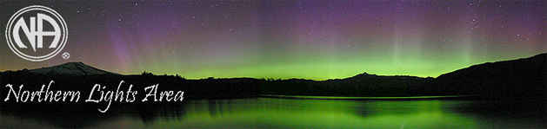
Northern Lights Area of Narcotics Anonymous
Meeting List (Updated 12/08/2021)
DULUTH, CLOQUET, SUPERIOR
All meetings follow facility Covid-19 protocols. Please bring a mask.
Sunday
4 PM - Romp n’ Stomp
Pilgrim Lutheran Church, 820 Belknap St Superior, WI 54880
Enter in the back
Monday
12 PM - Just for Today - Zoom Meeting ID # 919-054-8896
7 PM - We Made A Decision
First Covenant Church, 2101 W 2nd St Duluth, MN 55806
Lower level
Tuesday
12 PM - Just for Today - Zoom Meeting ID # 919-054-8896
7 PM - New Horizons
Trinity Lutheran Church, 1108 E 8th St Duluth, MN 55805
Wednesday
12 PM - Just for Today - Zoom Meeting ID # 919-054-8896
Thursday
12 PM - Just for Today - Zoom Meeting ID # 919-054-8896
7 PM - Hope Not Dope
Mt Olive Lutheran Church, 2012 E Superior St Duluth, MN 55812 Back Entrance
Friday
12 PM - Just for Today - Zoom Meeting ID # 919-054-8896
7 PM - Living Clean
Peace Church, 1111 N 11th Ave E Duluth, MN 55805 Lower level, Back Lot
Saturday
1130 AM - Just for Today - Zoom Meeting ID # 919-054-8896
6 PM - Hope Fiends
Neighborhood Church, 612 Cloquet Ave, Cloquet, MN 55720
7 PM - It Takes A Village
Peace Church, 1111 N 11th Ave E Duluth, MN 55805 Lower level, Back Lot
Find additional meetings world-wide at www.NA.org
Minnesota Helpline (877) 767-7676 Toll Free

