WHAT IS NARCOTICS ANONYMOUS?

Narcotics Anonymous is a non-profit fellowship or society of men and women for whom drugs had become a major problem . . . Recovering addicts who meet regularly to help each other stay clean.
Membership is open to any drug addict, regardless of the particular drug or combination of drugs used. There are no social, religious, economic, racial, ethnic, nationality, gender, or class-status membership restrictions.
Narcotics Anonymous believes that one of the keys to its success is the therapeutic value of addicts working with other addicts. In meetings, each member shares their personal experience with others seeking help. Not as professionals, but simply as people who have been there themselves and have found a solution.
Narcotics Anonymous has no professional therapists, no residential facilities, and no clinics. NA provides no vocational, legal, financial, psychiatric, or medical services. The closest thing to an “NA counselor” is the sponsor, an experienced member who gives informal assistance to a newer member.

ADDICT’S PRAYER

My gratitude speaks
When I care and when I share with others
The NA way
That no addict seeking recovery
need ever die from the horrors of addiction
without finding a better way to live

JUST FOR TODAY
Tell yourself:

Just for today, my thoughts will be on my recovery. Living and enjoying life without the use of drugs.
Just for today, I will have faith in someone in NA. Who believes in me and wants to help me in my recovery.
Just for today, I will have a program. I will try to follow it to the best of my ability.
Just for today, through NA. I will try to get a better perspective on my life.
Just for today, I will be unafraid. My thoughts will be on my new associations, people who are not using and who have found a new way of life.
So long as I follow that way, I have nothing to fear.

NA MEMBERS CAN HELP
CARRY THE MESSAGE

Service is an important part of our recovery.

Our groups join together to carry the message of Narcotics Anonymous on the 3rd Saturday of the following months: Jan, Mar, Apr, May, Jul, Aug, Oct and Nov. Please check with your local NA group for the service meeting location.

Vermilion Campout Committee
Meets from 11:00 to 12:00

Administrative Committee
Meets from 12:15 to 1:45

Area Service Committee
Meets from 2:00 to 5:00

CONTACTS

NORTHERN
LIGHTS
AREA
OF
NARCOTICS
ANONYMOUS
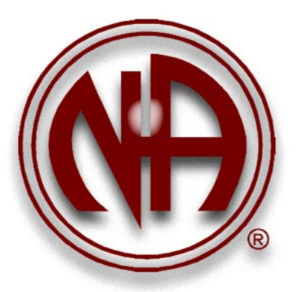

For more information or to find meetings in other parts of Minnesota please call the
Phone Line
1-877-767-7676

or visit

MN Regional Website
www.naminnesota.org

Northern Lights Area Website
www.northrenlights.naminnesota,org

Updated March 2011

Distributed by:
Northern Lights Area of Narcotics Anonymous
PO Box 16934, Duluth, MN 55816

