NA Meeting List
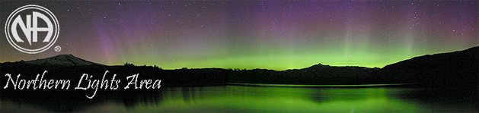
DULUTH, CLOQUET, SUPERIOR
Indoor meetings follow State Covid-19 protocols.
Please bring your mask and your own beverage.

Sunday:
- 4 PM Romp n’ Stomp
    - John Club, 1609 John Ave, Superior, WI
Monday:
- 12 PM Just for Today Zoom Meeting ID # 919-054-8896
- 7 PM We Made A Decision
    - First Covenant Church, 2101 W 2nd St, Duluth
Tuesday:
- 12 PM Just for Today Zoom Meeting ID # 919-054-8896
Wednesday:
- 12 PM Just for Today Zoom Meeting ID # 919-054-8896
- 7 PM Strength in Numbers Zoom Meeting ID # 244-729-4275
Thursday:
- 12 PM Just for Today Zoom Meeting ID # 919-054-8896
- 7 PM Hope Not Dope
    - Mt Olive Lutheran Church, 2012 E Superior St, Duluth
Friday:
- 12 PM Just for Today Zoom Meeting ID # 919-054-8896
- 6 PM Cloquet NA Group
    - Alano Club, 103 10th St, Cloquet, MN 55720
- 7 PM Living Clean Zoom Meeting ID # 435-920-7484
- 7 PM Beach Fire Meeting Weather Permitting look for posted information each Friday.
    - Wisconsin Point, Superior, WI
Saturday:
- 11:30 AM Just for Today Meeting Zoom ID # 919-054-8896
- 6 PM Cloquet NA Group
    - Alano Club, 103 10th St, Cloquet, MN 55720
Find additional meetings world-wide at NA.org

