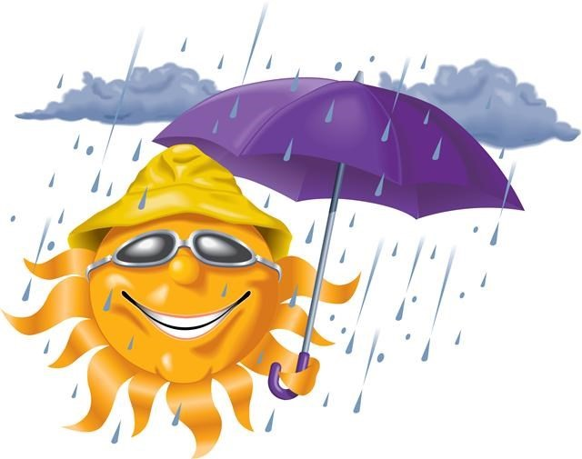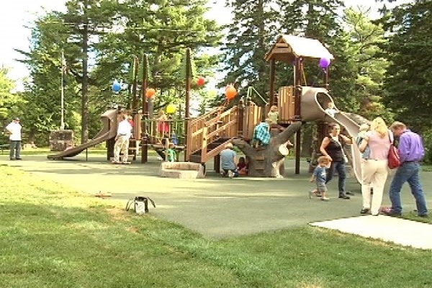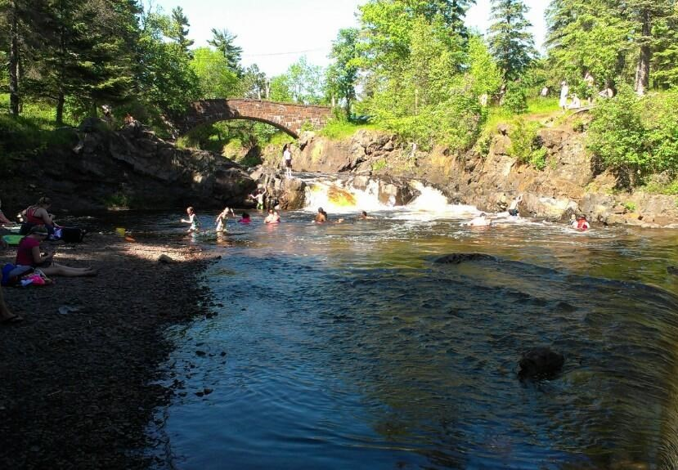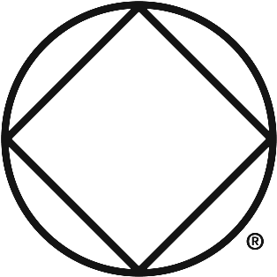
Sun or Soak

your Buns

Northern Lights Area of
Narcotics Anonymous

Saturday July 8th, 2017

Noon until 5:00

Lester Park

-

Superior St & Lester River Rd

Near the area of the park next to the playground.

→

This is a self
-
serve event. This means everyone brings their own picnic food & picnic
supplies. Bring your beverages, chair, blanket, charcoal, utensils for cooking, paper
plates, silverware, etc.

→

Bring games to share.

→

Bring your swimming suit and towel.

→

This is a family friendly event. There are no lifeguards on duty in the swimming area of
the river.

→

Dogs are welcome
—
bring your pooper
-
scooper.

→

Questions? Call Marvella D. 218-212-6027

