 | 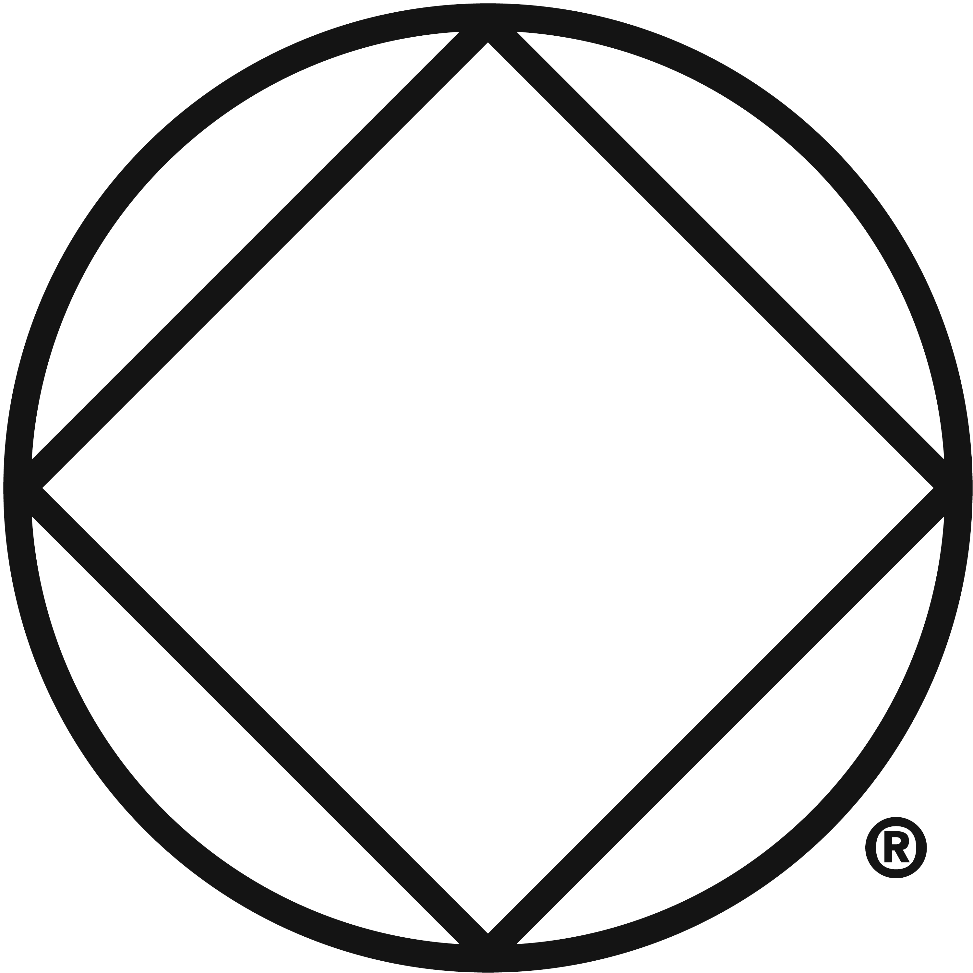
northern lights area of narcotics anonymous presents:
2022
NEW YEAR’S EVE Party

winter starry night theme
 |  |  |  | 31
 |  |  | December | 31 | 8:00 pm
mt olive church | 2012 E Superior St, Duluth
speaker at 9:00 pm with dance to follow
black tie suggested but not required
50/50 raffle: 50% cash, Vermilion registration, mnnac registration
dessert POTLUCK, BEVERAGES will be provided
$5 suggested donation
 | 

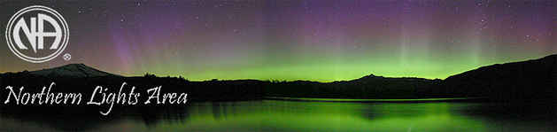

December 8, 2021

Greetings,
We are pleased to provide a drug free New Year’s Eve event. Please encourage your clients to join us. The details are provided on the enclosed flyer.
We create events and activities to build unity and celebrate together. We believe that it is vital for addicts to know that we can and do have fun in recovery.
Our speaker for the event has 20+ years of recovery and carries a strong Narcotics Anonymous message of hope.
Although some members of the fellowship will enjoy dressing up for the dance many will attend in their everyday attire so do not worry about feeling out of place.
A $5 donation is suggested but not mandatory.
Questions can be sent to info.nl@naminnesota.org.

In loving service,

NLA New Year’s Eve Committee
\

